2025-2026 Parent/Guardian/Student Handbook
OUR LADY OF GOOD COUNSEL SCHOOL



Table of Contents

Academic Expectations (B.2) 1
Graduation (E.19) 1
Homework (E.8) 1
Grades and Grading (G.4) 2
Assessments (G.4) 5
Accidents (E.26, E.27) 6
Admission Policies (E.1, E.2, E.3) 6
After School Program 7
Announcements 7
Artificial Intelligence (AI) Use in Schools (B.11) 7
Attendance (E.5, E.6) 12
Birthday Parties 13
Schools should insert their own policy regarding birthday parties. 13
Books (B.3, B.4) 13
Buses 14
Cell Phone/Smart Device Policy 14
Change of Address, E-mail, Phone (G.1) 15
Charter for the Protection of Children and Young People (B.11) 15
Child Abuse Laws (C.6) 16
Child Custody (E.28) 16
Communication (H.3, H.4) 16
Confidentiality (G.3) 17
Contacts with the Media (H.2) 17
Crisis/Emergency Information (B.9, E.7) 17
Daily Schedule (B.10) 18
Discipline Code for Student Conduct (E.12, E.13, E.18) 18
Dress Code (E.20) 20
Drug and Alcohol Policies (E.15) 21
Electronic Devices (E.30) 21
Emergency Closings/Delayed Openings (E.7) 22
Expectations and Responsibilities for Students (E.13) 22
Extracurricular Activities (E.31) 23
Faculty Meetings (D.9) 23
Field Trips (E.10) 23
Financial Policies 24
Fire & Emergency Drills/Lockdown Drills (E.25) 26
Guidance (D.4) 26
Guidelines for the Education of Non-Catholics (A.5) 26
Harassment/Bullying Policies (E.17, E.18) 27
Illness (see Medication) (E.26) 27
Immunizations (E.24) 28
Lateness (E.6) 28
Liturgy/Religious Education (A.4) 28
Lunchroom 28
Maternity/Paternity Policies (E.22) 29
Medications (E.26) 29
Money 30
Parents/Guardians as Partners (A.1, H.4) 30
Parent/Guardian Organizations (H.4) 32
Philosophy and Goals (Forward) 32
Pregnancy Policy (E.22) 32
Re-registration (E.1, E.14, G.5) 34
Release of Students (during school day) (E.6) 34
School Calendar 35
School Publications (H.3) 35
School’s Right to Amend 35
Security (E.27) 36
Sex Offender Policy (B.11) 36
Smoking (E.15) 37
Special Learning Needs (F) 37
Summer School (G.4, G.5) 38
Telecommunications Policy (E.29) 38
Student Expectations in Use of the Internet 39
Use of School Grounds 39
Withdrawals and Transfers (G.3) 39
Summary Statement 39
Telecommunications Policy 41
APPENDIX 44
Parent/Guardian Signature Page – Return Due Date: September , 2025 44
MEDIA AUTHORIZATION AND RELEASE 45
Technology Use/Telecommunications Policy 46
Agreement for 2025-2026 School Year 46
Absent Note 47
Textbook/Software/Hardware Request Form 48
2025-2026 New York State Immunization and Medical Forms 50
DATA PRIVACY CONSENT FORM 99
Authorization to Release Records 102

School Policies

Academic Expectations (B.2)

The school expects students to perform to the best of their ability. Teachers are expected to evaluate student progress on a regular basis. Students will be given quizzes or tests regularly. After the test is graded, it will be sent home for the parent/guardian to review and sign or posted to Student Information System (SIS) for parent viewing. A parent/guardian’s signature indicates that the parent/guardian is aware of the student’s progress. Schools should insert current policy regarding gradebook in Student Information System (SIS) and how tests and work is sent home to be reviewed by parents/guardians.

Graduation (E.19)

At the discretion of the principal, each school has the right not to certify the student's graduation or provide transcripts of the student's academic record to third parties such as other schools, colleges, or employers, or to issue a diploma to the student, if there has been a breach of a material condition of this educational contract (i.e., failure to meet financial obligations, infractions against the school’s code of conduct, etc.).

Homework (E.8)

Homework is an essential part of the instructional program, reinforces learning, and provides students with opportunities to practice what they have learned. This practice helps students establish good study habits, become independent learners, and strong readers, writers, and mathematicians. All homework times include 15 minutes of reading (or being read to).

The time allotments for homework (written and study) are as follows:

Grade K short homework assignments related to the curriculum.
Grades 1 & 2 approximately 30 minutes
Grades 3 & 4 approximately 45 minutes
Grades 5 & 6 approximately 90 minutes
Grades 7 & 8 approximately 120 minutes

Students are required to complete all their homework.

Grades and Grading (G.4)

Report cards are distributed four times a year for Grades K to 8. Pre-K report cards are distributed two times a year. The report card is an important part of the ongoing communication between the school and the home.
Academic Achievement (G.5)

The first part of the Archdiocesan Report Card is used to mark the student’s achievement in academic subjects.
- The achievement mark in each quarter is based upon the demonstration of mastery of material covered in class such as:
- classwork/participation
- homework
- quizzes
- formative assessments
- summative assessments

There are no grades for Computer Science or Library as these two areas are to be supportive of, and integrated into, the total learning process.

Foreign Language will be given a letter grade if the class meets for less than 120 minutes per week. Foreign Language will be given a numerical grade only if the class meets for more than 120 minutes per week.

The Final Report Card Grade is the weighted average of the four previous quarter grades (with end-year tests in Religion for grades 3-5 and in all core subjects, including Religion for grades 6-8). This Final Grade will be recorded on the student’s permanent record.

- Numerical marks are recorded on report cards for Grades 1– 8.

- The marks are an average of summative assessments, quizzes, classwork, homework, and formative assessments

- Passing is any mark 70% or above or any mark of D or higher.

The Parent/ guardian will be informed in a timely manner in the event of a student who is not satisfactorily performing in a course or activity.

The Parent/guardian is encouraged to monitor their child’s progress by using the Student Information System (SIS) portal.

Character Development (E.13)

The Conduct and General Effort Scale indicates grades for General Effort and Character Development. A single letter grade is used with progress codes indicating improvement needed in any sub-category.

Honor Roll (G.4)

The criteria for inclusion in the Honor Roll are particular for each school. An acknowledgment of achievement in academics, a suggested model would be:

Grades 4 – 8 | High Honors | 95% average.  no mark less than 90%
 | Honors | 90% average.  no mark less than 85%

Good conduct is a requirement to receive First or Second Honors. Therefore, a student must receive an A (excellent) or B (good) in conduct to be eligible for honors. A student who does not receive an A or B in Conduct will not receive First or Second Honors even though marks might warrant it.

Schools have the discretion in determining whether or not a student receives High Honors or Honors depending on the individual school’s attendance and lateness policy. Students cannot receive either honors designation if they exceed three late arrivals per quarter.

Report Card Distribution (G.4)

Report cards will be withheld if financial obligations have not been met and fees are outstanding.

Retention/Promotion (G.5)

Very few decisions we make about children are more important than recommendations to promote or to retain a student. When a school accepts a student, that school accepts the responsibility for providing appropriate instruction to help the student achieve the prescribed goals. If the student successfully achieves the program’s objectives, the student progresses to the next level.

Testing, diagnosis, and actual performance, however, may indicate that some students cannot follow the school’s complete course of study. The principal and school faculty develop for each of these students a special program, based on the school’s regular program, which follows the New York State Standards. A copy of the student’s modified program is retained in the student’s file. Conferences must be held with the parent/guardian periodically to inform them of the specific demands of this program and on-going progress. Therefore, the decision to retain a student presupposes that the school has done everything to help the student achieve success, and the student still has not made satisfactory progress.

If a student is being considered for retention, teachers must begin discussing this possibility early in the school year with the principal. Parent/guardian conferences must be held periodically, and notification of the possibility of retention must be made no later than mid-January, with the written notation having been made on the report card. Although the teacher consults with the principal, the final decision for retaining a student rests with the principal.
The following are specific criteria that will assist teachers as they consider a recommendation for retention.

The student has failed to pass the major subjects on each grade level.
The following table indicates the specific failures by grade level that might result in retention at that grade level:

LEVEL | ACADEMIC PROGRESS
Kindergarten | Evidence that the child is not meeting academic expectations of the program.
Grade 1 | Evidence of insufficient developmental progress and a failure in English Language Arts (ELA)
Grade 2 | Failure in ELA
Grade 3 | Failures in ELA and Mathematics
Grade 4, 5, 6 | Failures in ELA and Mathematics,  or  Failures in ELA or Mathematics and failures in two of the following subjects: Religion, Science, and Social Studies
Grade 7, 8 | Failures in ELA and Mathematics  or  Failure in ELA  or  Failures in Mathematics  Or failures in ELA or Mathematics and failure in one of the following subjects: Religion, Science, and Social Studies

The student has not demonstrated acceptable progress toward mastery of standards. The following types of behavior might indicate unacceptable progress:

- failure to complete assignments
- failures on multiple summative assessments
Generally, a student would be retained only once in the elementary grades (1 - 5), and only once in the upper grades (6 - 8).
If a student completes all requirements for promotion or graduation, a family cannot self-select the student to be retained in their grade.

Assessments (G.4)

In addition to class and school exams, every student will take part in the Archdiocesan testing program which includes the Archdiocesan religion tests, interim assessments, and New York State Education Department assessments. All students enrolled at our school are expected to participate in all exams and assessments. No alternative assignments will be provided. If a parent/guardian refuses to allow their child to participate in the New York State Education Department assessment, their child will not be permitted to attend school on testing dates.

Archdiocesan Test
Religion Final Exams | Grade 3 to 8 | June
Core Subject* Final Exams | Grade 6 to 8 | June

*In June, the Archdiocesan Religion exam will be used as the student’s End-Year Examination in Religion for Grades 6-8.

Interim Assessments

Interim Assessments – Administered Three Times per Year
Grades K-8 | NWEA MAP Interim Assessments

NY State Tests

New York State Exams
Grade Tests
3 English Language Arts and Mathematics
4 English Language Arts and Mathematics
5 English Language Arts, Mathematics, and Science (if applicable)
6 English Language Arts and Mathematics
7 English Language Arts and Mathematics
8 English Language Arts, Mathematics and Science (if applicable)
New York State Regents Exams (if applicable)

The faculty of the school reviews these assessments regularly for the purpose of fostering student growth and achievement.

Accidents (E.26, E.27)

Student accident insurance is included in the school’s yearly fees. In the event of an accident at school, you may obtain a claim form from the office.

Please note that the school accident insurance usually is secondary to the parent/guardian’s own medical insurance coverage.

Admission Policies (E.1, E.2, E.3)

Roman Catholic schools in the Archdiocese of New York base their educational purpose and all their activities on the Christian teaching of the essential equality of all persons as rooted in God’s love.

Thus, with discrimination so repugnant to their nature and mission, Catholic schools in this Archdiocese do not discriminate on the basis of race, color, national and ethnic origin, or gender in administration of educational policies, admission policies, scholarship and loan programs, and athletic and other school-administered programs.

This policy is subscribed to by all Catholic elementary and secondary schools in the Archdiocese of New York, whether owned or operated by the parishes within the Archdiocese, Catholic school regions, or religious communities within the Archdiocese.

The process for admission to the school is: The parent/guardian must complete the school application form and provide all required documents. For regional schools, this application is found online and is processed through FACTS . Following an interview and evaluation of the materials, the parent/guardian will be notified in writing about the status of the child. For regional schools, this notification occurs via email.

While admission is on a first-come, first served basis, the school endeavors to give preference in admission following these guidelines: first, to siblings of currently enrolled students; second, to Catholic students whose parent/guardian are active members of the parish, or if a regional school, active in a parish in the region; third, to Catholic students whose parent/guardian are active in another Catholic parish or, if a regional school, active in a parish outside the region; and fourth, to non-Catholic students.

After School Program

An after-school program is available to the parent/guardian of a student. As long as a student is engaged in school sponsored programs or activities, the student is expected to follow school policy. Directors of individual activities may also issue rules of behavior, which recognize the special nature of non-classroom activities. In instances where students are picked up, the parent/guardian is expected to make arrangements to pick up his or her children at the end of the program or activity. Students will be released only to a parent/guardian, or a person previously specified IN WRITING by the parent/guardian. Program fees are expected to be paid in full upon being invoiced. Past due balances will result in your child not being allowed to participate in the program until their accounts are brought up to date.

Announcements

Informational announcements are handled through the school P.A. system. Courteous attention is expected when any message is presented over the P.A. system, especially when prayers are said. All announcements must be written, brought to the office, and approved by the principal.

Artificial Intelligence (AI) Use in Schools (B.11)

Catholic Schools in the
Archdiocese of New York
Artificial Intelligence (AI) Policy

Purpose
This policy provides guidance for the responsible, faith-formed, and mission-aligned use of Artificial Intelligence (AI) in the Catholic Schools in the Archdiocese of New York. It supports the holistic development of students—cognitively, affectively, and spiritually—while upholding Catholic values and the inherent dignity of every person.

AI Ethics
Antiqua Et Nova is the title of a doctrinal note published in January 2025 by the Vatican's Dicastery for the Doctrine of the Faith and the Dicastery for Culture and Education. This document addresses the relationship between artificial intelligence (AI) and human intelligence, exploring the anthropological and ethical challenges posed by AI.

Core Principles
- AI is a tool to enhance, not replace, teacher-led instruction and human relationships.
- All AI use must align with Catholic teachings, respect individual privacy, and promote creativity, critical thinking, and moral discernment.
- AI must be used in a faith-formed manner, with transparency, fairness, and reverence for the dignity of each community member.

Acceptable Uses of AI
Students may use AI for formative instructional support, with clear guidelines and teacher oversight. Any AI use must follow the teacher’s assignment requirements, including specific directions and rubrics.

Acceptable uses include, but are not limited to:
- Students may use AI under teacher supervision to support learning, such as through instructional support or language tools. AI should enhance, not replace, student engagement and reflection.
- Brainstorming or outlining ideas, provided the students develops their own original final product.
- Grammar and spelling suggestions, similar to using spell check tools.
- AI may be used for academic research and other educational purposes aligned with instructional goals and Catholic moral principles. Any use of AI-generated assistance must be clearly cited, even when modified or adapted. Students should clearly acknowledge AI contributions while demonstrating their own learning and original work.
  - MLA Style Center
- Research support, when used to gather general information or inspiration with proper citation; using AI to summarize a reading, then checking for accuracy and citing it.
  - Example: A student uses an AI tool to summarize an article on the life of St. Teresa of Calcutta, then reads the original to verify accuracy and includes a note like:
“Summary assisted by ChatGPT, June 2025.”
  - MLA Style Center
- Practicing vocabulary or grammar through an AI-powered language tool.
  - Example: A student uses Duolingo’s AI assistant to practice Spanish verbs or sentence structure as extra practice—not for graded work.
- Asking an AI chatbot for help understanding a complex topic.
  - Example: A student asks a Catholic AI tutor, “What is the difference between mortal and venial sin?”, and uses the explanation as a starting point for class notes—crediting the tool when appropriate.

AI use is tailored to the developmental needs of students at different grade levels:

- Elementary (K–5): AI tools may be used primarily for formative support, such as vocabulary practice, formative spelling and grammar checks, and guided use of AI tutors for faith-based questions under close teacher supervision.

- Middle School (6–8): Students may engage with AI for brainstorming, research summaries with teacher guidance, and language learning tools, with explicit instruction on ethical AI use and citation practices.

Unacceptable Uses of AI

Unacceptable uses include, but are not limited to:
- Academic Dishonesty: Using AI to complete assignments, assessments, or projects without permission or proper citation constitutes cheating. Students must follow teacher guidelines and cite AI assistance when allowed. Additionally, using AI during tests, quizzes, or timed assessments, unless explicitly allowed, constitutes cheating.
- Failing to disclose AI assistance when it has contributed to submitted work.
- Inappropriate Content: AI must not be used to generate or share content that violates Catholic values, including offensive, harmful, or misleading material.
- Misuse – AI tools may not be used for harassment, bullying, deception, or any behavior prohibited by the Parent/Student Handbook.
- Asking AI to generate content that goes against Catholic values.
  - Example: A student asks an AI to write a joke or story that includes offensive language, misinformation, or content that disrespects people or faith.
- Using AI tools to message or impersonate others online.
  - Example: A student uses an AI voice or image generator to create a fake message “from” another classmate. This is dishonest and may count as harassment.
These actions must be addressed according to the school’s Code of Conduct and Acceptable Use Policy for Computer and Internet Access (under Telecommunications policy).

Sample Citations for Student Use
Students should cite AI tools just like any other source. For example:
- “Assisted by ChatGPT, June 2025, for summary purposes only.”
- “Used Grammarly AI to check spelling and grammar.”
- “Image generated with Canva AI Art, June 2025.”
- MLA Style Center
Inclusion
We promote a consistent message to families about the responsible and faith-formed use of AI. Students with additional learning or social needs may require more support—such as reminders, prompts, or tailored instruction—to help them apply AI use guidelines thoughtfully and safely.
Educators ensure AI-related activities are developmentally appropriate, well-structured, and responsive to students’ individual needs.

Information Sessions
Every Catholic school is encouraged to post the Catholic School in the Archdiocese of New York AI Policy on its website and provide clear access to it for families and staff.
Schools aim to offer periodic information sessions to help stakeholders understand the role, risks, and rewards of AI in education.

Unacceptable Material or Use of AI in a Manner Contrary to Catholic Belief
- Accidental exposure to content that is unacceptable or contrary to Catholic beliefs must be reported immediately to the Principal. Disciplinary measures may be taken locally. Accidental exposure includes, but is not limited to:
  - Children and young people may interact with AI chatbots that, through ongoing conversation, expose them to inappropriate, dangerous, or highly personal content they did not intend to encounter. This can include advice or information on self-harm, risky behaviors, or details that should not be shared with minors.
  - A student unintentionally accessing inappropriate AI content or using AI without full understanding of citation requirements.
- Deliberate misuse or exposure must be reported to the Principal and Regional Superintendent and documented. Deliberate misuse or exposure includes, but is not limited to:
    - Intentionally using AI tools like ChatGPT or generative AI models to complete assignments, essays, or exams with the goal of bypassing academic work or learning expectations.
    - Using AI-powered platforms to solve complex math or coding problems and submitting those solutions as if they were the result of the student's own efforts.
    - Employing AI to paraphrase or rewrite existing texts in order to evade plagiarism detectors.

    - Using AI chatbots during online or take-home exams to get immediate answers to assessment questions, rather than relying on their understanding of the material.

    - Manipulating AI plagiarism detectors by making subtle changes to AI-generated text, such as altering synonyms or sentence structure.

    - Utilizing AI to generate discussion posts or language assignments, intentionally submitting AI-generated content as personal work.
- Serious offenses must be reported to the Principal and the Regional Superintendent and may result in investigation by the Office of the Superintendent of Schools and disciplinary measures taken as outlined in school policies.

Grading

Students are encouraged to use AI responsibly to support their learning. If a student misuses AI, the situation will be handled with care through local disciplinary processes, ensuring that each case is addressed thoughtfully and fairly. Misuse of AI may affect academic and/or Conduct and/or General Effort grades.

Community Engagement
The Office of the Superintendent of Schools, in partnership with schools and Regions, aims to provide parents and caregivers with opportunities to learn about AI tools, their benefits, and potential risks.

Conclusion
This policy will be regularly reviewed to ensure it remains current, faithful, and aligned with the mission of the Catholic Schools in the Archdiocese of New York to ensure our schools are Christ-centered, academically excellent, and welcoming communities that teach students to be life-long learners and leaders, energized by fidelity to Christ, the Church, and one another.

Attendance (E.5, E.6)

In the State of New York, full-time education is compulsory from age six to age 16. Regular attendance is the responsibility of the child(ren)’s parent/guardian.

Excused Absence: A child is legally absent from school for the following reasons: sickness, sickness or death in the family, impassable roads, or extreme weather. All other absences are unexcused.

Lateness: A child should come to school even though he/she may be late. All lateness is recorded and marked on the report card. The Parent/guardian will be consulted about chronic lateness, and the child may be required to make up missed work.

When the child returns to school from an absence, a completed absence form must be given to the teacher (See Appendix). This form is distributed at the beginning of the school year and contains appropriate spaces for the child’s name, date of absence, class, reason for absence, and the signature of a parent/guardian.

Doctor or dental appointments should be scheduled for after school or on Saturdays. Family vacations are not to be planned for those days when school is in session. Teachers will not provide assignments ahead of a vacation planned while school is in session. The school provides families with an annual calendar to ensure that does not happen. If it is necessary for a child to be dismissed during the school day, the parent/guardian or adult (must be 18 years of age or older) chosen by the parent/guardian MUST come to the school for the child and sign out the child in accordance with the standard sign out procedure. The school must be informed ahead of time about such occurrences.

Students in kindergarten through grade eight who miss 10 or more days of the school year, whether excused or unexcused, and who have not satisfactorily completed the required work, may be considered for retention. Students with more than 10 absences are in jeopardy of not successfully completing the school year. Principals will meet with the student’s parent/guardian to determine appropriate next steps. Certification of an absence by a physician is an exception to the 10-day limit. However, satisfactory completion of required work is mandatory.

When a child is absent, parents/guardians are required to notify the school by 9:00 A.M.

Absence notes are still required upon student’s return to school in addition to the phone call.
Excessive absences and lateness may be considered educational neglect.

Birthday Parties

Birthday parties for Grades Pre-K – 5 may be held monthly in each homeroom with the teacher’s permission. The Parent/guardian should notify the teacher in writing. The Parent/guardian may bring small individually wrapped items such as cupcakes, brownies, etc. The Parent/guardian may not bring in favors or “goodie” bags for the students.

Books (B.3, B.4)

All resource materials chosen for use in academic courses must be consistent with the religious nature of our schools. Books, DVDs, or other electronic-based supplementary resources that contain profanity, inappropriate sexual references, and other immoral information would be in violation of this policy.

All books must be properly covered. Contact paper is NOT to be used to cover any books obtained under N.Y.S. Textbook Loan. These books are stamped on the inside front cover. Each child is responsible for keeping his/her books in good condition. Books that are lost or defaced become the liability of the student and his/her parent/guardian. If a book is lost or defaced, the school will bill the parent/guardian for the cost.

- ASSIGNED TEXTBOOKS: When a textbook is lent to a pupil on a semi-permanent basis, the New York State Department of Education requires that:

- the pupil’s name be placed in the space provided in each book.
- the teacher makes a record of the number of the book.
- the teacher makes a record of the condition of the book.
- in September, each child will put a clean cover on each textbook received.
- in June, all textbooks are collected, extra materials and covers are removed.
- all workbooks are collected in June.

- SUPPLEMENTARY BOOKS: When books are handed out to the children for use during a specific period within the classroom, they will be immediately collected after they have been read. If the book is to remain with the child for any length of time, his/her name must appear in the book and the teacher should have a record of this.

3. LIBRARY BOOKS: Books may be borrowed for one week. Books are charged to the child so that he/she will have the experience of signing out a library book and abiding by due dates. If books are not returned, the child cannot take out another book until the original book is returned. All lost library books must be paid for so that the school can purchase a replacement copy. If the book is located after a new order is placed, the child will be allowed to keep the old book since he/she has paid for it.

Buses

Busing is provided within a 15-mile limit to students from their residence. The public school district where the student resides provides and manages this service. If the student is not taking the bus home on a given day, the parent/guardian must inform the school in writing at the beginning of the school day.

To obtain student transportation in school districts outside of New York City, the parent/guardian must file requests with the district in which they live by April 1 of the preceding school year or within 30 days of moving to the district. The Parent/guardian must contact their local public school district to determine their eligibility.

The student and parent/guardian should consider riding on the school bus as a privilege and an extension of the school. Thus, students are to demonstrate a respectful, Christian, and safety-conscious attitude at all times on the bus.

- Students should always obey the driver and monitors.

- Students should do nothing to cause annoyances or distraction to the driver, as this places the safety of all in danger.

- In cases of extreme or persistent misbehavior, the school will work in consultation with the public school district about possible consequences.

Cell Phone/Smart Device Policy
This policy applies to all students enrolled in Pre-Kindergarten through 8th grade during school hours, on school property, and at school-sponsored events (including before/after-school activities, weekends, and holidays).
Policy:
Pre-Kindergarten - 3rd Grade: (subject to Principal discretion)
Students in Pre-Kindergarten through 4th grade are strictly prohibited from bringing cell phones or other personal electronic communication devices to school unless expressly permitted by Principal. If a cell phone is found in the possession of a student in Pre-Kindergarten through 4th grade, it will be immediately confiscated and returned only to a parent/guardian.
4th - 8th Grade: (subject to Principal discretion)
Students in grades 5th through 8th who bring a cell phone to school must surrender it upon morning entrance into the school building, during homeroom, or during their first period class. All collected cell phones will be inventoried and safeguarded in a secured receptacle until school dismissal. Students will be able to retrieve their cell phones at the end of the school day. Cell phones collected by the school will not be accessible to students during the school day. Students needing to contact a parent/guardian during school hours may do so through the school office. Parents/guardians needing to contact their child during school hours should call the school office. In the event of a genuine emergency, school staff will facilitate communication between students and their parents/guardians.
General Rules for All Grades (PreK-8th):
- No Photography or Recording: Students are strictly prohibited from taking any pictures, videos, or audio recordings at any time while on school property or a school sponsored event. Unauthorized photography, recording, sending and/or distribution of cell phone/Smart Device content will result in disciplinary action.
- Violation of Policy: Any violation of this cell phone policy may result in disciplinary action, including but not limited to:
  - Confiscation of the device.
  - Parent/guardian notification and required meeting.
  - Detention.
  - Suspension.
  - Loss of privileges.
  - Expulsion.
- School Not Responsible for Lost or Damaged Devices: The school is not responsible for lost, stolen, or damaged cell phones or personal electronic devices brought to school in violation of this policy or for devices collected and safeguarded by the school. Students and parents/guardians assume all risk for devices brought onto school property.
- Updates to Policy: This policy may be updated as needed. Parents/guardians will be notified of any changes.

Change of Address, E-mail, Phone (G.1)

The office must be informed immediately if there is a change of home address, email address, cell phone number, or home telephone number for purposes of mailing and/or emergency notification. All students must have a residential address on file with the school office. P.O. Box numbers are not sufficient.

Charter for the Protection of Children and Young People (B.11)

- All institutions and programs of the Archdiocese will comply with the Safe Environment Policies of the Archdiocese.
- The Department of Education has developed a curriculum for the children in our parishes and schools, entitled "Right, Safe, Good Relationships", which provides age-appropriate instruction in child sexual abuse. The lessons in this curriculum must be given annually to all children in all grades.
- The parent/guardian reserves the right to remove their children from the classes. The school administration should take care to cause as little embarrassment to these students as possible.
- If the parent/guardian chooses not to have their child participate in the safe environment classes, the parent/guardian will be offered training materials and will be asked to sign a form acknowledging that the materials were made available to them. This form will be maintained in the records of the school. If the parent/guardian declines to sign such a form, a notation of this will be made in a record maintained by the school.

Child Abuse Laws (C.6)

Under NYS law, school personnel are legally obliged to report any suspected cases of child abuse or neglect to the proper agency. In so reporting, no allegation is made against a parent, guardian or caregiver. Rather, it is a judgment by the school that the child may be presenting signs of abuse or neglect.

Child Custody (E.28)

At the time of school entry or at any other time when a change in custody status/arrangements occurs, it is the responsibility of the parent/guardian to provide the principal with a copy of the legal document from the parent/guardian for any student for which there is a legal custody agreement or for any student not residing with his/her parent/guardian.

School communication with the appropriate guardian is essential. Accordingly:
- Custodial parent/guardian must identify in writing other adults who may have access to information regarding their child.
- A Non-custodial parent/guardian may receive information (when requested) regarding the child unless specific documentation to the contrary is provided in the legal custody agreement.

A Non-custodial parent/guardian may pick up a child only if written permission has been granted by the custodial parent/guardian.

Communication (H.3, H.4)

Since, as parents/guardians you are the child’s first teachers, you are our partners in education. Regular communication with you is an essential part of your child’s school experience. Scheduled parent/guardian conferences allow teachers and a parent/guardian to discuss student achievement as well as to develop means to assist students in areas of difficulty.

A parent/guardian may request a meeting with a teacher at any time by simply sending a note to the teacher in question and the teacher will arrange for this meeting outside class time at a mutually convenient time. The meeting should take place in the classroom or someplace that ensures privacy, never in a hallway or on the street. A parent/guardian who is refused such a meeting should notify the principal.

Parent/guardian-teacher conferences will be scheduled each year in conjunction with report card distribution to provide an opportunity for in-depth discussion of student growth. Parent/guardian-teacher conferences are required at the end of the first marking period. Teachers are expected to be reasonably available to parents/guardians throughout the school year in order to keep open the lines of communication in the best interest of the students.

Respectful communication fosters a positive home-school relationship. As such, disparaging the school, students, administration, faculty, and staff either verbally or on social media is unacceptable, will harm the relationship between your family and the school, and may jeopardize the continued enrollment of your child in the school.

Confidentiality (G.3)

There is a professional, legal, and moral ethic that requires all persons to safeguard all student information of a privileged nature.

It is imperative that such information be regarded as a sacred trust.

- If there is evidence of knowledge that could impact the health or safety of any person, the teacher has the responsibility to share the information with the principal.
- Under Section 423 of the Child Protective Services Act, school officials are required to report when they have reasonable cause to suspect that a child coming before them in their professional or official capacity is an abused or maltreated child (See section on Child Abuse).

The rules that govern privileged information apply, as well, to any personal or academic information that is discovered through daily classroom instruction or other social interaction with students, parents/guardians, or peers. Always, the sense of confidentiality should prevail.

Contacts with the Media (H.2)

Parents/guardians have the right to exclude their children from videotaping, audio recording, school pictures, other photography or participation involving printed materials or on the internet. Parent/guardians should provide such documentation to the school office; otherwise, they must fill out the media authorization release form.

Crisis/Emergency Information (B.9, E.7)

Should a crisis require evacuation from the school building, students will be brought to a safe place located at OLGC Chruch and a parent/guardian should meet them at that location.

Catholic schools throughout the Archdiocese of New York utilize the Immediate Response Information System (IRIS Alert) to notify parents/guardians directly about the crises.

For further information concerning the crisis, parents/guardians can refer to the following:

Remind app | On the Internet at www.goodcounselsch.org

Daily Schedule (B.10)

The following schedule will be observed by Grades K - 8:

7:50 AM | Enter School
8:00 AM | School Begins
11:30-12:00 | First Lunch (Gr. 1 - 4)
12:00-12:30 PM | Second Lunch (Gr. K, 5 - 8)
2:30 PM | Dismissal

Before 7:30 AM and after 3:00 PM the school does not have staff available to watch out for problems on school grounds or to supervise children on school grounds. Students must not arrive on the school grounds prior to 7:30 AM and parents/guardians must arrange pickup at dismissal times.

To avoid interruption during the school day, any messages, forgotten lunches, books, boots, etc., must be taken to the office and not to the classrooms while school is in session. The school office will see to it that the child receives these items.

Discipline Code for Student Conduct (E.12, E.13, E.18)

The goal of discipline in a Catholic school is for students to learn self-discipline, which strengthens and promotes the values incorporated in our Catholic faith community. As the school builds community, it develops in students the awareness that sensible rules serve to safeguard the individual's freedom and provide an atmosphere conducive to learning. Disciplinary measures should have as an end the development of the human person who respects oneself, other persons, and those in authority.

By enrolling a child in this school, the parent/guardian agrees to be supportive of the rules and regulations that we deem as critical in the spiritual, academic, and behavioral growth of the child.

Teachers discipline students directly for minor classroom disruptions (i.e., not coming prepared to class; not being in the complete school uniform; not completing assigned homework; minor verbal disputes with other classmates; etc.). A Parent/guardian is notified of classroom problems by the teacher and are asked to help the teacher to ensure that inappropriate behavior is modified.

Teachers are not permitted to use corporal punishment on any child. Perceived acts of corporal punishment should be reported to the principal of the school immediately by students and/or a parent/guardian.

It happens that some classroom discipline issues are referred to the administration of this school. This would include chronic minor problems listed above or major problems (i.e., chronic lateness; verbal abuse of the teacher by a child; signs of disrespect to a teacher or another adult on the staff; fighting; physical, sexual, or verbal harassment or bullying of a fellow student; violent behavior; stealing; smoking (including vaping and e-cigarettes); vandalism; or the possession of drugs, drug paraphernalia, cigarettes, alcohol, dangerous items, such as lasers or a weapon). The administration handles such matters in a variety of ways depending on the severity of the incident.

The school employs a progressive discipline system for minor acts of misbehavior in order to encourage students to change inappropriate behavior so that sanctions do not increase in severity. Repeated violation of these rules and regulations may result in suspension from school or the non-re-registration of the child for the next school year.

For more serious acts of misbehavior such as, but not limited to, fighting, stealing, vandalism, harassment, improper use of technology and social media, the student is immediately suspended for a period of one to five days. In cases of vandalism, the parent/guardian must pay the full cost of the repair or replacement of the item before the child may return to school. In cases of theft, the item is either returned in good condition or the cost of replacement is borne by the parent/guardian before the child can return to school.

In cases where a child engages in a fight which causes injury to another child or adult, the police may be summoned and then, the parent/guardian will be notified. Likewise, the possession of drugs or alcohol by a child is reported to the police. The school reserves the right to begin the expulsion process and request an expulsion from the Superintendent of Schools for such an offense.

In cases in which a child brings a weapon to school, the police are summoned, and then the parent/guardian is called. The school reserves the right to begin the expulsion process and request expulsion by the Superintendent of Schools for any serious offense.

Individual-directed threats of violence or harm communicated directly or indirectly by any means, as well as building-directed threats of violence or harm communicated directly or indirectly by any means (e.g., shooting, bomb threats), or to harm students, employees, or visitors are taken seriously. Upon knowledge of the threats, the principal will notify the Regional Superintendent and call the parent/guardian. The Office of the Superintendent will also be notified and, along with administration, will determine the course of action to be taken up to and including calling law enforcement, requiring a mental health referral and/or expulsion.

It is the expectation of this school that student behavior is exemplary both on and off school grounds. A student always represents the entire school community. Therefore, the school reserves the right to discipline students for acts such as, but not limited to stealing, fighting, vandalism, bullying or any other type of threatening or inappropriate misconduct (personally, via telephone, or improper use of technology and social media internet). Such misconduct could result in punishments including suspension and/or expulsion.

Lastly, a child’s arrest for a crime on or off school grounds, within or beyond the vicinity of the school, at any time could result in the child’s suspension or expulsion. A child’s conviction of a crime on or off of school grounds, within or beyond the vicinity of the school, will likely result in a child’s expulsion.

Dress Code (E.20)

Your school uniform confirms your attendance at the school and is a symbol of unity within the school community. It minimizes distractions in the learning process. It is important that you take pride in your appearance by wearing your complete uniform always remembering that by wearing it inside and outside the classroom and the school you are representing the school, and your behavior should be a credit to both you and the school community.

Girls K - 5: Jumper and white uniform blouse with round (peter pan) collar, navy blue cardigan sweater
Girls 6 - 8: Skirt, vest or cardigan sweater, and white uniform blouse with pointed collar
Girls K - 8: All girls must wear navy-blue knee-high socks or tights and black
school shoes. Simple jewelry is permitted, such as a necklace, bracelet and post earrings. Hoop earrings are not permitted. No makeup is allowed, and only clear or light pink nail polish is permitted.
Girls may wear navy blue, white, or gold hair ribbons in their
hair or simple barrettes.
Boys K - 8: Navy dress uniform trousers (no corduroys or Dockers, or
baggies), white shirts (long or short sleeves), black shoes and socks,
no sneaker type shoes or boots are permitted, navy cardigan
or vest sweater, plaid uniform tie.
Boys K - 8: Necklaces must be worn inside the shirt.

Gym Uniform (6-8): Navy blue school uniform shorts with the school’s name on the shorts or track pants, navy blue school tee-shirt and white sneakers.
Gym Uniform (K-5): Royal blue shorts, tee-shirt, pants, crewneck sweatshirt; all with the school logo. White sneakers.
All students may wear an OLGC hoodie on gym days. Other types of sweaters or sweatshirts may not be worn.
Grades K-8: Summer uniform: light blue banded golf shirt with school logo, blue twill shorts or skort (girls), white sneakers and socks.
Girls and Boys: The presence of anything that proclaims a current fad is not permitted, including but not limited to the following: dyed hair, faux hawks, mohawks, shaved numbers or symbols in head or shaved eyebrows

Personal Appearance

A good personal hygiene routine should be followed daily: ears, neck, and fingernails should be given special attention. When appropriate, children should be instructed in the use of deodorant.

Uniforms should be neat and clean.

Hair should be clean and well groomed. The boys’ hair must not be below the shirt collar. Bangs should not be so long that they impede vision. Hair should not be dyed.

The Parent/guardian will be notified if a child comes to school consistently in an unkempt manner. If no improvement is noticed within a reasonable amount of time, an appointment with the parent/guardian will be made by school officials.

Drug and Alcohol Policies (E.15)

In recognition of the seriousness of drug and alcohol problems to which the children are exposed, school will follow the policy as stated below:

- If a teacher suspects that a child is under the influence of either drugs or alcohol, the matter will be referred to the principal immediately.
- The principal will verify the teacher’s observation and will notify the parent/guardian.
- If the student confirms suspicion or appears unstable, student should be brought to the attention of the School Nurse (as per the Emergency Guidelines).
- If necessary, the principal will call 911 (as per the Emergency Guidelines).
- The police may be called if the student is in possession of an illegal substance (as per the Emergency Guidelines).
- The Parent/guardian must pick up the child immediately should it be determined that the suspicion is founded. The Parent/guardian will be expected to follow the recommendations of the school principal if the child is to continue in the school; and
- Any student who appears to be under the influence of alcohol or any drug, and appears at a school function in questionable condition, will be barred from attending or participating in that ceremony, party, dance, or school outing. The Parent/guardian will be notified, and appropriate action will be taken, which may include suspension or expulsion from the school.

Electronic Devices (E.30)

Electronic devices may be dynamic tools in the 21st century school environment, but only when used appropriately by faculty, administration, staff, and students.

The use of electronic devices by faculty, administration, staff, and students must be appropriate to the educational setting, and may not distract the student, other students, or the class as a whole during the course of the school day and after school. (i.e., cell phones, iPads, iPhones, Smart Watches, and other personal electronic devices). In the event an electronic device, including a student cell phone, is believed to contain evidence of a violation of school policy and/or a threat to the school community, the individual possessing the electronic device is obliged to grant the administration of the school access to the device and the information on the device to ensure compliance with policy and the safety of the school.

Inappropriate use of any electronic device may result in serious consequences as stated in the school’s Technology Use Policy. Parents have a responsibility to monitor their children’s phones on a regular basis.

Emergency Closings/Delayed Openings (E.7)

- The schools in the Archdiocese of New York follow the policy of local public schools when closing due to inclement weather, loss of power or other issues.
- In addition to following the lead of New York City public schools, Catholic schools in the Bronx, Manhattan, and Staten Island, may need to close based on local situations. That said, all closure decisions must be approved by the Superintendent of Schools. Schools in Westchester, Putnam and the Upper Counties that rely on public school districts for bus transportation will follow the delayed opening and/or closing policy of the local district.
- Catholic schools throughout the Archdiocese of New York utilize the Immediate Response Information System (IRIS Alert) to notify a parent/guardian directly about delayed openings and closures due to weather. The school will also post schedule changes on our website.
- When a school in the Archdiocese is closed for the day due to inclement weather or other unforeseen situation, the following will apply:
- All school-related extracurricular activities, interscholastic contests, team practices and field trips will be cancelled.
- After School and/or extended day care programs will be closed all day.

Expectations and Responsibilities for Students (E.13)

Students attend the school in order to develop fully their God-given talents and capabilities. To accomplish this, students are asked to:

- do their best work at all times.

- treat all members of the school community (i.e., teachers, staff, priests, parents/guardians, and students) with respect. This includes respecting the work of others by not cheating.

- obey all school rules and regulations, including those forbidding the use of
drugs, alcohol, cigarettes, disruptive behavior, and improper use of technology and social media.

- develop personal standards of conduct that reflect Christian morals and behavior, and refrain from use of inappropriate language, verbal threats, and sexual behavior (including touching, gestures, writing, and dress).

- speak in a well-modulated tone of voice.

- observe the school dress code, including standards on non-uniform days.

- help care for school property and keep the school free from damage and defacement.

- report concerns to an adult, especially if they witness what they know to be a violation of school conduct policy, violent or criminal act or become aware of a potentially violent or criminal act in school or at a school function.

Extracurricular Activities (E.31)

Students are encouraged to participate in the extracurricular activities of the school. Participation in these activities is a privilege. Students are expected to fulfill their obligations in the classroom (class work and homework). In order to participate in extracurricular activities, students must pass each subject on their report card and model acceptable behavior both on and off school grounds and during the selected activity. Failure to meet academic or behavioral requirements will result in the student’s suspension or dismissal from the activity. Participation in these activities requires a commitment of both student and the parent/guardian. Attendance will be taken at each activity to determine a student’s participation. In individual cases regarding participation in extracurricular activities, the principal holds the final determination.

Faculty Meetings (D.9)

The school will schedule early dismissal days to accommodate faculty meetings and professional development throughout the school year. The dates and times for these early dismissal days are provided on the school calendar.

Field Trips (E.10)

Field trips must serve an educational purpose, and their value should be an integral part of the school’s instructional program. They broaden the students’ educational experiences. Field trips are privileges given to students; no student has a right to a field trip.

It is the policy of the schools within the Archdiocese that overnight trips, trips to water parks, amusement parks, dude ranches, beaches/pools, and ski slopes are strictly prohibited.

- Field trips are designed to correlate with teaching units and to achieve curricular goals.
- Field trips vary for each grade level.
- Field trips are permissible when advanced planning, location, and the experience ensure a successful learning opportunity.
- Individual teachers in consultation with the administration reserve the right to restrict or deny student participation on any field trip due to, but not limited to, poor academic performance and/or poor conduct or behavior.
- A written official permission slip, signed by the parent/guardian, is required before a child will be permitted to attend a field trip. Verbal, emailed, or faxed permission cannot be accepted. Permission slips are due in the office 48 hours before the day of the trip.

- Students participating in field trips must leave and return to school with their class. For insurance purposes, no private transportation will be permitted.

Financial Policies

Tuition Management Policy –
We make every effort to keep tuition and fees as affordable as possible. We also understand the financial sacrifice that parents/guardians make to send their children to Catholic school. The majority of the school’s funding is derived from tuition and fees. The school must operate in a financially sound manner in order to provide a top-quality Catholic education for each and every one of our students.

The school’s expectation at the time of registration is that all tuition and fees will be paid on time. Tuition is an annual charge that may be paid in monthly installments. Tuition must be paid directly to FACTS by each month’s designated due date.

WITHDRAWALS AND REFUNDS
Considerable effort and expense are expended throughout the registration period and continues during the summer months as we plan and prepare for your child’s inclusion in our school community. We understand that plans and circumstances sometimes change. Should you decide to withdraw your child, the following policy applies:

- If completion of the digital withdrawal form is completed on or before August 15, the entire tuition obligation will be waived, and any payments made will be refunded upon written request to the school.
- If completion of the digital withdrawal form is completed after August 15 and the student does NOT attend, 90% of the annual tuition will be forgiven. You, the family, are obligated to pay the remaining balance of 10% of the annual tuition as billed. If payments were made in excess of 10% of the annual tuition, a refund for that amount will be issued upon written request to the school.
- In the case where a school requires a tuition deposit to complete enrollment, that tuition deposit is not refundable, regardless of withdrawal date.
- If you, the family, choose to withdraw your child(ren) from the school once they begin attending, the family tuition obligation will be calculated as follows:

Withdrawal Date | Annual Tuition Obligation
September | 80% of tuition forgiven; family obligation 20%
October | 70% of tuition forgiven; family obligation 30%
November | 60% of tuition forgiven; family obligation 40%
December | 50% of tuition forgiven; family obligation 50%
January | 40% of tuition forgiven; family obligation 60%
February | 30% of tuition forgiven; family obligation 70%
March | 20% of tuition forgiven; family obligation 80%
April | 10% of tuition forgiven; family obligation 90%
May | No adjustment; family obligation 100%
June | No adjustment; family obligation 100%

  - Calculations will be based on the last month in which the child(ren) attended one or more days of school. If payment has been made in excess of the family obligation, a refund will be granted upon written request to the school.
  - Student records can only be provided to the child’s new school upon satisfaction of the tuition obligation.

DELINQUENCIES
Failure to keep current with the tuition obligation jeopardizes the family’s child(ren)’s placement in school. If tuition and fees cannot be paid on time, families must communicate with the school administration in writing to prevent enforcement of delinquent tuition procedures.
  - Families whose tuition payment is delinquent (late) will receive a letter from FACTS immediately following the due date.

- Families whose tuition payment is delinquent 60 days will receive a second letter; this letter will come from their principal. If a parent/guardian does not contact the principal within two weeks of receiving this letter, the child(ren) may not be permitted to attend classes.
- Failure to address the delinquent tuition payment/s as agreed with the principal may result in the child(ren)’s suspension.
- Records and report cards cannot be transmitted for students with delinquent tuition payments, and financial aid/scholarships provided will be at risk and may be rescinded.
- Families with delinquent tuition payments may be ineligible to re-register or apply for financial aid for the following school year.
- Students with delinquent tuition payments may not participate in school activities and graduation ceremonies.
- Three or more failed payments within a month will result in a change of payment terms.

FEES
- Families are charged an annual $50 FACTS administrative fee upon activation of their account.
- Accounts with late payments will be assessed a late fee of $40 for each late payment.
- Checks and electronic payments that fail (i.e., do not clear the bank) will result in a $30 fee per occurrence.
- Families may be charged for other fees in addition to tuition (i.e., after school programs, meal programs, graduation, technology, or other general fees).
- Fees are not refundable. This includes the Registration Fee paid in the spring.
- Families with accounts requiring collection action will be responsible for paying all associated collection fees, attorney’s fees, and costs.

ACCEPTANCE OF THIS TUITION AND FEES POLICY
SCHOOL YEAR: 2025-2026

When completing the registration/re-registration process in FACTS, a digital copy of this policy is available for review, and your electronic acceptance will be requested to successfully complete enrollment. Your electronic acceptance confirms the following:

I have read this policy and agree to the following:
- I understand my obligation to make timely tuition payments.
- I understand that FACTS will charge a $50 administration fee for its service.
- I understand that my account will be assessed as a $40 late fee for each late payment.
- I understand that I will be charged a $20 fee for returned or rejected checks and failed electronic payments.
- I understand that I have a tuition obligation if withdrawal notice is given after August 15th even if my child does not attend school.

FUNDRAISING ACTIVITIES

The school provides several fundraising opportunities throughout the school year. There are four mandatory fundraising items, and other voluntary fundraisers throughout the year. We encourage families to participate in these opportunities. The four mandatory fundraisers are chocolate sale #1 and #2 ($60 each), the Jackpot ticket ($100), and the $200 rebate through the Raise Right program. Requirements for fundraising are listed on the Tuition and Fees Schedule.

Fire & Emergency Drills/Lockdown Drills (E.25)
Fire & emergency drills/lockdown drills at regular intervals are required by the law and are an important safety precaution. It is essential that when the fire signal is given, everyone obeys promptly and clears the building by the prescribed route as quickly as possible. Students are not permitted to talk during a fire drill and are to remain outside the building until a signal is given to return inside. Teachers will direct the students. For other emergency drills (e.g., lockdown drills), students are expected to remain quiet and follow teacher directions. Fire drills and emergency drills/lockdown drills may take place on any day and at any time regardless of weather conditions.

Guidance (D.4)

A guidance program is a resource available to the school students. Service may include counseling, psychological intervention and support for families experiencing change.

Guidelines for the Education of Non-Catholics (A.5)

A Parent/guardian must be made aware of the intentional Catholic witness in our schools. As a Catholic school within the Archdiocese of New York, our school has as its primary mission the formation of children in the Catholic faith.

All children will participate in the total academic life of our school, including religious education. According to the norms of our Church, it is expected that non-Catholics participate as fully as they can in the liturgical and prayer life of the school.

The religious educators of our schools are committed to teaching the fullness of revelation as it is taught by the Roman Catholic Church and as the life and doctrine are set forth in the Religious Education Guidelines of the Archdiocese of New York. While our teachers value ecumenical education, and respect the traditions of other ecclesiastical communities, they always teach within the context of fidelity to the doctrine and traditions of our teaching church.

Harassment/Bullying Policies (E.17, E.18)

All persons have a right to be treated with dignity and in a Catholic school environment all demeaning behavior is unacceptable. Students, parents/guardians who become aware of acts of bullying or harassment involving any student must report these incidents to the principal.

The school provides a safe environment for all and participates in the ADAPP anti-bullying curriculum annually. Verbal, internet, telephone, or written threats made against the physical or emotional well-being of any individual are taken seriously. Students making such threats, even in jest, face appropriate disciplinary action including detention, suspension, or expulsion. The principal investigates all complaints of harassment and bullying. Students determined to have been involved in harassing and/or bullying behavior on school grounds are subject to detention, suspension, or expulsion and, where appropriate, will be referred for counseling services and/or reported to the local authorities.

Harassment, intimidation, or bullying includes, but is not limited to, written, verbal, or physical acts, which physically harm a student or damages the student’s property or has the effect of substantially interfering with a student’s education or is so severe, persistent, or pervasive that it creates an intimidating or threatening educational environment or has the effect of substantially disrupting the orderly operation of the school. Harassment, intimidation, or bullying can take many forms including slurs, rumors, jokes, innuendos, demeaning comments, drawings, pranks, gestures, exclusion or other forms of relational aggression, or physical attacks, actions, or threats. Actions may take any form including written, oral, physical, or electronic.

These behaviors, which are contrary to the teachings of the Catholic Church, are prohibited in all Catholic schools in the Archdiocese of New York and will not be tolerated regardless of time or place.

No student shall be subjected to bullying and harassment on the basis of actual or perceived traits or characteristics i.e., age, color, creed, national origin, race, religion, gender, physical attributes, physical or mental ability, ancestry, political beliefs, socioeconomic status, or familial status.

Illness (see Medication) (E.26)

If a child has an illness or chronic medical condition, it is the parent/guardian’s responsibility to notify the school and to provide necessary documentation and medication. The school reserves the right to call 911 in any case of a medical emergency. In the event that a child exhibits symptoms related to infectious disease or communicable diseases, the parent/guardian is obligated to notify the school and to keep the child home until properly tested and cleared by a physician or appropriate licensed medical professional.

Immunizations (E.24)

Students are required to have all inoculations as required by the Department of Health before admission to and for continued attendance at the school. Students will not be permitted to enter school unless all appropriate inoculations are documented on or before the first day. See appendix for most current information published by NYC and NYS Departments of Health. It is the responsibility of the parent/guardian and their personal physician to ensure that, as immunization requirements change, students are kept current in their schedule.

Lateness (E.6)

Student lateness interrupts the learning process for your child and all other children in that classroom. Any student arriving at school after the published opening time is considered late. If late, the student may be admitted to class only with a late pass, obtainable in the main office. Repeated lateness affects your child’s ability to be on the honor roll, may lead to disciplinary action and could impede your child’s re-registration for the coming year. Excessive absences and lateness may be considered educational neglect.

Liturgy/Religious Education (A.4)

All Catholic elementary schools will follow and adhere to current Archdiocesan policies and curriculum guidelines in religion.

Students in grades 3 through 8 are required to take the Archdiocesan Final Religion Examination.

Non-Catholic students are expected to participate in the religious formation and education programs of the school, including, but not limited to, liturgies, religious functions, and religion classes for credit.

A parent/guardian of non-Catholic students must be willing to accept the standards, values, and regulations of the school. They must understand and agree to the religious education program of the school at the time of enrollment.

Lunchroom

The school provides a hot lunch through a local restaurant. This is an optional program and is billed through a separate website. No money is exchanged in school.
- Each child is assigned a seat in the lunchroom and is expected to remain in the assigned seat until dismissed.
- It is the responsibility of the individual child to keep the area clean.
- Respect and obedience are to be shown at all times to those who work in the lunchroom.
- In good weather, the children go directly from the lunchroom to the schoolyard; first lunch until 12:00, and second lunch until 12:30.
- During inclement weather, the lunchroom period will be:
First lunch: 11:30 - 12:00 Children report to homeroom.
Second lunch: 12:05 - 12:30 Children report to homeroom.

Maternity/Paternity Policies (E.22)

As members of the Church committed to the preservation of life at all levels, the Catholic school must act in ways consistent with that commitment. Catholic schools - elementary as well as secondary - are faced sometimes with the situations of unwed mothers and fathers. School officials will carefully consider the consequences of any policies that are adopted. At the very minimum, students will be encouraged to finish their work and to receive grades and diplomas. The decision concerning a student’s continued school attendance is made by the principal after consultation with his/her parent/guardian, and in consideration of the best interest of the student, the unborn child, and the school’s educational expectations.

Medications (E.26)

If a student needs any kind of medication during the school day, it is the parent’s or guardian’s responsibility to bring the medication to the school nurse (or school office in the absence of a nurse) to be kept there. A written statement from the parent/guardian requesting administration of the medication in school as ordered by the licensed prescriber is required.

Medication must be presented in a properly labeled container. Prescription medication must be in the original container. On the prescription medication, the pharmacy label should display:
- student name
- name and phone number of the pharmacy
- licensed prescriber name
- date and number of refills
- name of the medication and dosage
- frequency of administration

Medication should not be transported daily to and from school. A Parent/guardian should be advised to ask the pharmacist for two containers – one for home and one for school.

The school may receive a written request from a parent/guardian or physician to permit a student to carry and self-administer his or her own medication. Under certain circumstances, it may be necessary to do so. Such a decision will be made on a case-by-case basis and will reflect the age and maturity of the child, as well as:

- severity of health care problem, particularly asthmatic or allergic conditions.
- prescriber order directing the student be allowed to carry his/her medication.
- written statement from a parent/guardian requesting compliance with prescriber order.
- student has been instructed in the procedure for self-administration and can assume this responsibility.
- The parent/guardian contact is made to clarify the parent/guardian responsibility in monitoring the child on an ongoing basis to ensure the child is carrying and taking the medication as ordered.

Money

Bringing cash to school as a payment is discouraged – except for well-founded and specific situations in which payment cannot be made in any other way. Money that is brought to school for a specific purpose (class trip, book fair, milk money, etc.) must be put into an envelope with the child’s name, grade, and amount. Since snacks are sold on a daily basis, students may choose to bring in small amounts of money (less than $5) for such purchases. If a student does bring money to school, the money should be kept on the student’s person and not left in the school bag, coat pocket, lunch box, or desk. The school cannot be responsible for lost money.

Parents/Guardians as Partners (A.1, H.4)

Just as the parent/guardian look to the school to provide the facilities and the trained personnel that are essential to their child’s proper development, so the school looks to the parent/guardian to assume active responsibilities that cannot be delegated to others.

No school can be wholly effective in teaching the values of religion and the virtues of honesty, respect for authority, consideration for the rights and property of others, and standards of personal morality and integrity unless these principles have been established, upheld, and valued in the home. If the parent/guardian cooperates with the school, instills respect for the integrity of its teachers and administration, and actively supportstheir authority in the home, this is likely to be reflected in the positive attitudes of their children. The parents/guardians are invited and encouraged to participate in the spiritual and academic programs developed for the education of their children. The wide spectrum of this involvement includes participation in school celebrations of prayer and liturgy, volunteer work, participation in parent/guardian-teacher conferences, attendance at meetings and seminars designed to help the parent/guardian assist their children at home, and active involvement in the school’s parent/guardian/teacher organization.

The Parent/guardian is asked to take an active role in their child’s education by:

- assisting their child in his/her academic and moral development by
- carefully reviewing class work, test results, progress reports, and report cards; supervising home study; and reinforcing school policies.

- explaining and reviewing periodically the school behavior code with their child. The parent/guardian should discuss school disciplinary episodes in relation to the school behavior code.

- recognizing their child’s talents and interests so they may be developed in
- cooperation with the classroom teachers.

- seeing that the dress code, including gym uniform, is enforced, and
- insisting that children dress according to Christian virtue.

- insisting on their child’s regular school attendance and punctuality and on complying with attendance rules and procedures.

- making all tuition and fee payments on time and participating in fundraising activities. If tuition payments are not made on time, parents are encouraged to reach out to the school to establish a payment plan.

- providing proper supervision at home, and not tolerating harassment, inappropriate or violent behavior, or viewing of such in videos, movies,
song lyrics, and through the use of technology and social media.

- teaching their child respect for law, for authority, for the rights of others, and for public and private property. This includes showing respect for the work of others by not tolerating cheating in any circumstance.

- arranging for a time and place for their child to complete homework assignments.

- working with the school in a cooperative effort to carry out recommendations made in the best interest of their child, including those related to educational evaluations and counseling.

- attending all Parent/Guardian-Teacher Conferences and Home-School Association meetings.

- by always interacting in a respectful manner when speaking with or about the administration, teachers, and staff of the school. Verbal abuse, improper use of technology and social media, or physical harassment may result in your child being required to withdraw from the school immediately or not being allowed to re-register for the following year.

The education of a student is a partnership between the parent/guardian and the school. Just as the parent/guardian has the right to withdraw a child if desired, the school administration reserves the right to require the withdrawal of a student if the administration determines that the partnership is irreparably broken.

Parent/Guardian Organizations (H.4)

A Home-School Organization provides an effective channel of communication between the parent/guardian and teachers for the benefit of the students and the whole community. Its main purposes are:

- to create mutual support and understanding between home and school and thus bring about a total learning environment for students.

- to provide a means for keeping the parent/guardian informed of school activities, programs, etc., and if any, parent/guardian service requirement.
- to assist the school in meeting its financial obligations, primarily through
fundraising activities
- to provide adult education programs
- all parent activities must be done in collaboration with the school principal and all communications must be approved by the principal before they are shared with the school community.

Philosophy and Goals (Forward)

The school endorses the call of the U.S. Conference of Catholic Bishops to express its educational ministry through the three objectives: personal spirituality, social justice, and a strong academic program in accord with Christian values. This commitment extends to building Christian community and to fostering Christian service to the whole human family.

Pregnancy Policy (E.22)

Rationale:
In accordance with the teachings of the Catholic Church, [Name of School] holds that all life is sacred and welcomes the gift of new life regardless of the circumstances. While not condoning sexual activity outside of marriage and being sensitive to victims of sexual crimes, it is the policy of the school to assist any student who becomes pregnant or fathers a child to meet this new responsibility. Students will receive support and encouragement from the school community during a time when they may feel overwhelmed or scared. Teachers and administrators will make reasonable accommodation necessary for the health of the mother and her unborn child and to help the student achieve both his or her educational goals and fulfil his or her responsibilities as a parent.

Policies:
1. When a teacher, guidance counselor, principal or other staff member is made aware that a student has become pregnant or has fathered a child, the student will be encouraged to meet with the Sisters of Life (212-737-0221) for support and encouragement during this challenging time. If he or she is willing, the Respect Life Office of the Archdiocese of New York (646-689-2613) may facilitate an introductory meeting with the Sisters of Life at the school. Other efforts of assistance may include helping the student inform his or her parents or guardians (if this has not already been done) and providing referral for appropriate medical evaluation and prenatal care.

2. If the student shares that the pregnancy is a result of a crime of a sexual nature involving a minor, we will follow the reporting policies outlined by the Safe Environment Office (646-794-2810).

3. While responding with compassion and understanding to a crisis pregnancy, under no circumstances will any staff member advise, encourage, assist, facilitate, or cooperate in any way with a student obtaining an abortion. Violation of this policy may result in adverse employment action for that staff member. Any student who assists a pregnant student to obtain an abortion may also be subject to disciplinary action. If a student is being pressured or forced into an abortion by a family member or other person, we will support the student’s legal right to freely continue the pregnancy. The Sisters of Life can help to inform family members of the rights of minors in the case of pregnancy.

4. In the tragic event that a student, or the mother of a student’s child, suffers an abortion or a miscarriage, and the school becomes aware, if appropriate, we will encourage him or her to meet with the Sisters of Life for support and healing from this trauma.

5. [Name of School] does not consider pregnancy in and of itself reason for the dismissal of any student. We will work with the student and her parents to determine how she can best continue her education during her pregnancy and after the birth of her child.

6. This information is intended to cover most cases of student pregnancy, but it also recognizes the circumstances in a particular student's situation may necessitate a deviation from the policy.

7. Guidelines During Pregnancy
  - The student must submit a letter from her physician which informs the school of her condition, together with any necessary accommodations that the physician recommends for her health and that of her unborn child.
  - The decision concerning a student's continued school attendance is made by the principal after consultation with her parents or guardians, and in consideration of the best interest of the student, the unborn child, and the school's educational expectations. The principal or guidance counselor should discuss other options open to a pregnant student for educational plans during and after the pregnancy:
    - Transfer to a special school for pregnant and/or parenting students
    - Enroll in a special program for housing and education at The New York Foundling, etc.
    - Participating in regular coursework through online portals
    - Independent study or online home-schooling program
    - Home instruction (provided by the public school district)

Before these options are approved, a conference with the principal, parents, guidance counselors, and other administrators is necessary. The Sisters of Life can assist with exploring the available options.
  - After receipt of a physician's letter concerning a student's pregnancy, the school nurse (if available), the student's guidance counselor (if available, ordinarily excluding Title I personnel), and other administrators (if necessary), should be notified immediately. Any adjustments to the student's schedule (e.g. physical education class, etc.) should be made after consultation with the parents or guardians, school nurse, and guidance counselor.
  - If the student continues regular studies at the school during her pregnancy, special accommodation may need to be provided especially during the 1st trimester in case of pregnancy-related illness, in the later months of pregnancy, and following delivery. These may include approved absences, extensions on assignments, and postponement or exemption from tests and exams. The guidance counsellor, school nurse and/or principal should meet with all the student’s teachers to develop a consistent and unified policy in the best interests of the student’s health and educational goals.

8. Procedures After the Birth of the Child

- The student who chooses to resume regular studies at the school must present a letter from her physician stating that she is able to resume a full educational program.
- Consultation with all parties concerned should take place prior to the student's return to school. In all cases, the best interests of the mother and child should remain a priority.
- If needed, continuing assistance for the care and nurturing of the mother and child can be provided through the Respect Life Office of the Archdiocese of New York.

Re-registration (E.1, E.14, G.5)

At the time of re-registration, the parent/guardian will be notified if their child is being invited to return to the school in September or if the child is not being invited back. Re-registration is by invitation of the principal. If the Registration Fee is not paid by the due date as outlined by the school, we cannot guarantee a seat for your child for the upcoming school year.

Release of Students (during school day) (E.6)

The school has a sign-out book located in the main office. Occasions for the use of a sign-out book are:

- in the event of a student illness, the parent/guardian or an adult designated by the parent/guardian on the school’s Emergency Contact list must come to the school and take the child. It is against the law to dismiss a child during school hours except in the direct custody of a parent/guardian or an adult designated by the parent/guardian. If the parent/guardian cannot be contacted, the Administrative Assistant will contact the name listed on the child’s emergency contact slip. Emergency Contact slips will be completed in September and must be updated, as necessary.

- for liturgies and services when altar servers leave the school, the students will sign out and in.

- when a student is released to a parent/guardian, that adult (must be 18 years of age or older) must sign the book.

- for a prearranged appointment when the student is released, the parent/guardian, or approved adult must sign the book. [Please note only the principal may approve the release of a student for a prearranged appointment.]

School Calendar

A yearly calendar is distributed at the beginning of the school year. Please refer to the School Monthly Calendar/Newsletter for any revisions to the Yearly School Calendar.

The Mid-Year and End-Year Examination schedule for Grades 6-8 will be sent to the parent/guardian when dates have been finalized.

School Publications (H.3)

All student or parent/guardian publications are subject to review and approved by the school administration prior to publication. The principal must have on file all current log-in information for any digital publication, email or social media accounts that represent or use the school’s name. Parent/guardian volunteers and external consultants must submit any and all postings for approval in advance. Maintaining a positive public image for the school is the responsibility of the principal and Superintendent’s staff.

School’s Right to Amend

The school reserves the right to amend this handbook without prior notice. Notice of amendments will be sent, as necessary.

Security (E.27)

To ensure the security of the building and the safety of each child, all exterior doors will be locked during the school day, the school strongly enforces its policy of requiring all visitors, even a parent/guardian, to report to the office.

To avoid interruption of the learning process, no one may enter a classroom without permission of the principal.

The school has a crisis management manual, and it is reviewed regularly with the faculty and staff.

Sex Offender Policy (B.11)

This notice is to remind you of the importance of taking steps to keep your child safe when he or she is involved in outdoor activities, including traveling to and from school. The following are some safety tips that we hope you will share with your children:

- Students should never go home with strangers.
- Students should never talk to strangers.
- Students should never take things from strangers.
- If students are approached by strangers and are still near the school, they should be encouraged to return to the school and immediately inform a staff member.
- Young students should be escorted to and from school.
- Older children should be encouraged to walk/travel to school in groups whenever possible.

The teachers at our school will also remind students of the importance of not responding to strangers and actions each child should take if approached by a stranger, including reporting it to responsible adults.

In addition, over the course of the school year, we may receive from the local police departments notification under the New York State Sex Offender Registration Act that a registered sex offender has moved into the region where our school is located. Copies of all the notifications we receive will be kept accessible to the parent/guardian in the principal’s office. You can also find information about registered sex offenders on the NYS Division of Criminal Justice Services website, located at https://www.criminaljustice.ny.gov/nsor/ or by calling 1-800-262-3257.

Finally, if our school is notified during the school year that a registered sex offender has moved within the vicinity of our school, further notice will be sent to you.

These procedures are part of our continuing effort to provide a safe environment for all children in this school.

Smoking (E.15)

New York State Law prohibits smoking in school buildings and on school property. Smoking is prohibited at all times in the school building, in its parking lot and playing fields. This prohibition applies to faculty, staff, a parent/guardian, and all visitors to the school. Smoking on the sidewalk in front of the school building is not allowed. This policy includes cigarettes, cigars, pipe or any other matter or substance containing tobacco, as well as the use of electronic cigarettes (e cigarettes), personal vaporizers, vape pens, e-cigars, e-hookah, vaping devices, mod systems, pod systems or any similar system.

Special Learning Needs (F)

Students with learning differences are children of God and members of the Church. The school makes every effort to meet individual students’ needs by providing accommodation. Sometimes, however, a student may have needs that do not permit him or her to benefit fully from the program. In those cases, your child’s teacher and/or principal may schedule a meeting with you to discuss having an evaluation of your child’s learning needs. If you suspect your child has a disability and you wish to have your child evaluated to determine if special education services are needed, you must contact the public-school district Committee on Special Education (CSE) in the school district where the Catholic school is located. The public-school district CSE for (insert school name) is (insert public-school district CSE here).
The CSE will arrange for and provide the recommended services for your child, including conducting special education individual evaluations, CSE meetings and developing an Individualized Education Services Plan (IESP). The IESP is the document for nonpublic school children with special education services. It is your right as a parent/guardian to ask the public-school district CSE to evaluate your child at no cost to you. You also have the option as the parent/guardian to have your child evaluated privately, at your own expense.

Once the results of the evaluation are available, the parents/guardians are obligated to share educational/psychological testing results and any resulting plan with the school. The parent/guardian must make an appointment to meet with the principal to discuss the results of the evaluation and the recommendations and provide a copy of the Individualized Education Services Plan (IESP). It is the responsibility of the parent/guardian to ensure that the child’s IESP is kept current.

If a student transfers in from a public school with an Individualized Education Program (IEP), the parent/guardian must notify the Catholic school. It is the parent’s/guardian’s responsibility to then contact the public school district Committee on Special Education (CSE) where the Catholic school is located to have the IEP converted to an IESP. The IESP is the document for nonpublic schools.

When a student qualifies for a 504 Plan, the principal will meet with the parent/guardian to review and discuss the 504 Plan and will then notify the parent/guardian of any reasonable accommodations/modifications that can or cannot be made at the school. If reasonable accommodations can be made, a Student Assistance Plan (SAP) (student.assistanceplans@archny.org) will be written, and a copy of the plan will be placed in the student’s confidential file at the school. The accommodation/modifications will be reviewed yearly. If the school cannot make reasonable accommodations, the school reserves the right to negate enrollment of the student.

Summer School (G.4, G.5)

Since most summer schools and programs offer reading, mathematics, and language arts, a student who has failed in one or more of these subjects in three marking periods of the report card will be required to take a remedial course during the summer. Summer school also may be recommended due to poor performance on standardized tests or in the classroom. Proof of successfully completing a summer school program is required to be presented to the principal in September.

The summer school report card must be submitted to the office in September. Failure to attend summer school will result in retention. It is the parent’s or guardian’s responsibility to provide documentation that summer school has been successfully completed. In cases in which tutoring is allowed for the remediation, it must be undertaken by a qualified teacher who will provide documentation to the school of no less than 25 hours upon completion of the tutoring sessions.

Telecommunications Policy (E.29)

SOCIAL MEDIA GUIDELINES

The principal of the school is responsible for maintaining all administrative logins for all social media outlets, blogs, or any school-branded media outlets in existence now or in the future that contain the school’s name. Principals must be mindful that their school’s social media may be linked to the Superintendent of Schools Office and the Archdiocese of New York media accounts.

All domain names and access must be owned, secured, and maintained by the school principal. UNDER NO CIRCUMSTANCES are these administrative logins, permissions, or oversight to be delegated to any parent/guardian, volunteer or external vendor separate and exclusive from the principal.

In addition to the login and administrative rights to the school website and all current or future social media outlets (Facebook, X formerly known as Twitter, Instagram, Snapchat etc.) the principal is also responsible for reviewing and approving the content on such sites.

All social media content must follow the Standards of Behavior for student internet use and must reflect the standards and mission of the school.

Student Expectations in Use of the Internet

(Please see below for complete policy requiring student’s signature)

Use of School Grounds

Unless students are formally registered for before or after school programs, the school does not have staff available to supervise students present on the school grounds before 7:50 AM and after 3:00 PM. Students must not arrive on the school grounds prior to 7:50 AM and a parent/guardian must arrange to pick up at dismissal times.

Withdrawals and Transfers (G.3)

When a student transfers from one school to another, enters high school or is withdrawn for any reason, the parents/guardians must notify the school of the student’s new learning institution within 5 days, or the appropriate authorities will be contacted. The child’s absence will be marked as unexcused until the school receives this notification or a request for records from the receiving school. The new school may request a copy of the permanent record and health card from the former school. Permanent records will not be released directly to parents/guardians. Such a request for records should come directly from the receiving school. An Authorization to Release Records request form must be obtained from the school Administrative Assistant. (Please see appendix.) All books must be returned. All bills must be paid before the records are transferred to another school.

Schools may disclose a student’s cumulative record (i.e., permanent record, attendance record, test results) to another school with legitimate educational interest if a written request is made and when a custodial parent/guardian has given written permission for the release of the child’s records. The parent’s or guardian’s signature is required for release of a student’s confidential file (i.e., special education records, psychological reports, disciplinary records, anecdotal information, or reports by the school counselor).

At the discretion of the principal, each school has the right not to certify the student's graduation or provide transcripts of the student's academic record to third parties such as other schools, colleges, or employers, or to issue a diploma to the student, if there has been a breach of a material condition of the educational contract (i.e., failure to meet financial obligations, infractions against the school’s code of conduct, etc.).

The school reserves the right to request the parent/guardian withdraw his/her child from the school due to serious disciplinary issues and/or unpaid financial obligations.

Summary Statement

Once students have met the necessary admission requirements and have been accepted in the school, the school warmly welcomes these students for the coming school year and will strive to provide them with a solid Catholic spiritual and academic education in a supportive learning environment. Students and the parent/guardian must always be mindful that attendance at the school is by invitation. It is not a “right” because this is a private school. Admission to and continued enrollment in this school include responsibilities regarding conduct, both inside and outside the classroom and school, and students are expected to conduct themselves in such a manner as to be a credit both to themselves and to their school.

In order to protect its standards of scholarship, discipline and character, the school reserves the right, and students and the parent/guardian concede to the school the right to require the withdrawal of any student at any time, for any reason deemed sufficient in the sole discretion of the school and its administrators. By the student’s attendance at the school, a student and his or her parent/guardian acknowledge the important obligations and restrictions contained in this handbook and agree to be bound by the terms of this handbook.

Students attending the school relinquish certain rights they might otherwise be entitled to if they were attending a public school. For example, a student’s freedom of speech is limited in many important respects here at our school. Speech, either written or oral, contrary to the Roman Catholic faith, the teachings of the Church or the directives of the local Bishop or Ordinary is prohibited, as is any other speech which is contrary or disruptive to the philosophy and purposes of our school. Another important right all students at the school surrender involves searches and seizures. School administrators may search a student’s person and belongings if there is a reasonable belief, in the sole opinion of the school administrator, that contraband, illegal substances or inappropriate objects are being concealed. Any unauthorized items found may be seized. Additionally, student desks and lockers, which are at all times under the joint control of the school and the student to whom the desk or locker has been assigned, may be searched by school administrators at any time, for any reason or for no reason at all. Students should have absolutely no expectation of privacy with regard to any item in their desks or lockers.

Another important right that a student and his or her parent/guardian give up when they decide to have a student attend this school is the right to sue the school, the parish, the Catholic School Region Corporation, or the Archdiocese of New York, and/or any individuals acting on behalf of the school, such as the school administrators, teachers, staff or any of their agents for any matter relating to academic or disciplinary decisions or other matters covered within this handbook. Each student and his or her parent/guardian, by their acceptance of enrollment at the school, agree to and accept the school’s rule and policy that students, a parent/guardian may not bring any civil action in any local, state or federal court or in any administrative agency or body to challenge any school decision on academic or disciplinary matters, including any decision relating to the rules, regulations, procedures or programs covered within this handbook. Students and the parent/guardian agree that any challenge to any school academic or disciplinary action or relating to the rules, regulations, procedures, or programs covered in this handbook may only be challenged or appealed within the hierarchy of the school, subject to the limitations contained in this handbook. This includes any decision relating to a student’s enrollment at the school or termination of that enrollment.

While any student and his or her parent/guardian are of course free to consult with legal counsel regarding any school decision taken with respect to a student, the school emphasizes that students and the parent/guardian are not permitted to have legal counsel present during any meetings with school administrators. School administrators are not obligated to meet with legal counsel at any time.

There are several grounds for disciplinary action or expulsion set forth in the “Discipline Codes” section of this handbook. It should be noted, however, that any listing of prohibited conduct is set forth by way of example only and to provide guidance to the student and his or her parent/guardian. It is not meant to be an exhaustive listing of improper conduct or resultant disciplinary action.

Telecommunications Policy
Student Expectations in Use of the Internet

The use of the internet is a privilege, not a right, and inappropriate use or violation of any of the following standards will result in serious consequences and could result in expulsion from the school.

- Use of the computer at school is limited to school-related activities. Internet users are expected to behave responsibly in accessing and viewing information that is pertinent to the mission of the school.
- Vandalism and other infractions of school policy while using the internet will result in immediate cancellation of privileges along with disciplinary action.
- After School/Home Access requires students to follow the same student expectations as stated in the “Discipline Code for Student Conduct” and “Harassment Policies” in the student handbook.
- Students must abide by the generally accepted rules of network etiquette both inside and outside school.
- Students are responsible for their explorations on the internet and are subject to the consequences of the school’s discipline policy.
- Students must sign a contract indicating their understanding and acceptance of the school’s guidelines.
- A Parent/Guardian must give their permission for their child to use the internet for educational purposes as an individual by signing the Contract Form once conditions are clearly understood. A parent/guardian also has the option of denying permission for their child to use the internet independently at school.

Standards of Behavior
- Be courteous and respectful in your messages to others.
- Use appropriate language. Do not use vulgar, harassing, obscene, threatening, bullying, abusive, or sexually offensive language, or make any statements that are slanderous or disparaging of any students or adults.
- Never visit inappropriate or offensive websites.
- Never download materials from inappropriate or offensive websites.
- Never expose yourself in an inappropriate, vulgar, or sexually offensive manner on any website or via e-mail, either in pictures or videos.
- Illegal activities are strictly forbidden.
- Do not reveal your home address or phone number, or that of other students or staff.
- Note that electronic mail (e-mail) is not guaranteed to be private. People who operate the system do have access to all mail. Messages related to or in support of illegal activities may be reported to the authorities.
- Proofread your message before you send it.
- Never agree to get together with someone you “meet” online.
- Only public domain software (“shareware”) can be downloaded.
- Copyright laws must be respected. Do not make unauthorized copies of software and do not give, lend, or sell copies of software to others.
- Do not use the network/internet for illegal activities.
- Software applications and games from home may not be used on school equipment without proof of licensure and prior approval of appropriate school personnel.
- Do not reveal personal passwords, use, or try to learn others’ passwords. Do not copy, change, read or use another user’s files without prior permission from that user. Do not attempt to gain unauthorized access to system programs for computer equipment.
- Do not post personal messages on bulletin boards, list servers or social media platforms. Send personal messages directly to the person to whom you want to write.
- Do not use the network in such a way that you would disrupt the use of the network for other users.
- Do not waste or take supplies such as paper or printer cartridges, that are provided by the school.
- Talk softly and work in ways that will not disturb other users. Keep computer work areas clean and do not eat or drink in the computer lab.
- If students encounter material on a network/bulletin board that is not appropriate (vulgar jokes, statements of belief that some might consider immoral, etc.,) the student is responsible for not pursuing this material and reporting the matter to appropriate school personnel.
- The use of cell phones, camera phones or other digital media is prohibited during the school day. Cell phones, camera phones, or other personal electronic devices will be confiscated if students use them during the school day without permission. In addition, any student who uses a camera, camera phone or other personal electronic devices in school or in the classroom for any reason will be suspended. Further disciplinary measures, including expulsion, will be considered depending on the nature of the camera, camera phone, or personal electronic device use.
- Technology use outside normal academic hours and/or off school grounds (including, but not limited to, cell phones, e-mail, text messages, camera-phones, cameras, iPads, iPhones, smart devices, etc.,) are subject to the same guidelines as previously cited in the “Discipline Code for Student Conduct,” “Harassment Policies,” and the “Summary Statement.”
- The school reserves the right to seek financial restitution for any damage caused by a student or other user. The system administrators will deem what is inappropriate use, and their decision is final. The administration, faculty, and staff of the school may request the system administrator to deny, revoke, or suspend specific privileges. Violation of the rules and code of ethics described above will be dealt with seriously, which may include contacting law enforcement.
- Transmission of any material in violation of any U.S. or state regulation is prohibited. This includes, but is not limited to copyrighted material, threatening or obscene material, or material protected by trade secret. The use of school computers and networking resources for commercial activities is not permitted. Their use for product advertisement or political lobbying is also prohibited.

Student Name: _______________________________ Grade _____
Student Signature: _____________________________ Date ______

APPENDIX

__________________School

Parent/Guardian Signature Page – Return Due Date: September 8, 2025
We have received a copy of the school handbook and have read it.

___________________________________ ___________________________________
(Parent/Guardian Signature) (Parent/Guardian Signature)

___________________________________ ___________________________________
(Grade 2 and above Student’s signature) (Grade 2 and above Student’s signature)

___________________________________ ___________________________________
(Grade 2 and above Student’s signature) (Grade 2 and above Student’s signature)

___________________________________ ___________________________________
(Grade 2 and above Student’s signature) (Grade 2 and above Student’s signature)

MEDIA AUTHORIZATION AND RELEASE

I hereby consent to the taking of photographs, movies, videos, and images capable of reproduction in any medium of me or my children or children of whom I am the designated guardian.

__________________________________________________________________
Names of Children, Parent/Guardian

by the Department of Education, Archdiocese of New York and/or the Catholic School Region and their parent/guardian, affiliates, trustees, directors, members, officers, employees, volunteers, agents, and contractors (the “School”).

I hereby grant to School the right to edit, reproduce, use, and reuse images for any and all purposes including, but not limited to, advertising, promotion and display, and I hereby consent to the editing, reproduction, use and re-use of said images in any and all media in existence and all media yet in existence including, but not limited to, video, print, television, internet, and podcasts.

I forever grant, assign, and transfer to School any right, title, and interest that I and/or my child/children may have in any images, including negatives, taken of me and/or my children by School. I hereby agree to release, indemnify, and hold harmless School from any and all claims, demands, actions, or causes of actions, loss, liability, damage, or cost arising from this authorization.

_____________________________________________________________________________________

Print Name Name of Child/Children [if applicable]

_______________________________________________

_____________________________________________________________________________________
Signature of Parent/Guardian

_______________________________ _______________________________________________
Date

SIGNED Form Due by September 8 , 2025

Return by September 8, 2025 A-2

Technology Use/Telecommunications Policy

Agreement for 2025-2026 School Year

for __________________School

adapted from NCEA’s From the Chalkboard to the Chatroom . . . 1997.

User

I understand and agree to abide by the Telecommunications Policy/Student Expectations in the Use of the Internet agreement. I further understand that any violation of these regulations is unethical and may constitute a criminal offense. Should I commit any violation, my access privileges may be revoked, school disciplinary action may be taken, and/or appropriate legal action may be taken.

User’s name (please print): ________________________________________________

User Signature: ______________________________ Date: _____________________

Parent/Guardian

As the parent/guardian of this student, I have read the technology use agreement. I understand that this access is designed for educational purposes. I am aware that it is impossible for the school to restrict access to all controversial materials, and I will not hold them responsible for materials acquired in use. Further, I accept full responsibility for supervision if and when my child’s use of school’s technology resources is not in a school setting. I hereby give permission for my child to use the school’s technology resources and certify that I have reviewed this information with my child.

Parent/Guardian’s name (please print): ___________________________________

Parent/Guardian Signature: ______________________________ Date:____________

Our Lady of Good Counsel School

Absent Note

STUDENT’S NAME ________________________________________

STUDENT’S CLASS _______________________________________

DATE(S) OF ABSENCE __________________________________________________

REASON FOR ABSENCE ________________________________________________

______________________________________________________________________

______________________________________________________________________

______________________________________________________________________

______________________________________________________________________

______________________________________________________________________

______________________________________________________________________

______________________________________________________________________

______________________________________________________________________

______________________________________________________________________

Doctor’s note is attached. Yes ____________ No ____________

Textbook/Software/Hardware Request Form
Our Lady of Good Counsel
42 Austin Place
Staten Island, NY 10304

NEW YORK STATE TEXTBOOK LAW (NYSTL), SOFTWARE LAW (NYSSL), LIBRARY LAW (NYSLIB),
AND COMPUTER HARDWARE (NYS CH)

PARENT/GUARDIAN REQUEST FORM FOR SCHOOL YEAR 2025-26

I hereby authorize the school to obtain state-loaned textbooks, software, library materials, and computer hardware for my child____________________________who is in grade ___________ pursuant to the New York State Textbook, Software, Library, and Computer Hardware Laws.

Signature of Parent/Guardian

Address

Date

Title I Participation Notice

Dear Parent/Guardian:

Your child may be eligible to participate in the New York City Department of Education’s Office of Nonpublic Schools Title I Program for the 2025-2026 school year, a federal program that provides supplemental educational services to eligible students at no cost to you, the parent/guardian. The Title I program is designed to enable all students to obtain a high-quality education. Your child’s school is working with a third-party vendor to provide supplemental educational services.

Your child may be enrolled in one or more of the Title I programs listed below.

- Literacy Instruction Services | - Mentoring Services
- Math Instruction Services | - Tutoring Services
- Distance Learning Services | - Academic Counseling Services
- Additional services not listed above as determined in consultation with the Superintendent of Schools Office, Regional Superintendent and Principal.

Title I Literacy Instruction Services: Your child will receive direct instruction aimed at improving literacy skills, including but not limited to, comprehension, fluency, and writing across content areas. This service is provided in a separate location from their regularly scheduled class, other than English Language Arts, during the school day.

Title I Math Instruction Services: Your child will receive direct instruction aimed at improving math concepts and skills. This service is provided in a separate location from their regularly scheduled class, other than Math, during the school day.

Title I Mentoring Services: Your child will receive support aimed at improving academic skills, including but not limited to, communication and organizational skills. This service is provided before and after school or during non-core instructional periods.

Title I Tutoring Services: Your child will receive support aimed at improving student learning across a variety of subjects. This service is provided before and after school or during non-core instructional periods.

Title I Academic Counseling Services: Your child will receive academic counseling support during the school day to assist with mitigating any barriers to learning. This service is provided in a separate location from their regularly scheduled instructional periods.

Parent/guardian may be invited to attend a parent/guardian orientation meeting to further explain the Title I-funded Program. You may also be invited to attend additional workshops to assist you in supporting your child at home.

2025-2026 New York State Immunization and Medical Forms
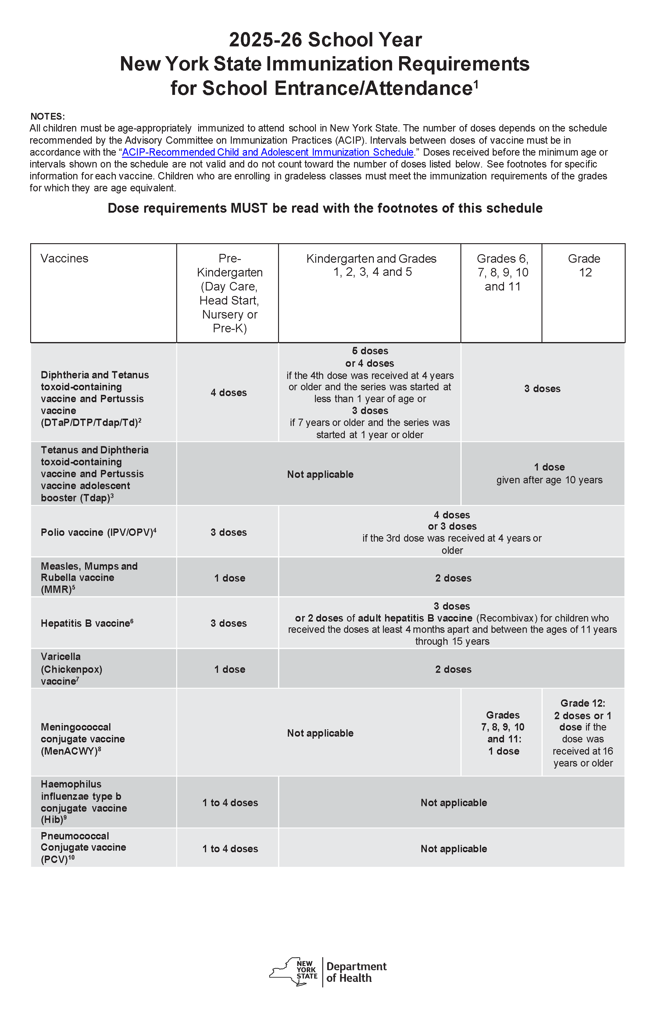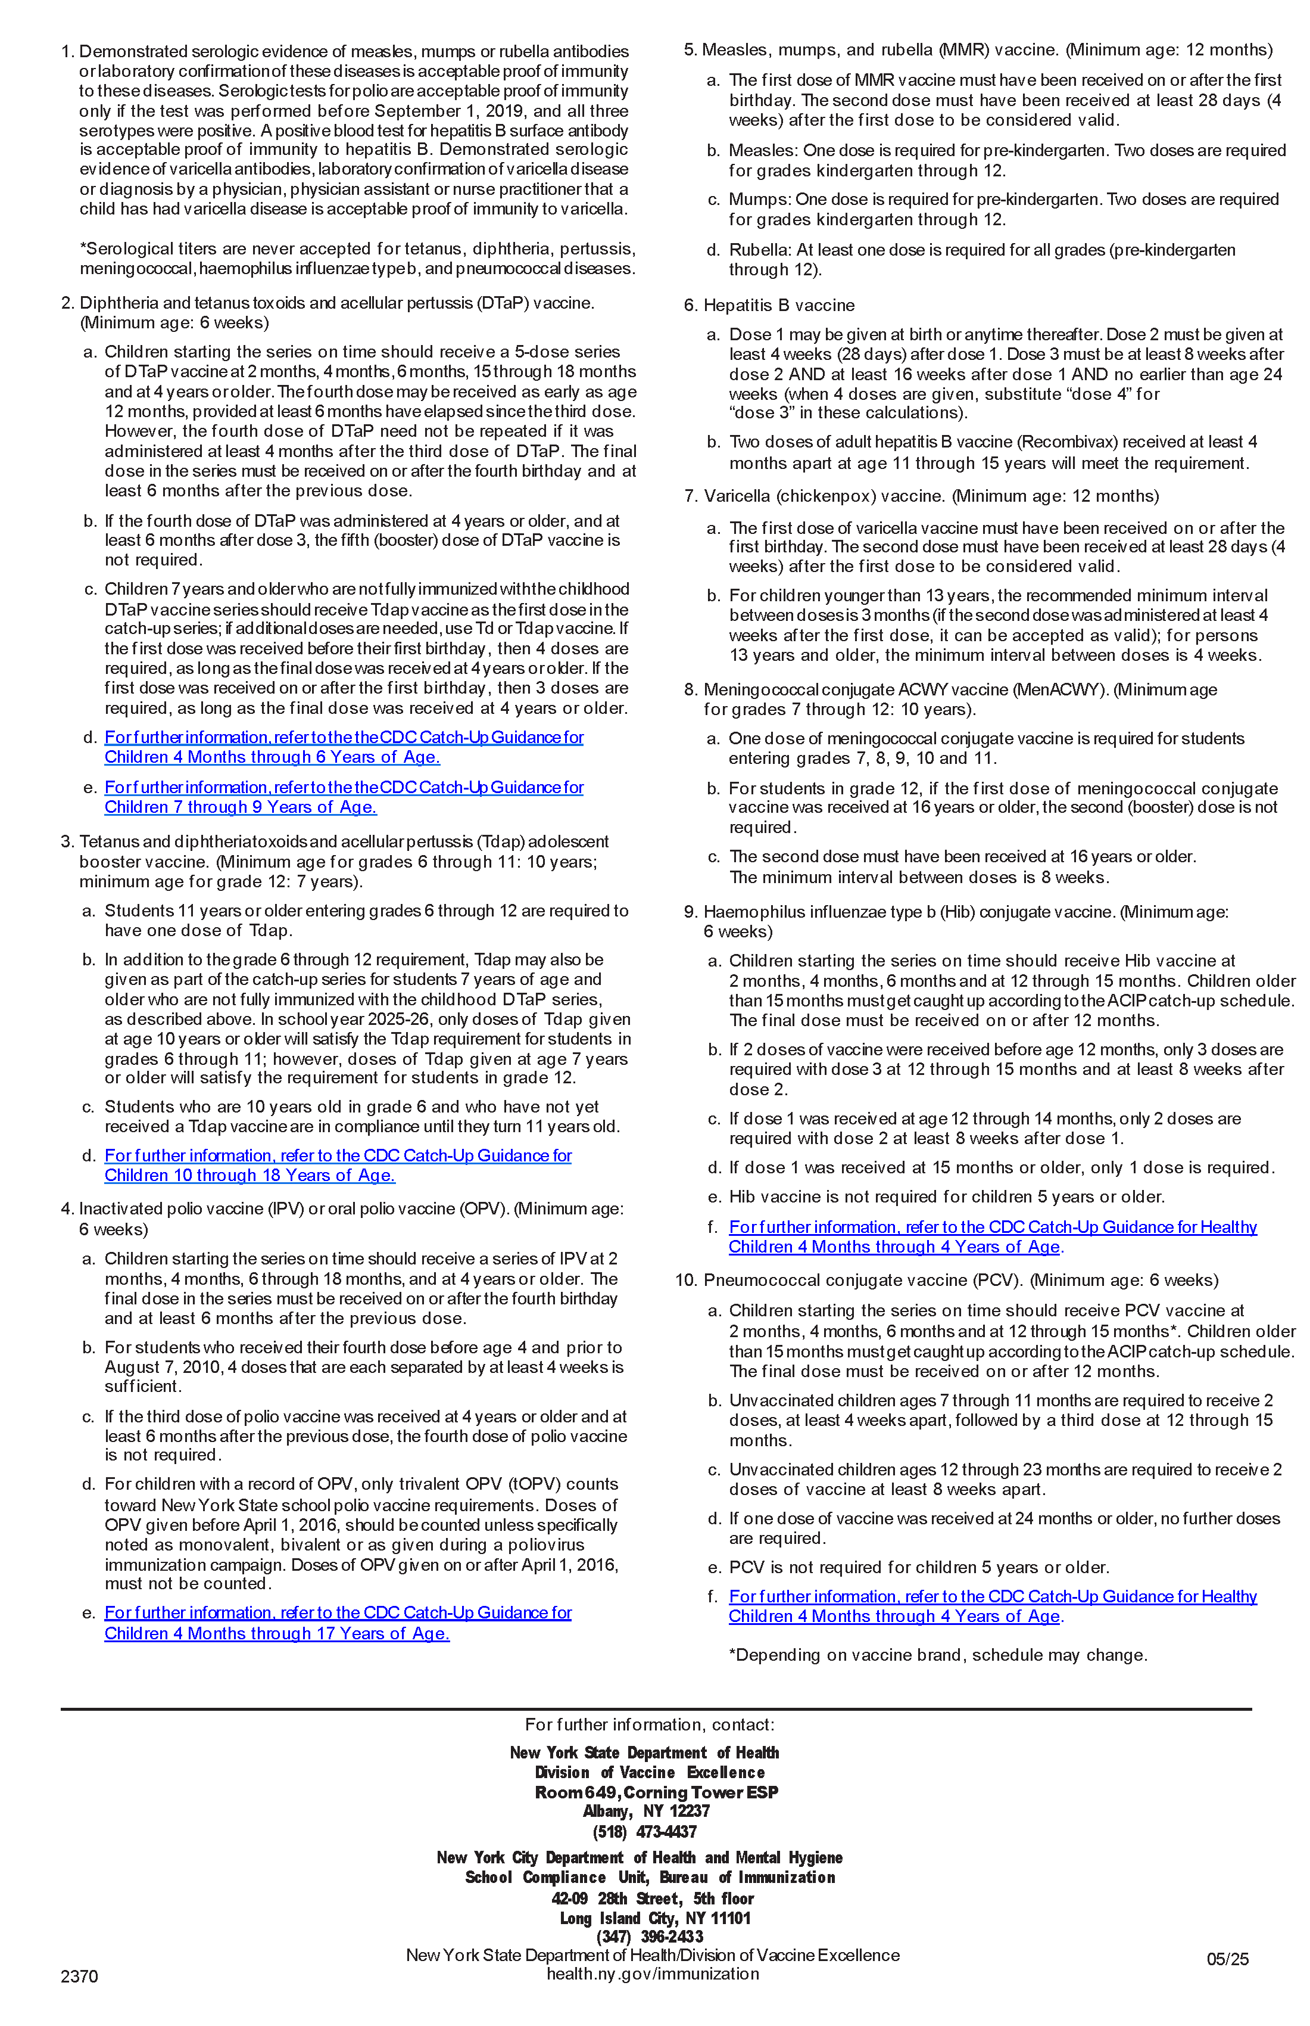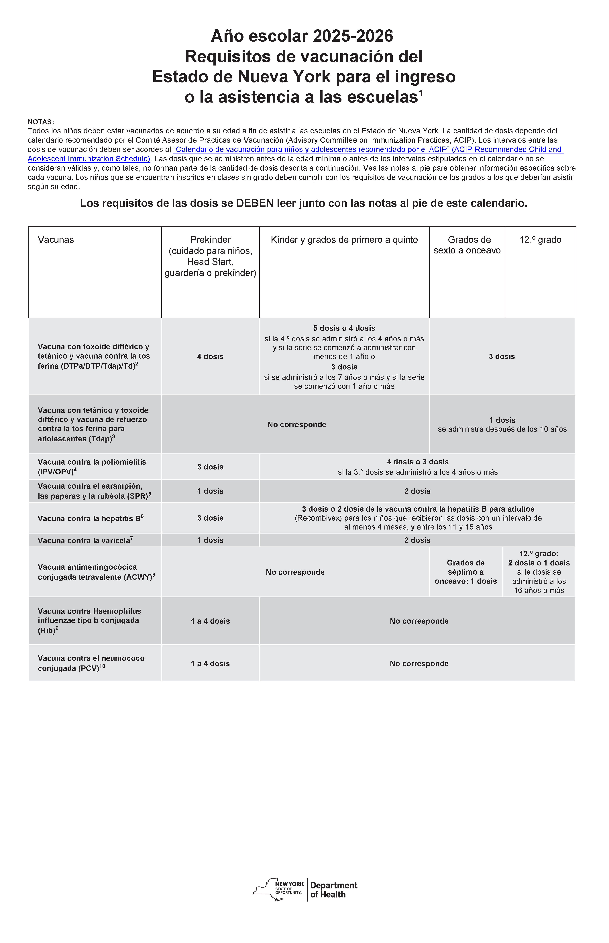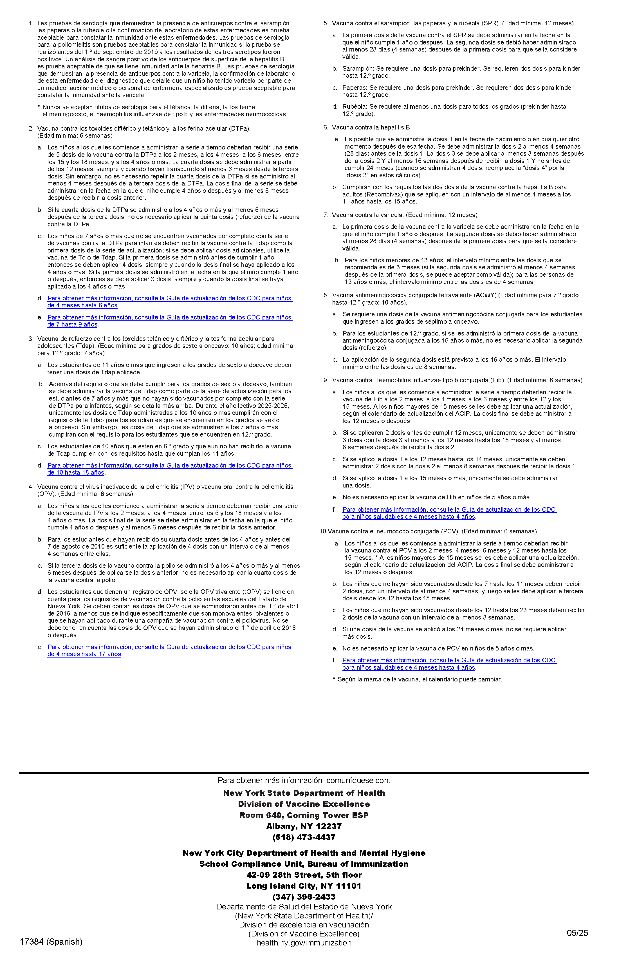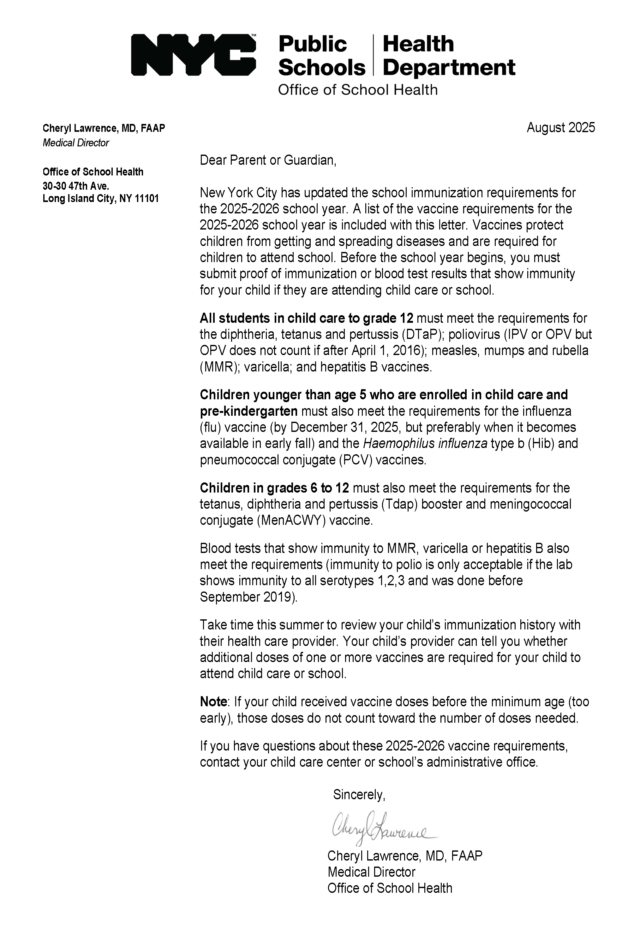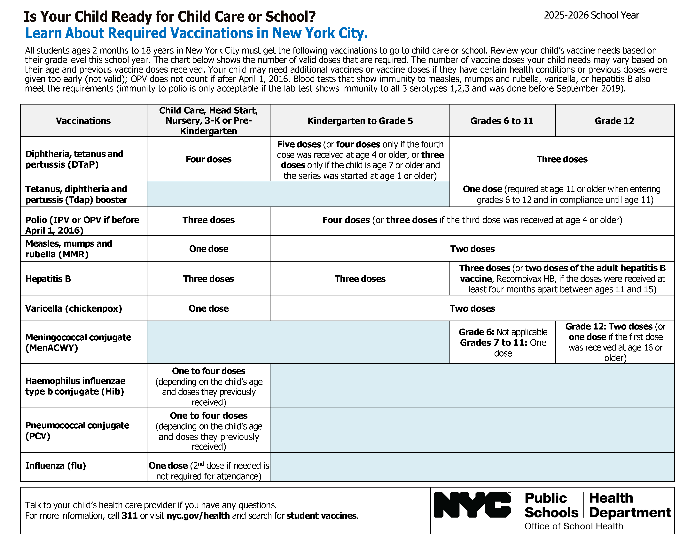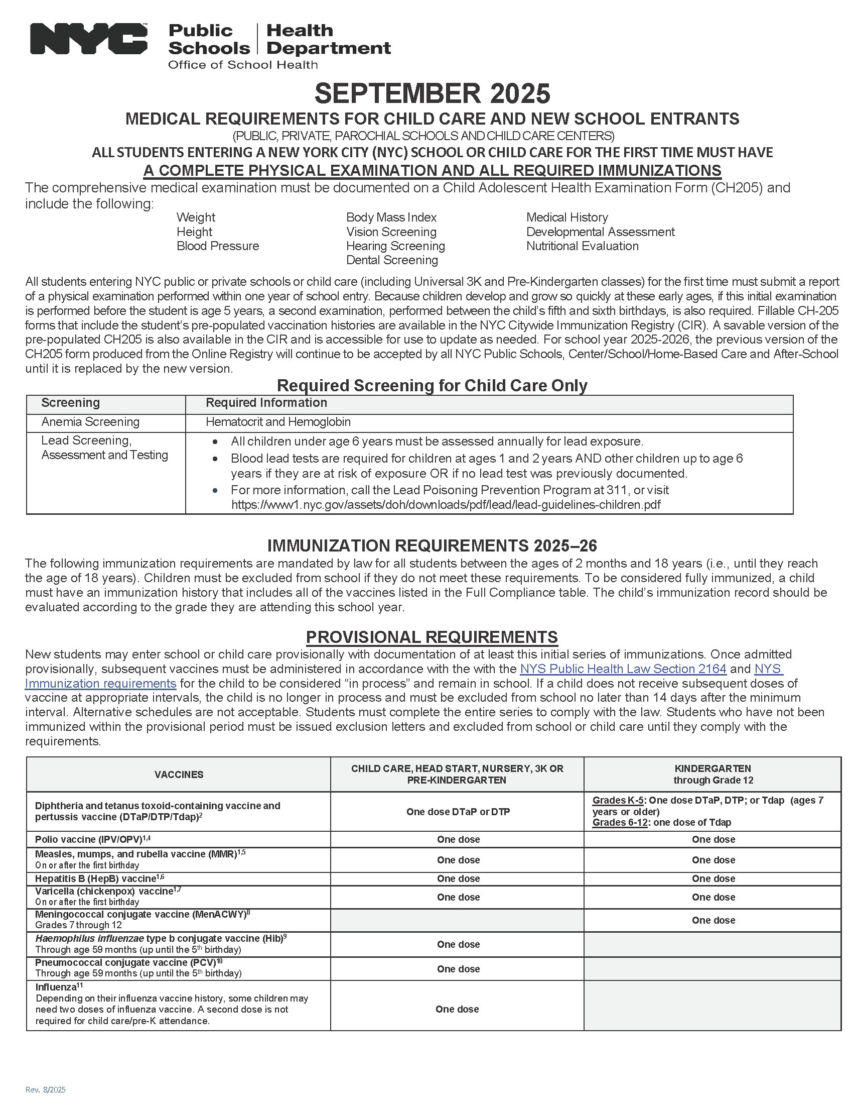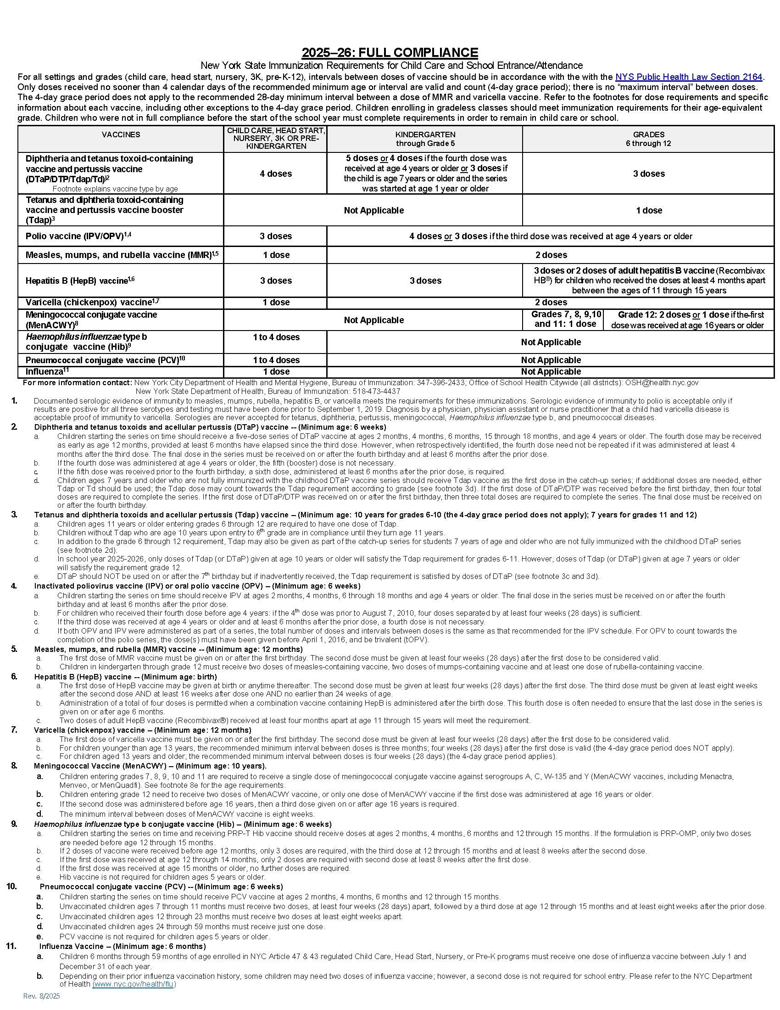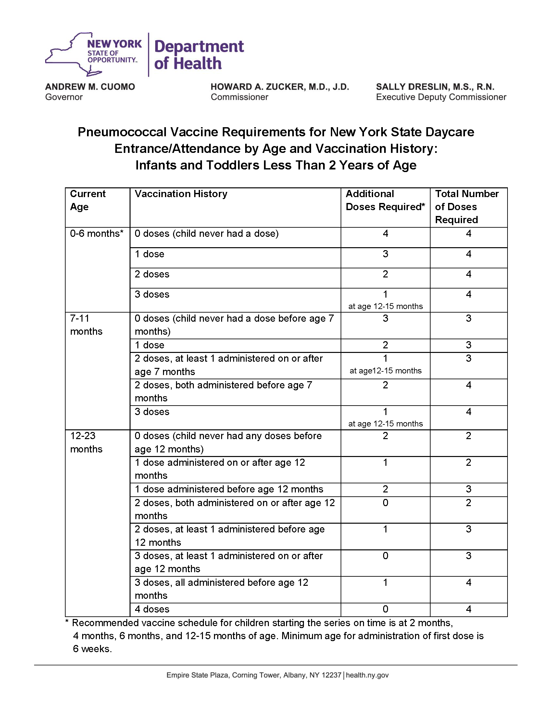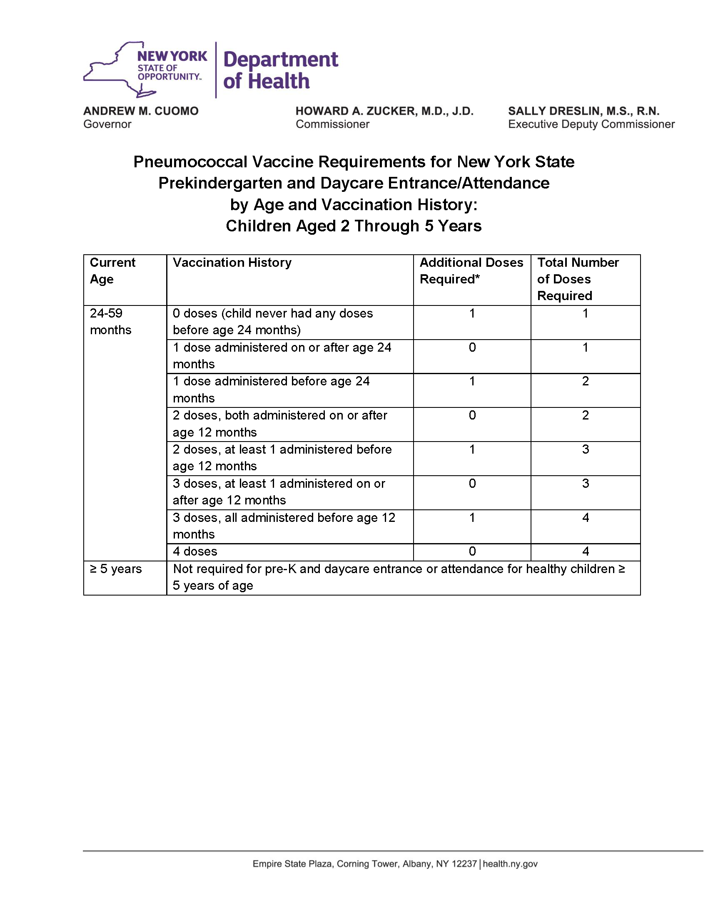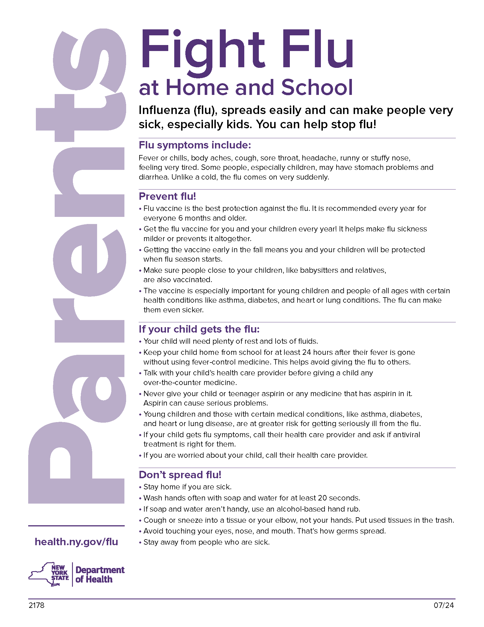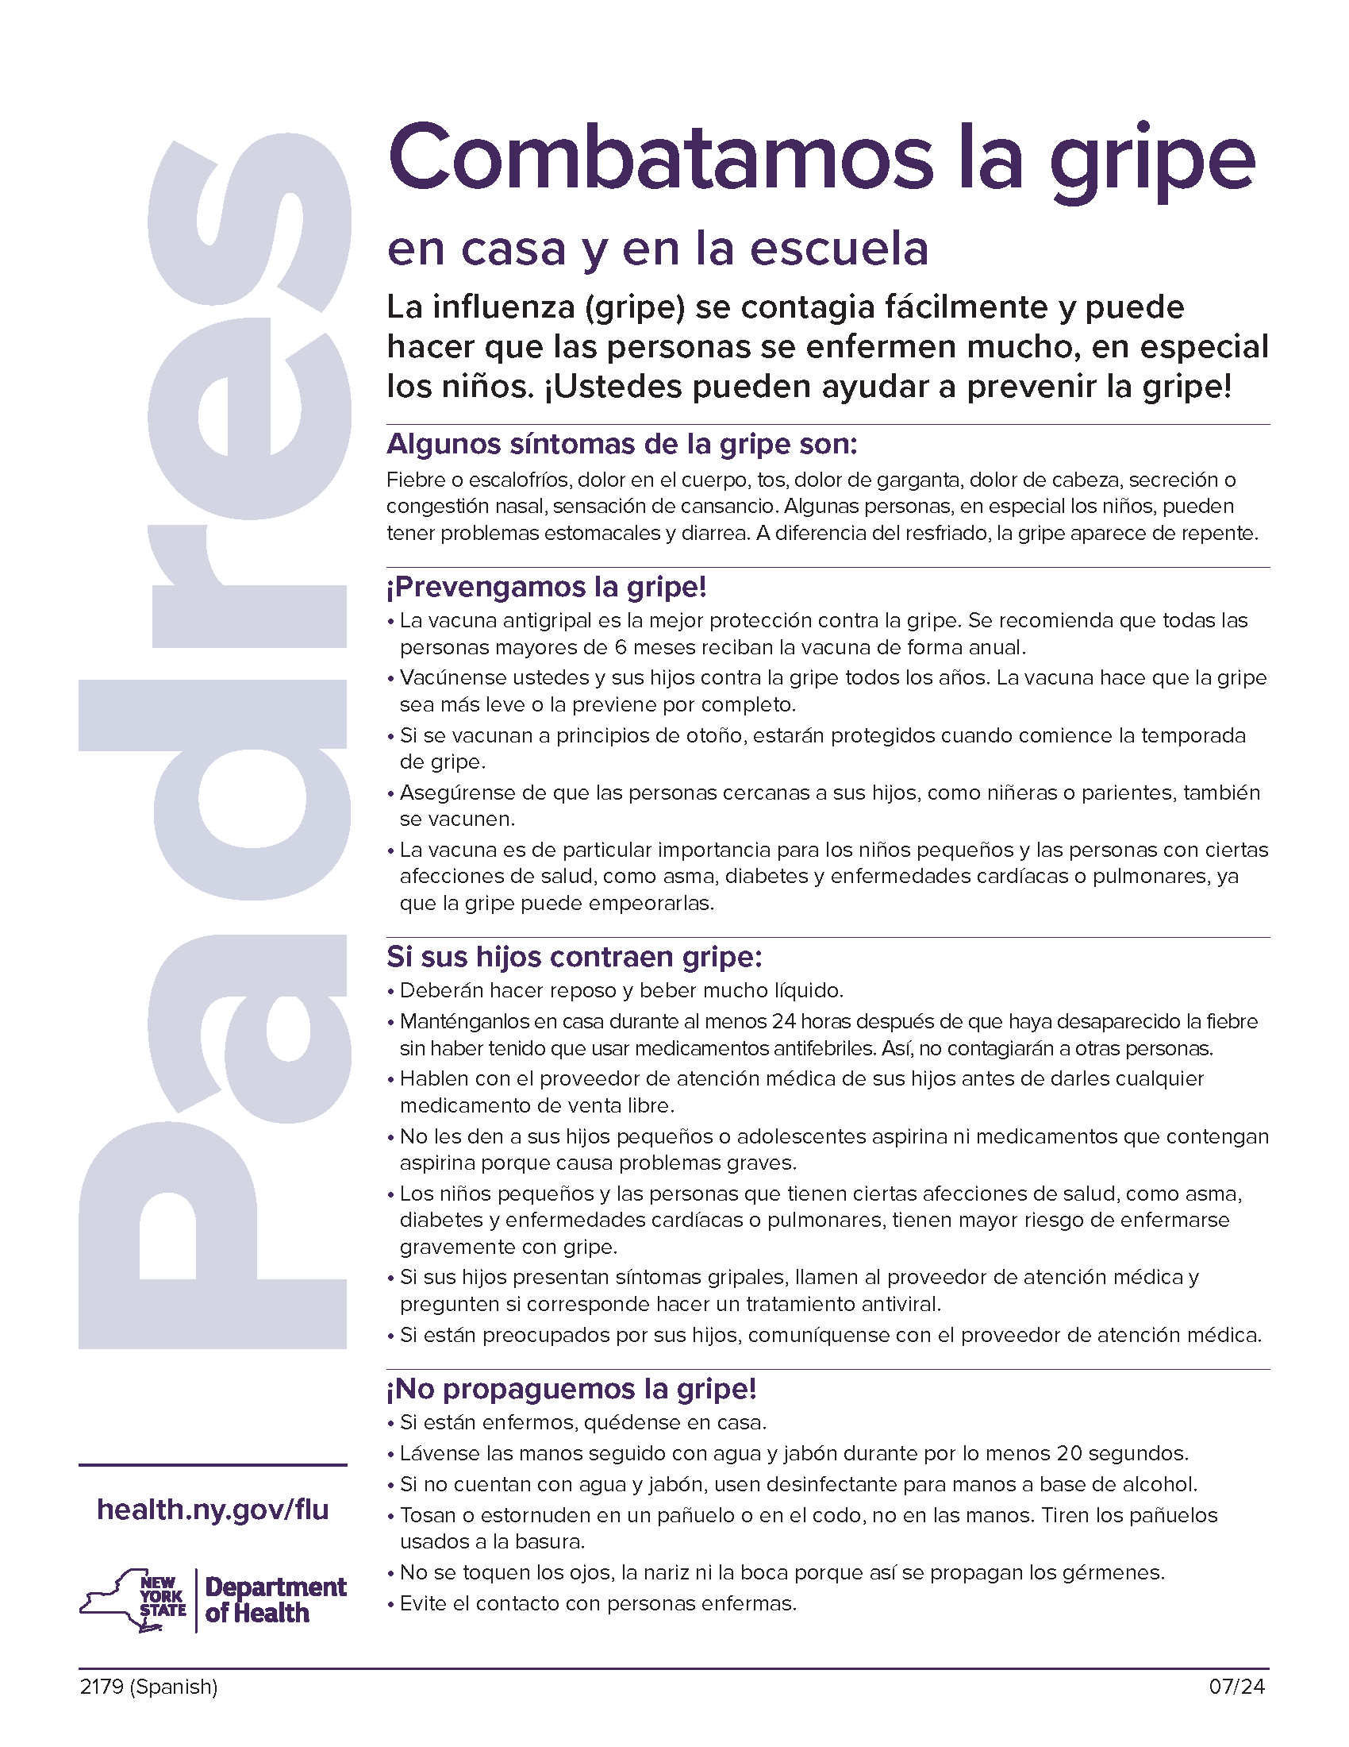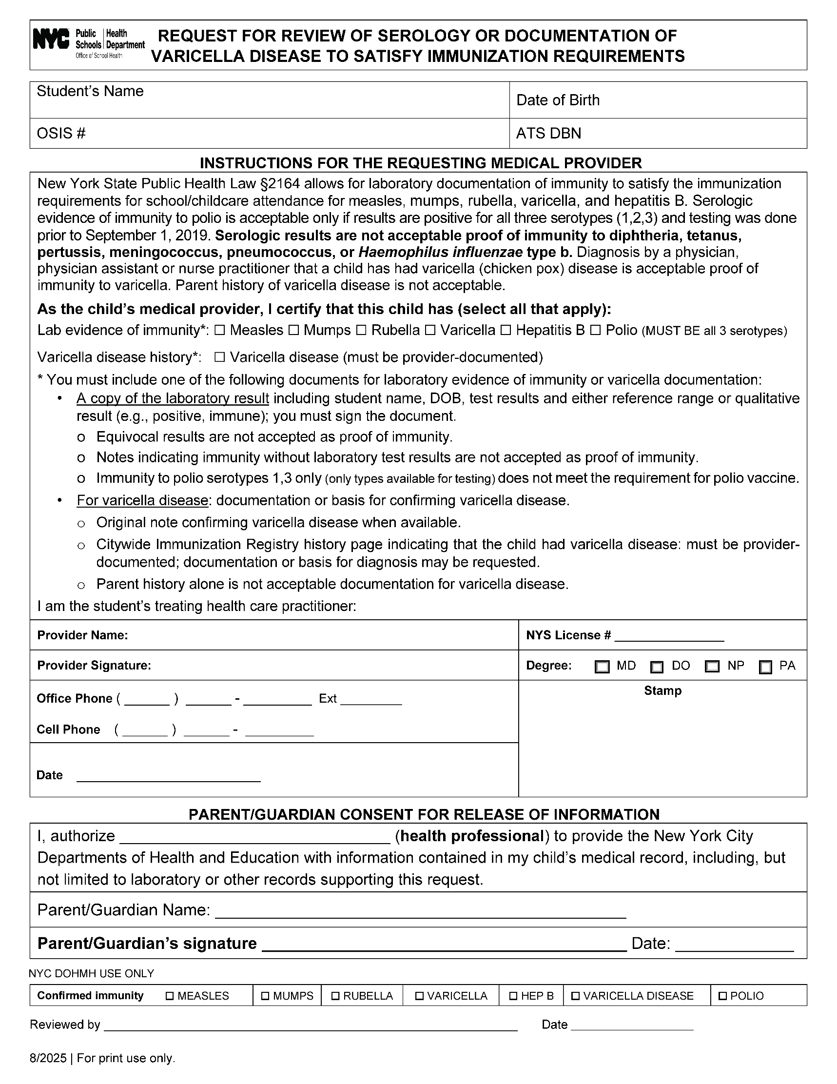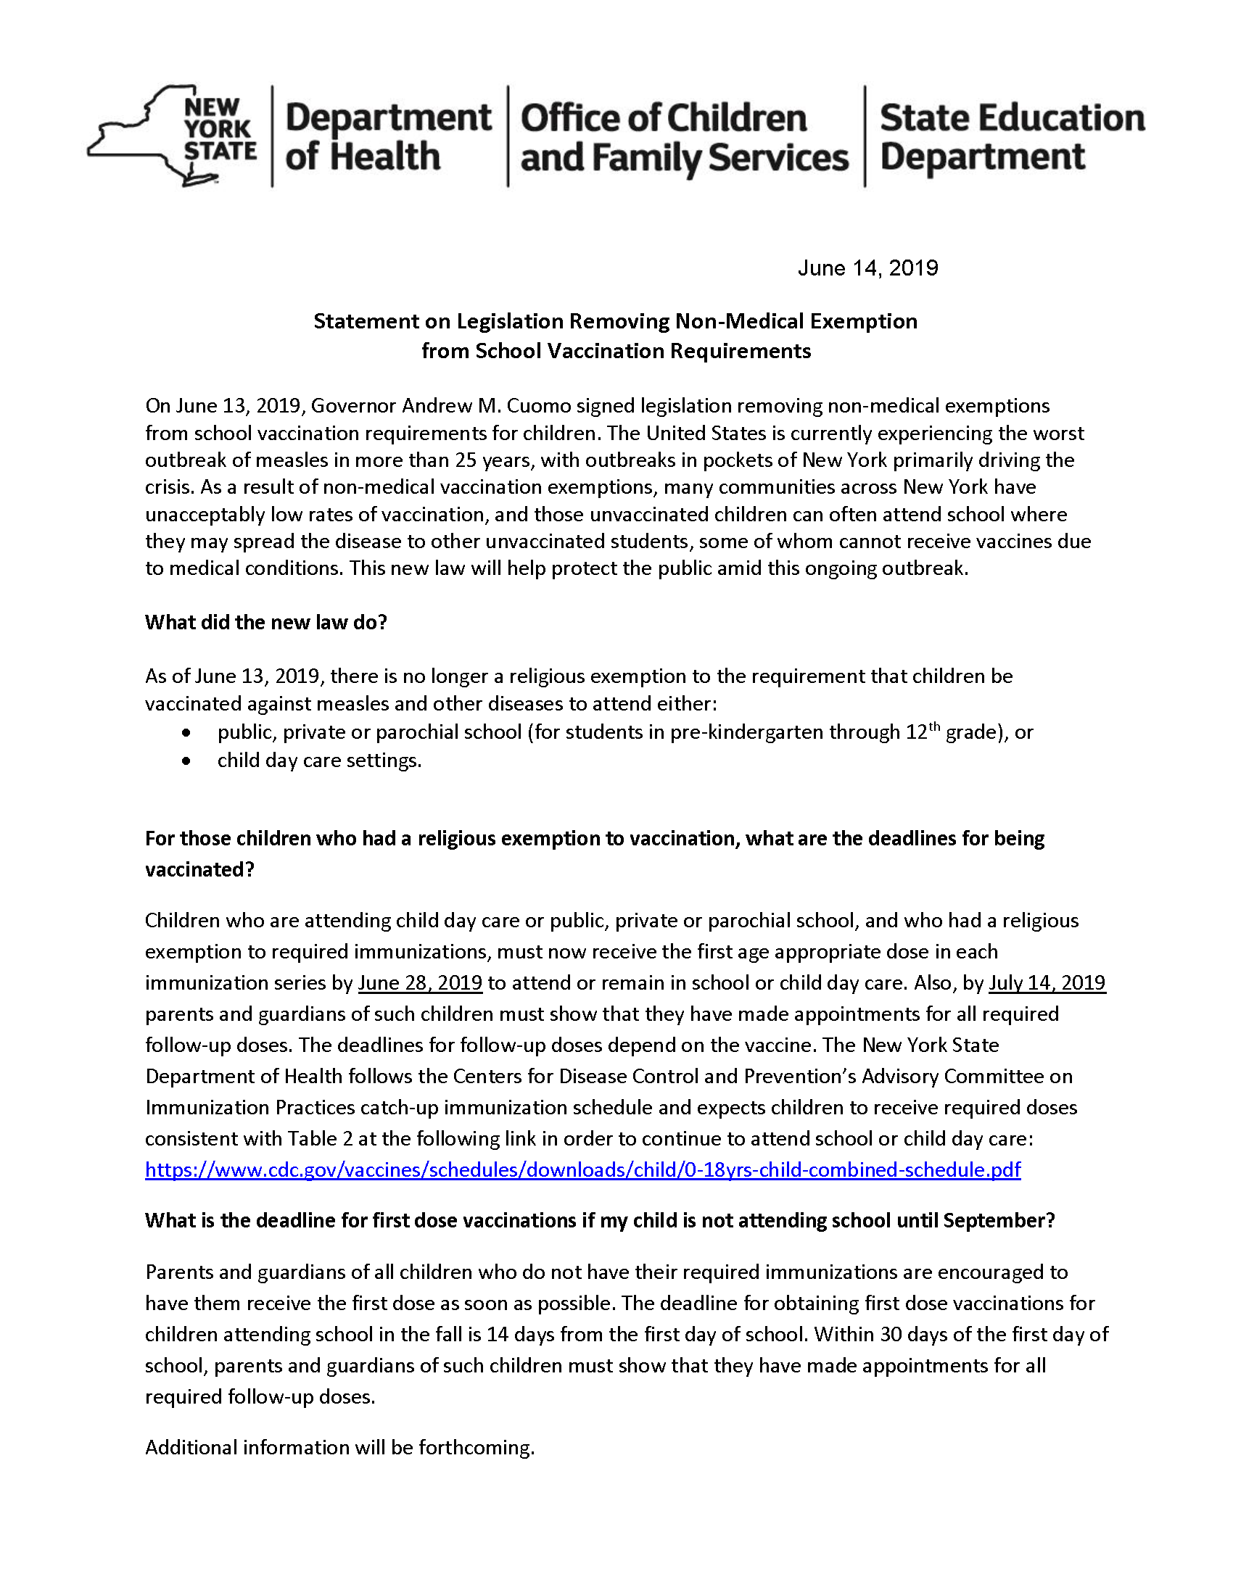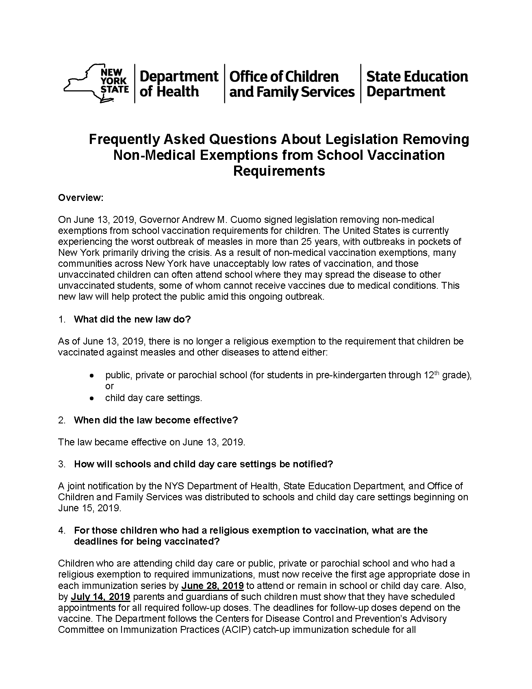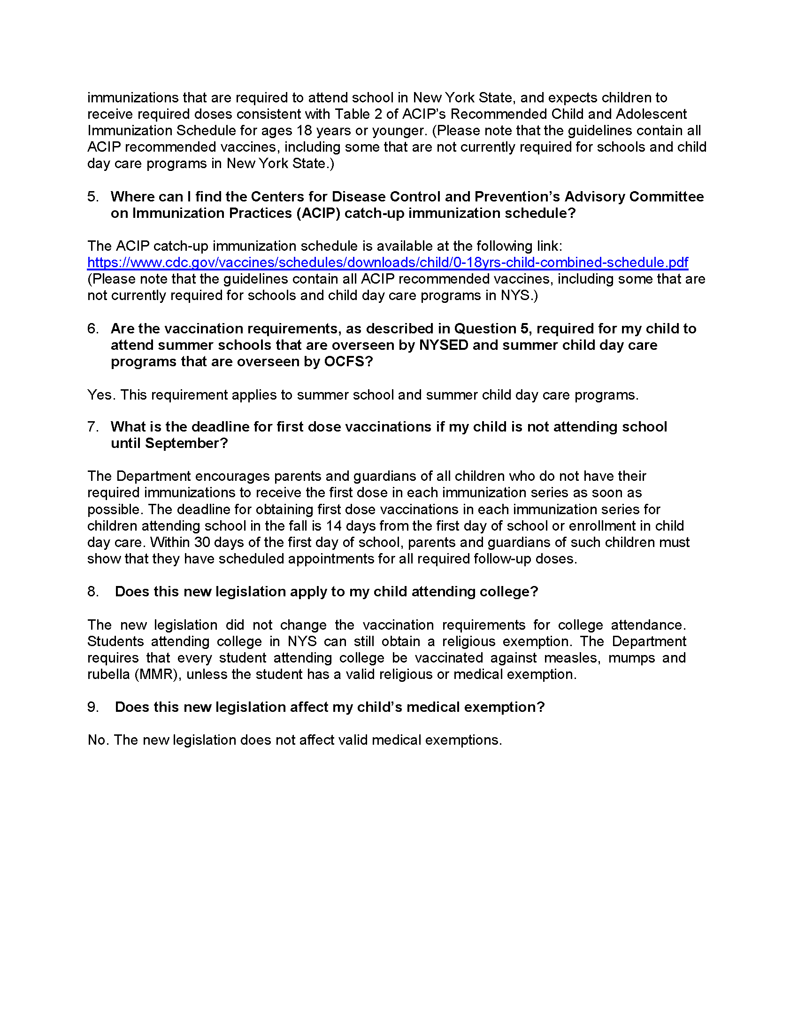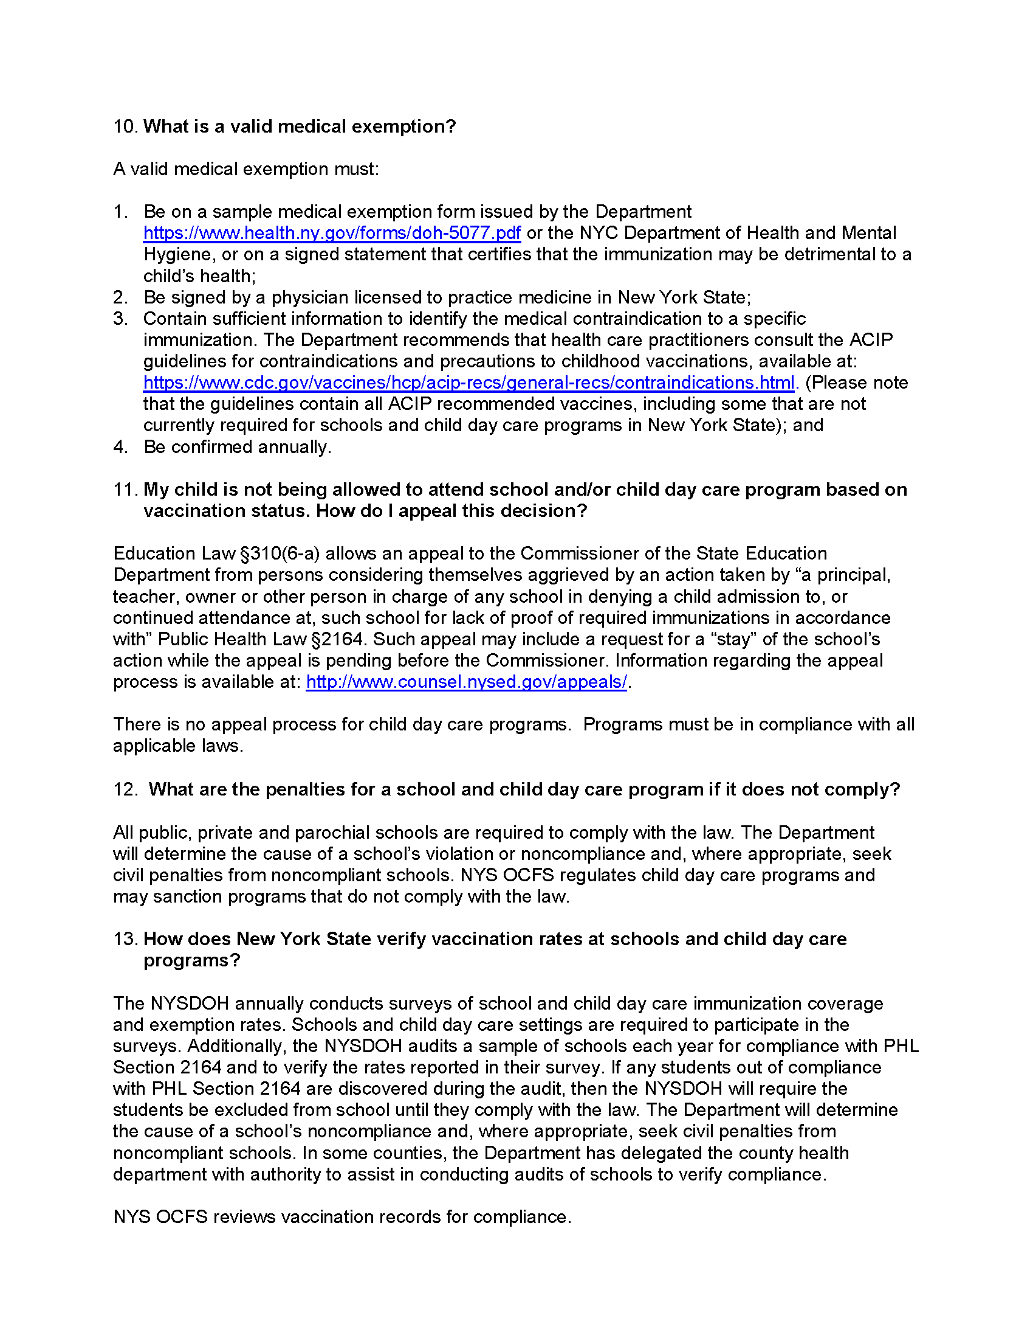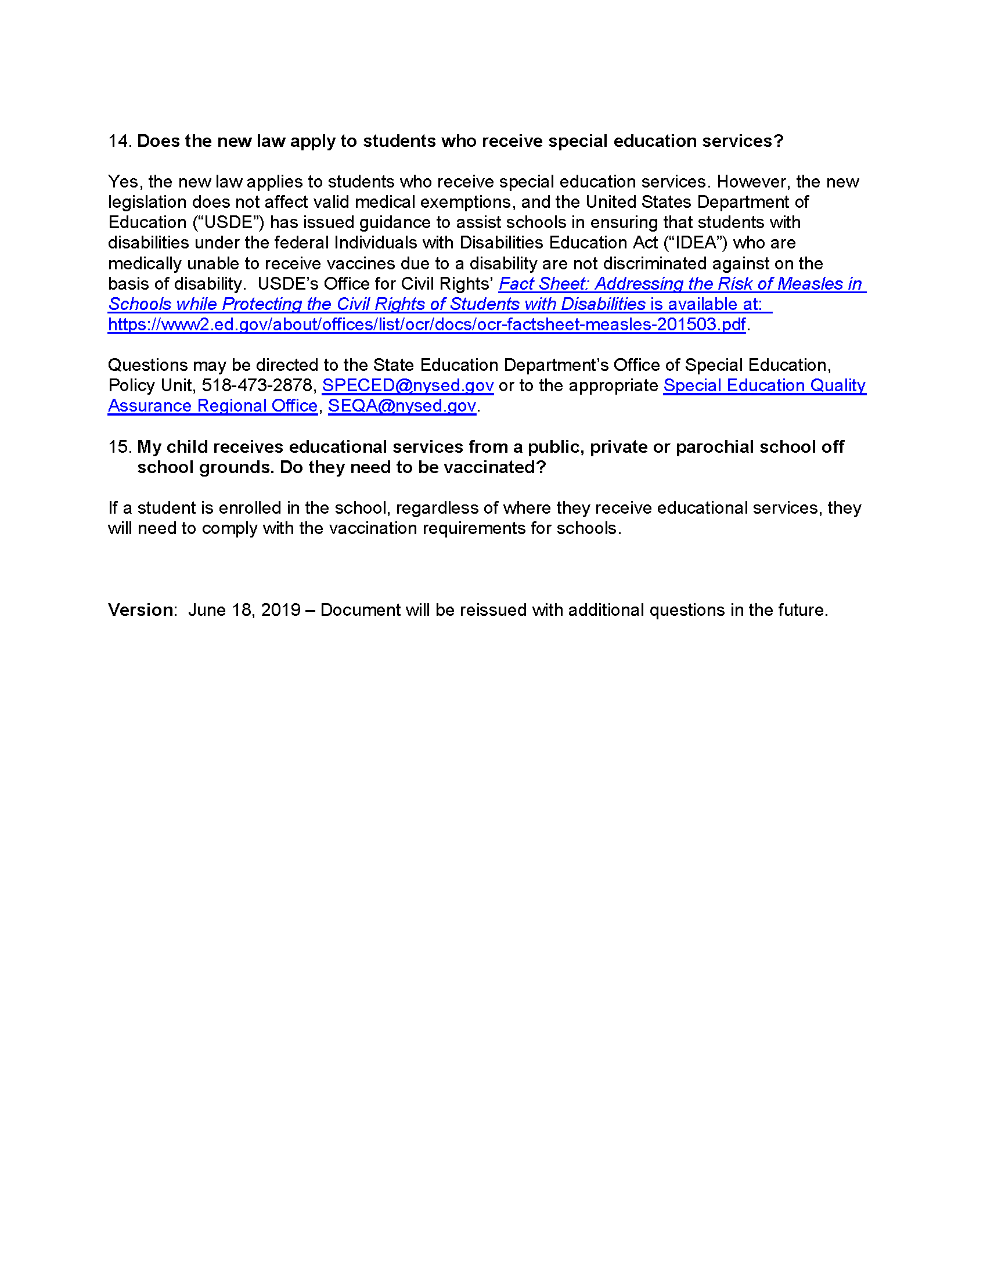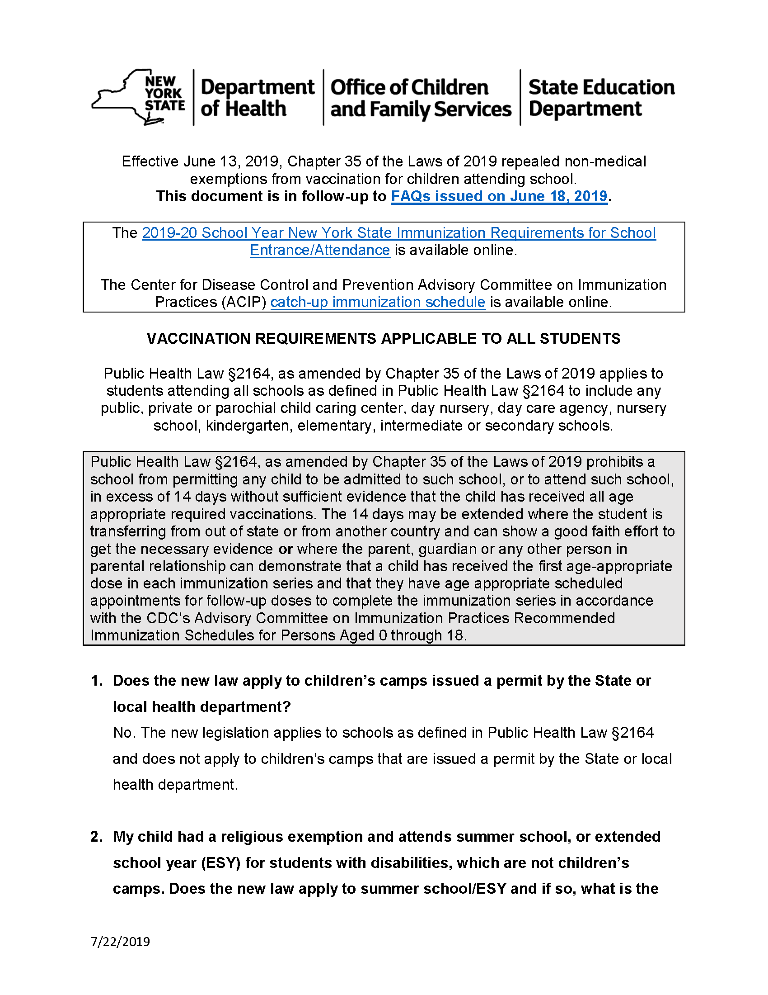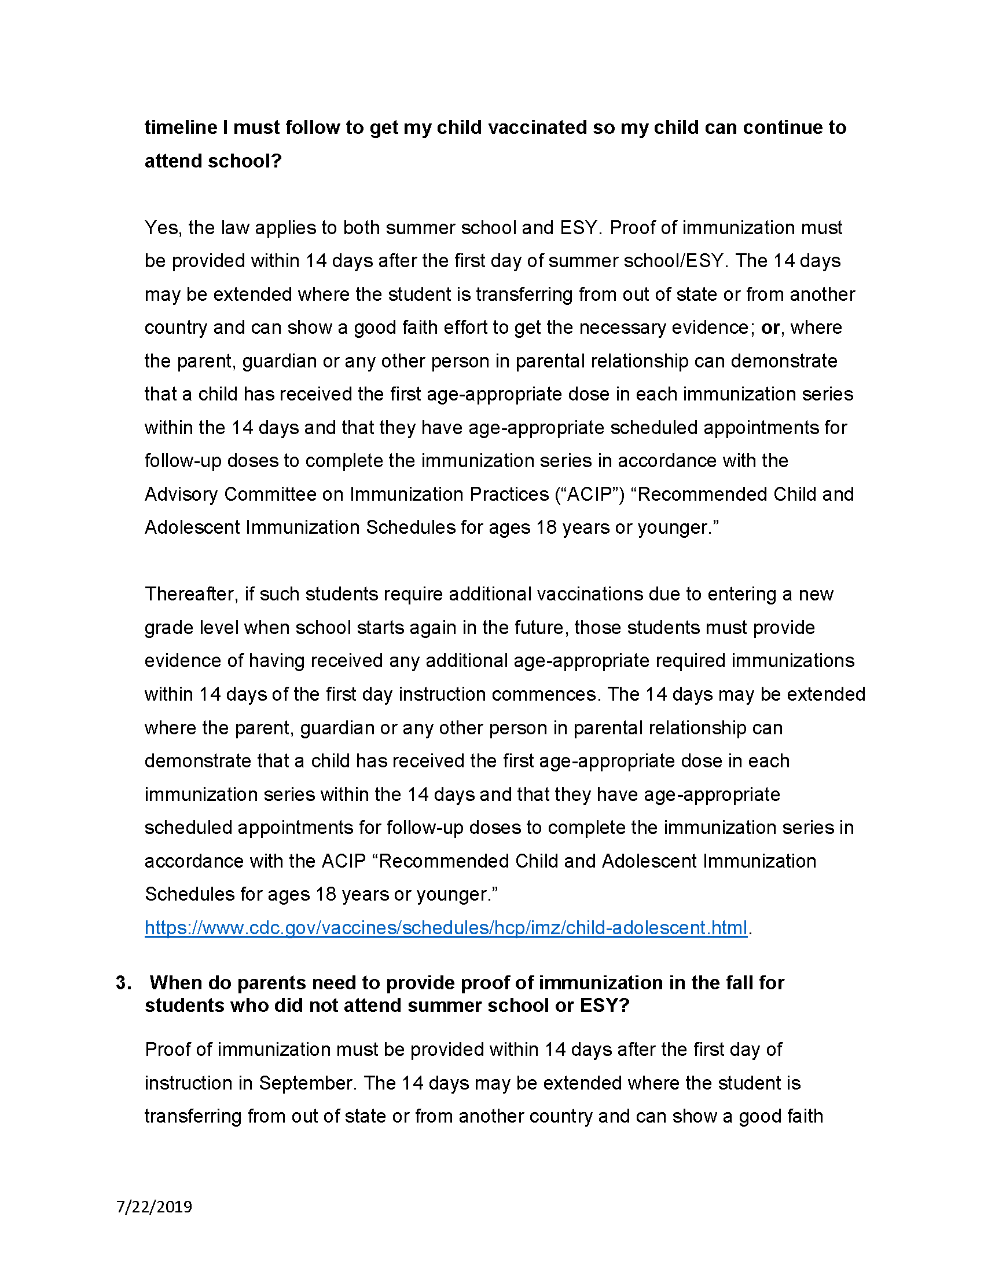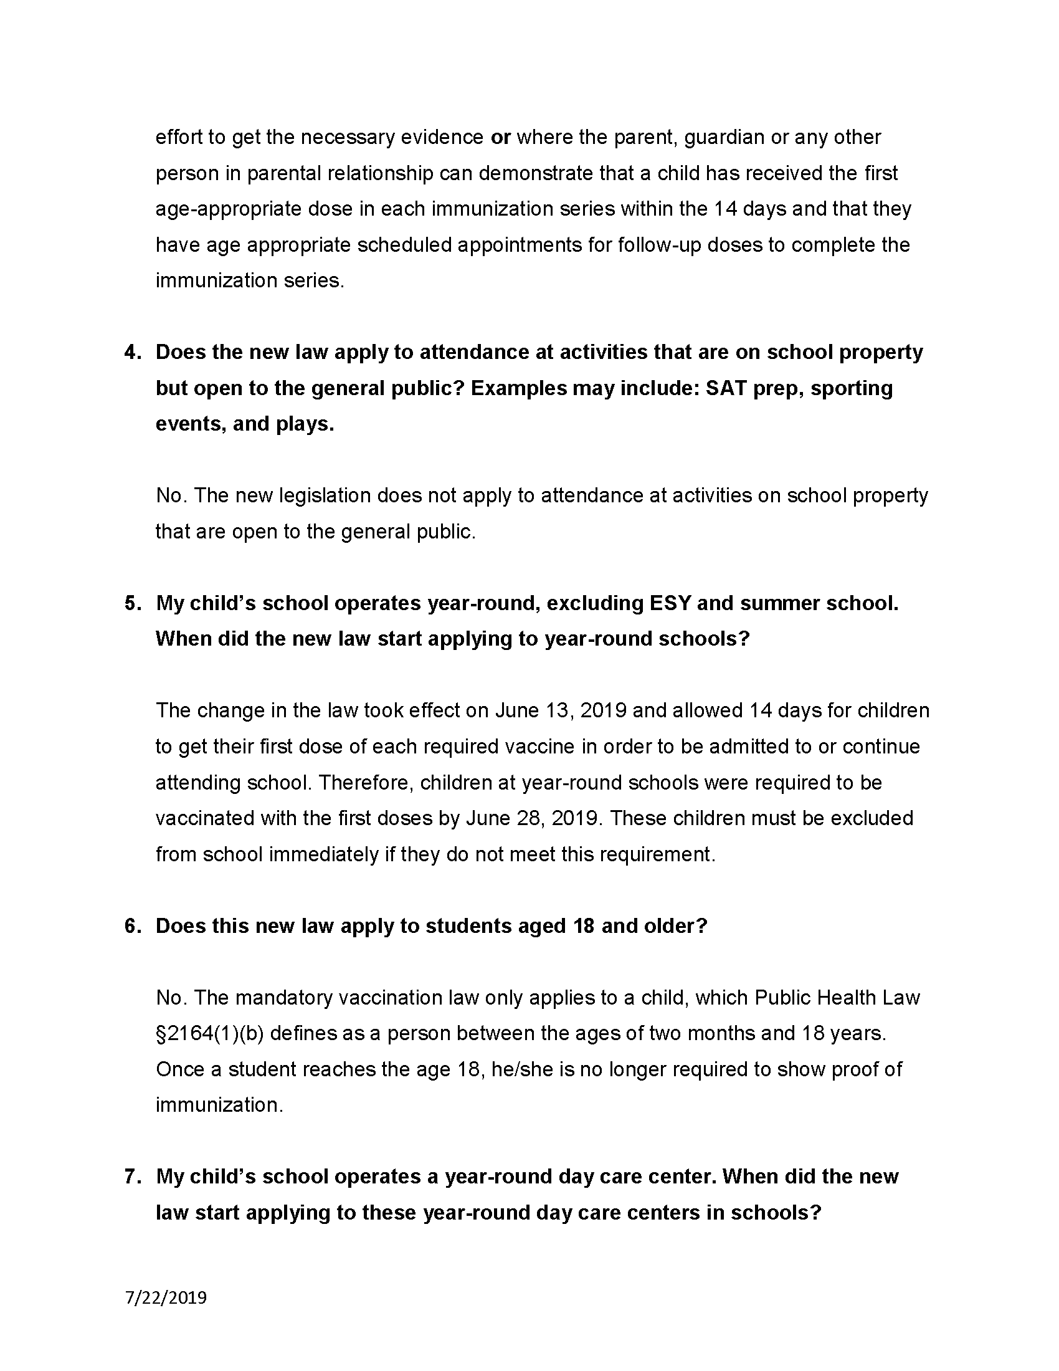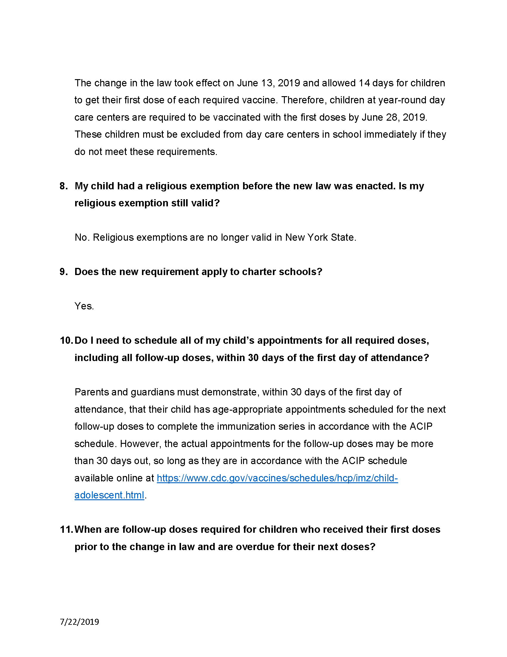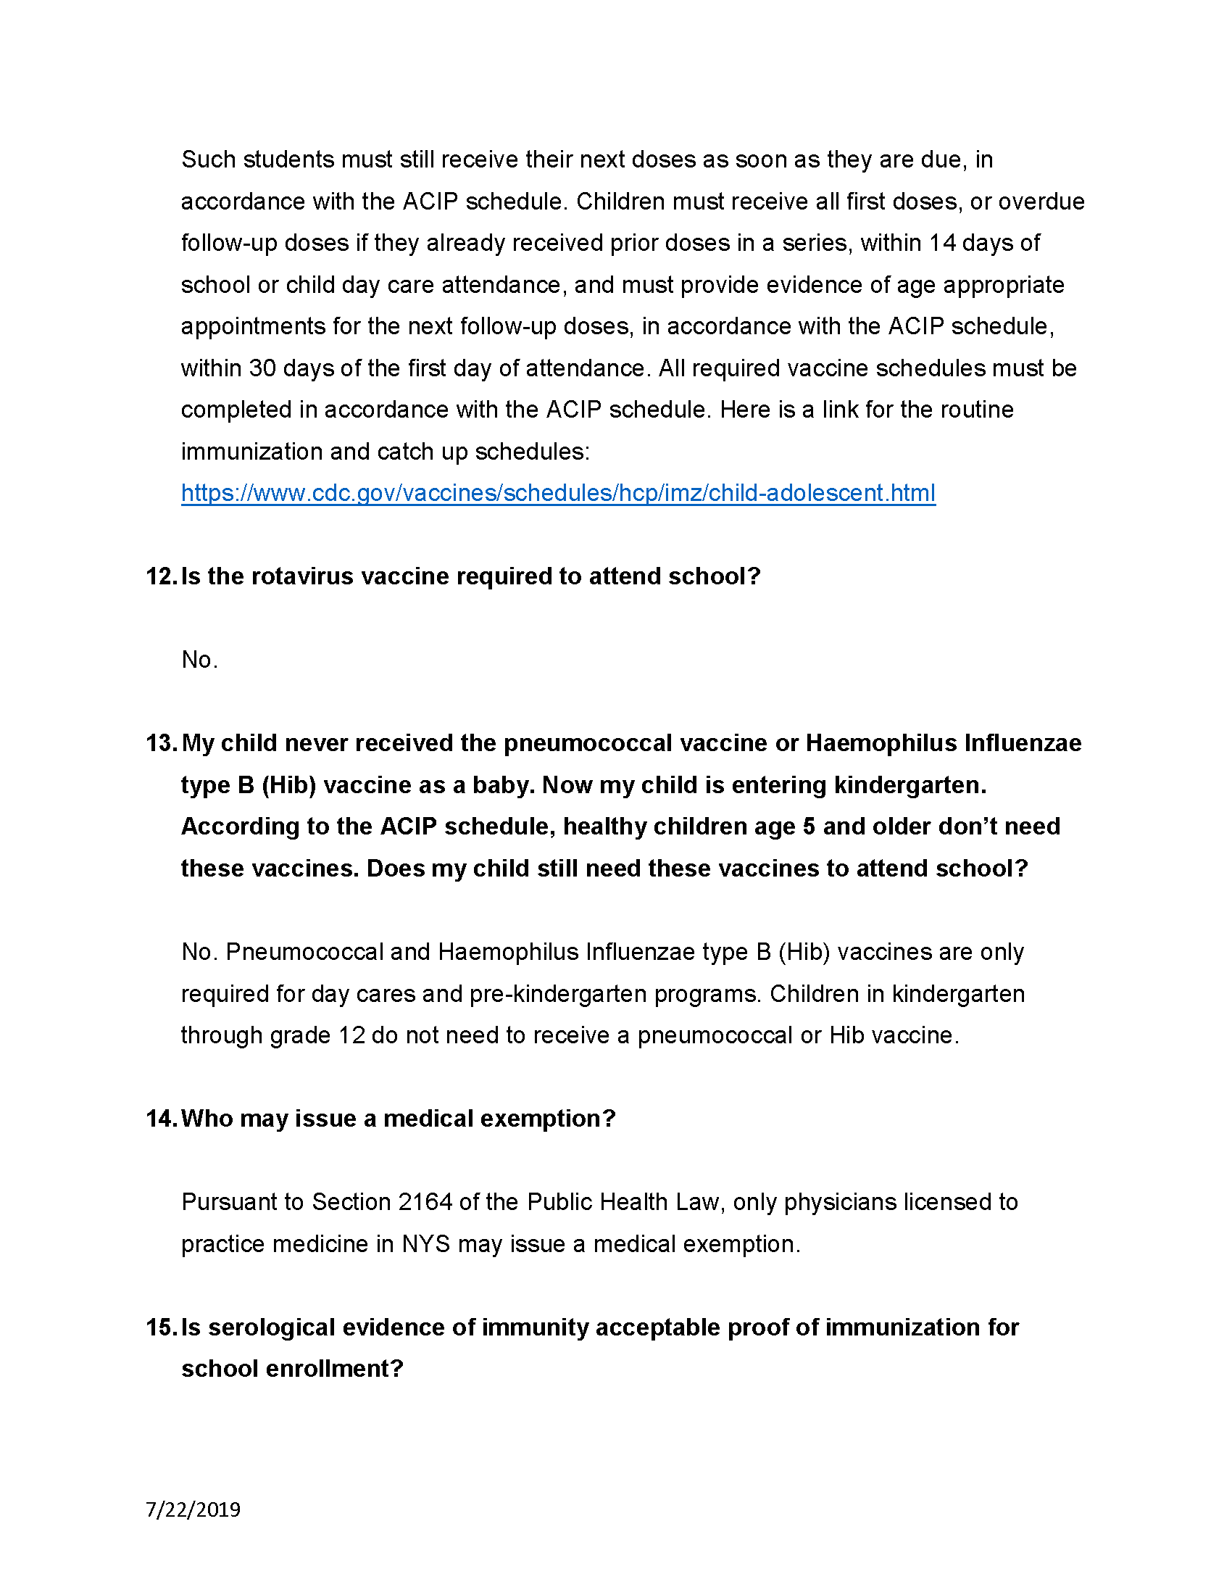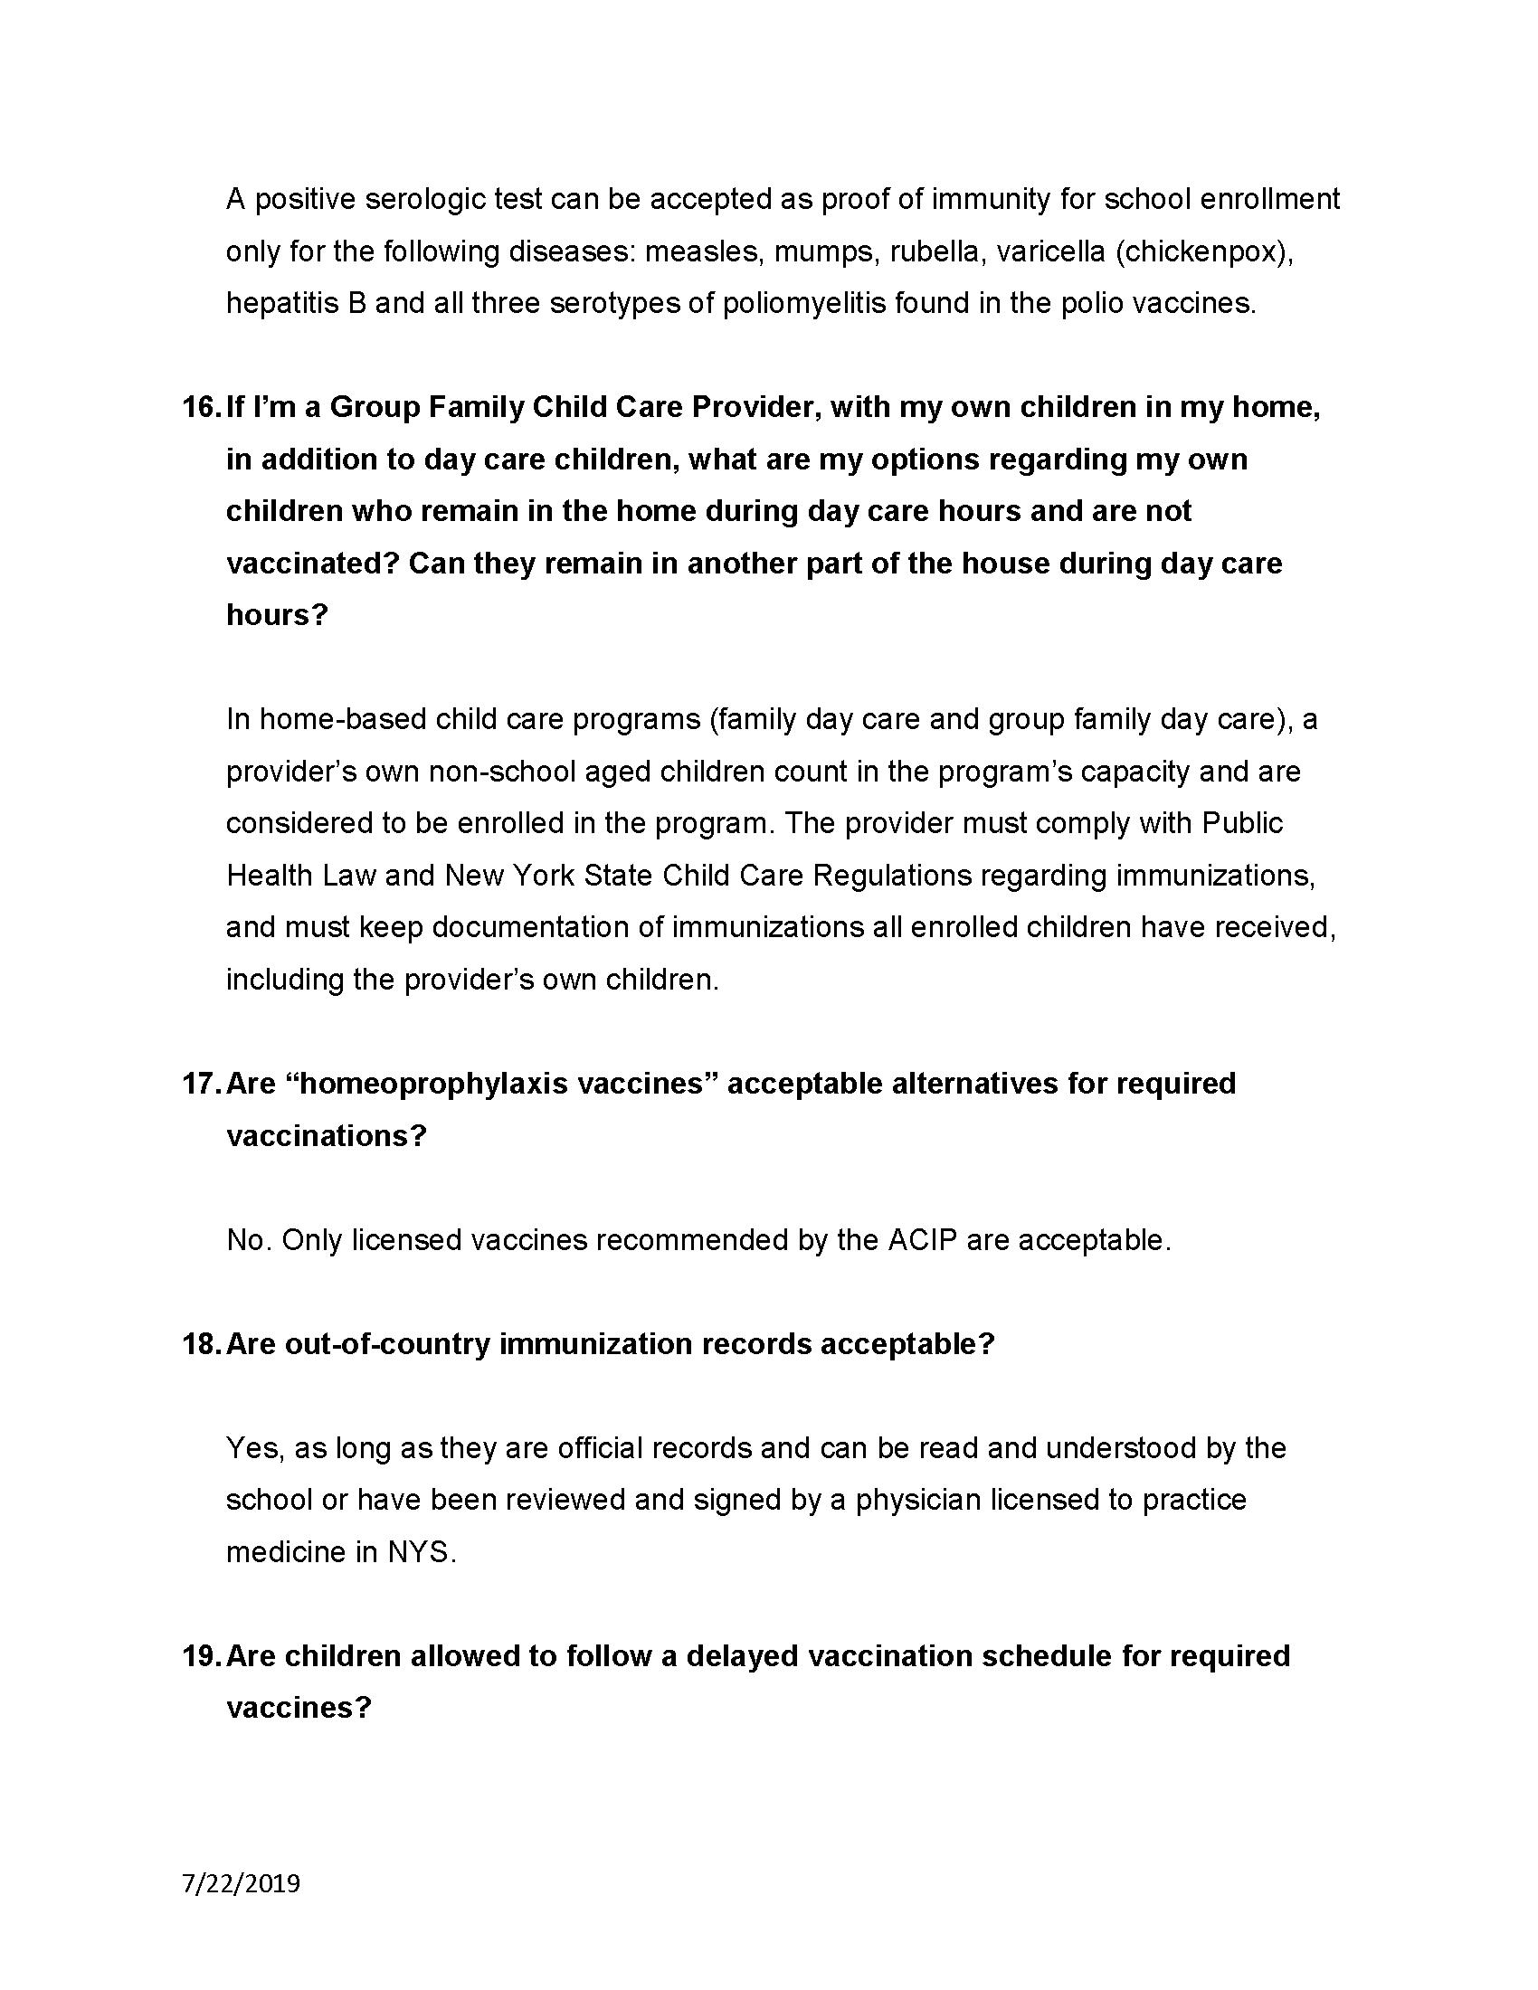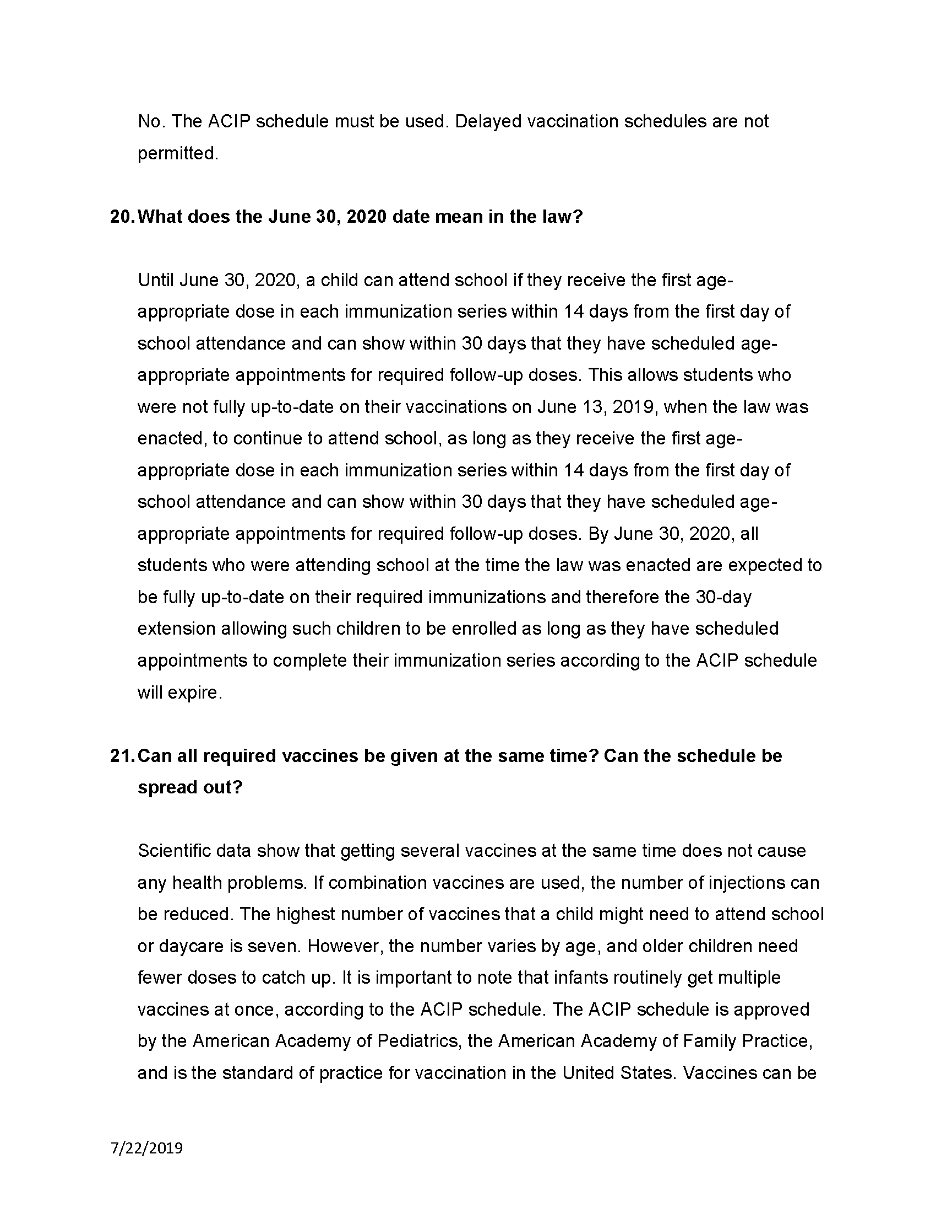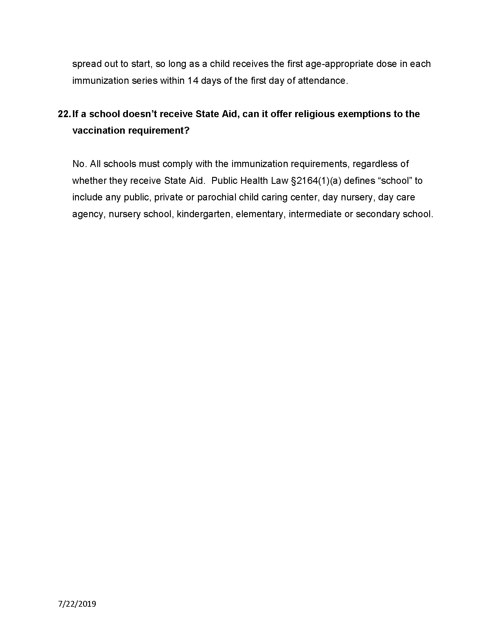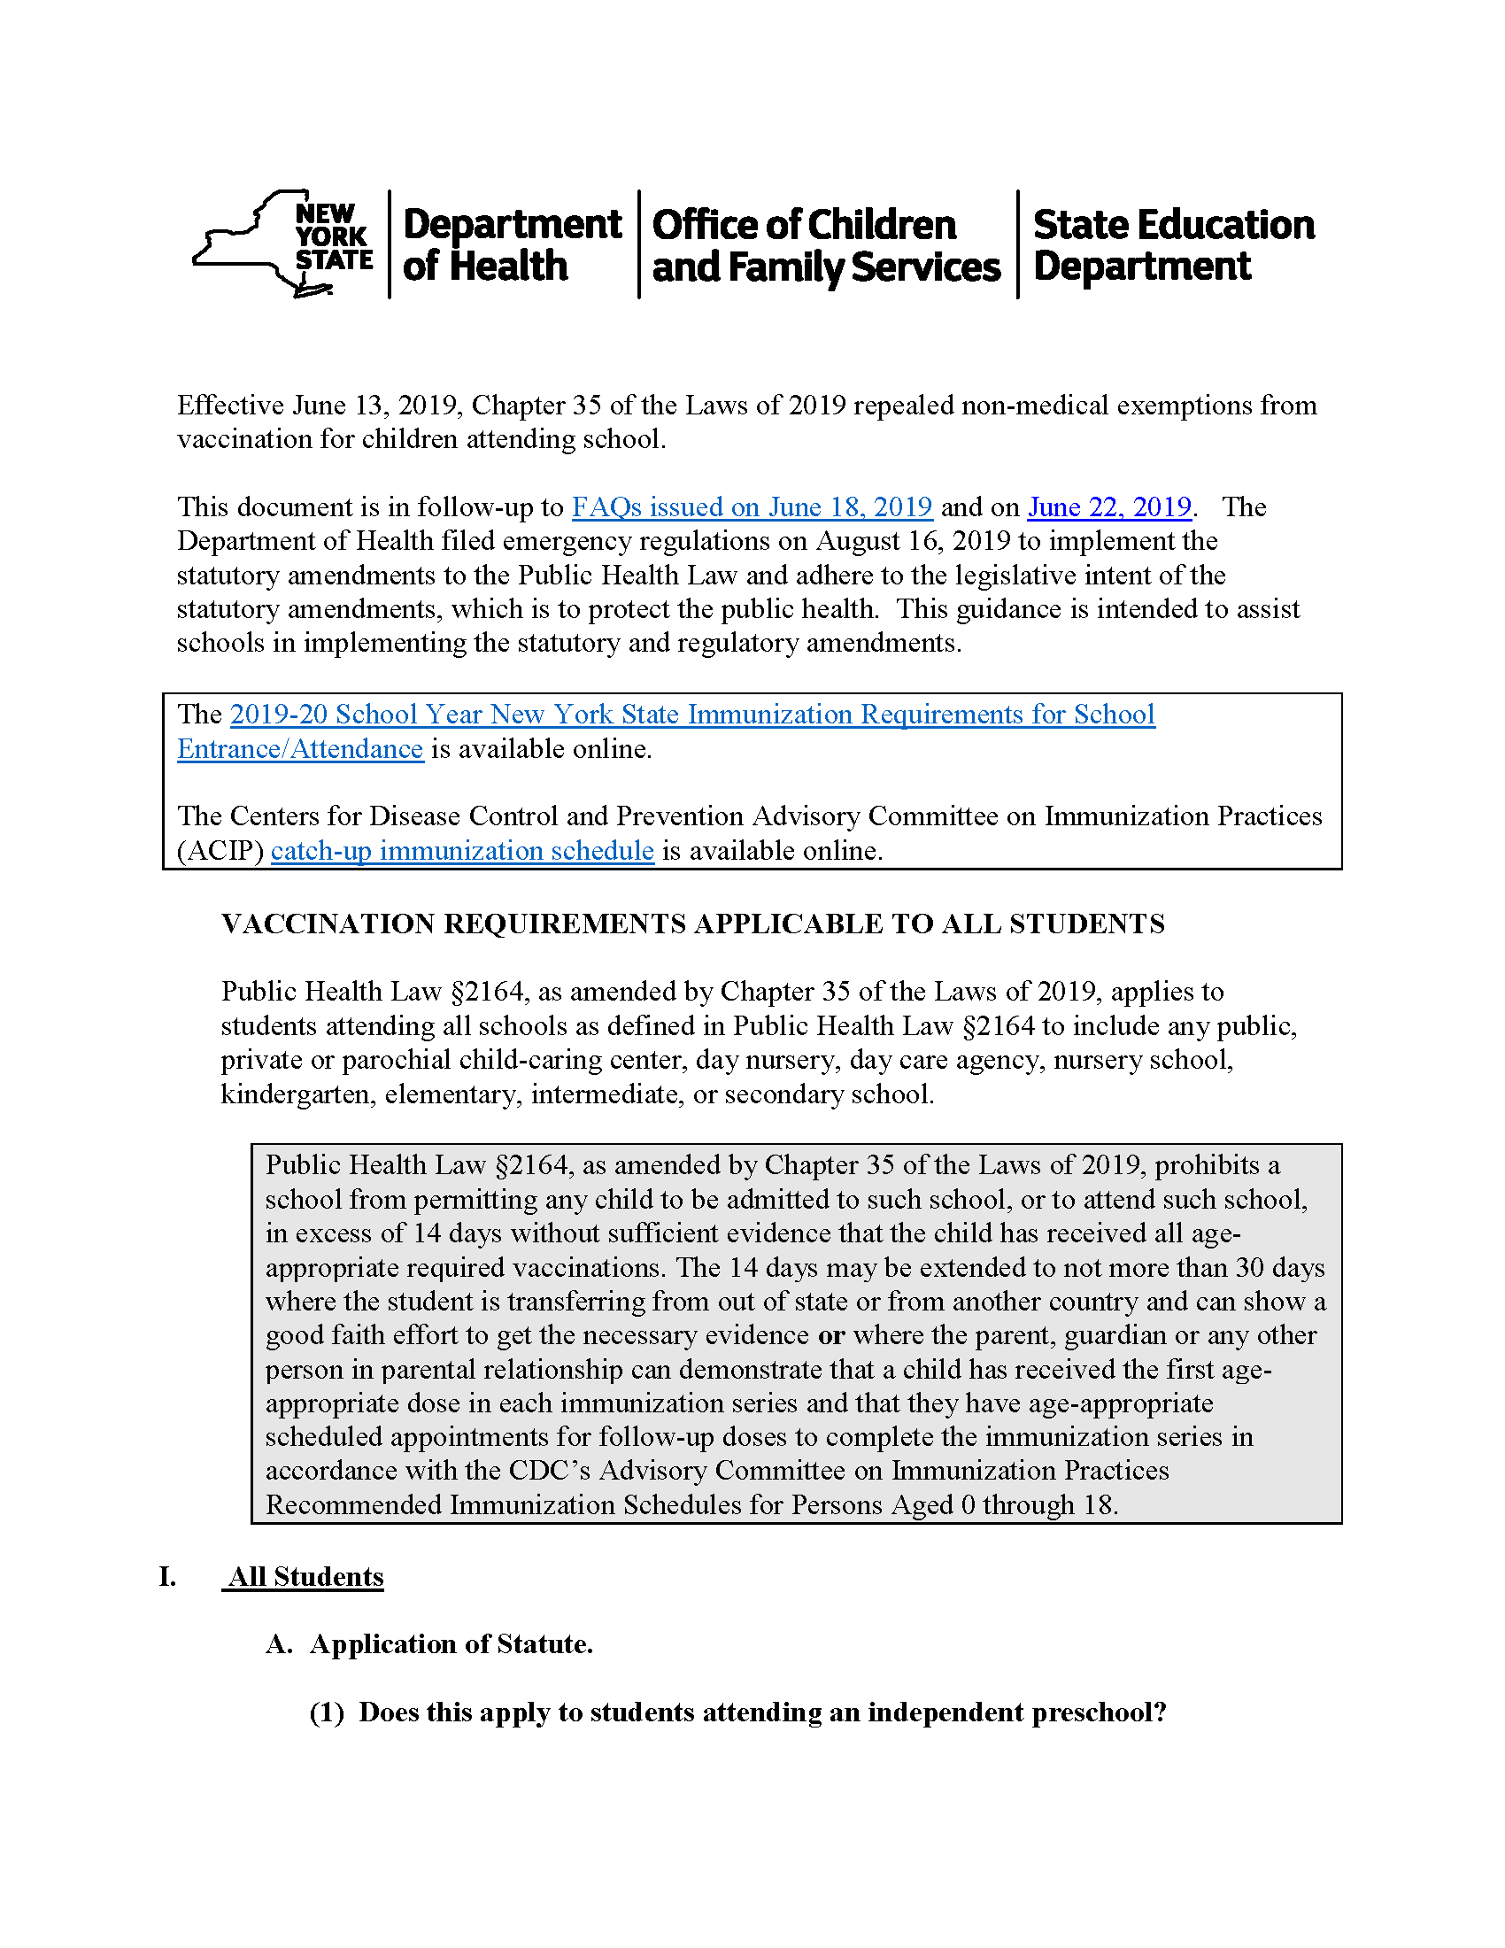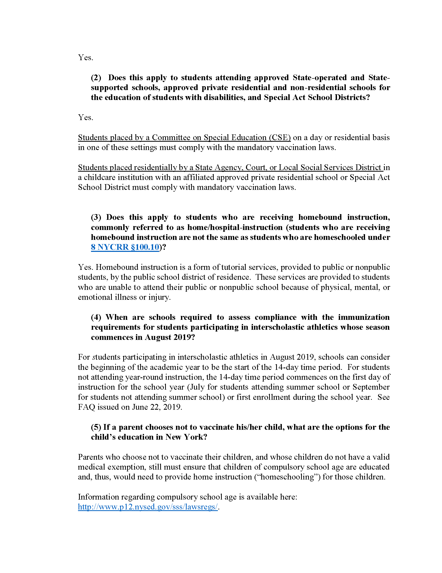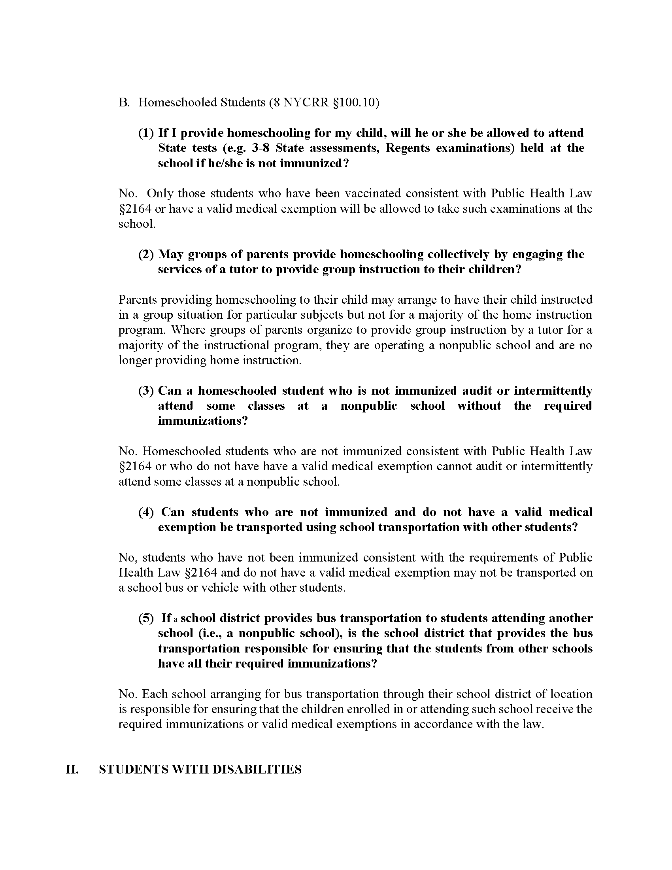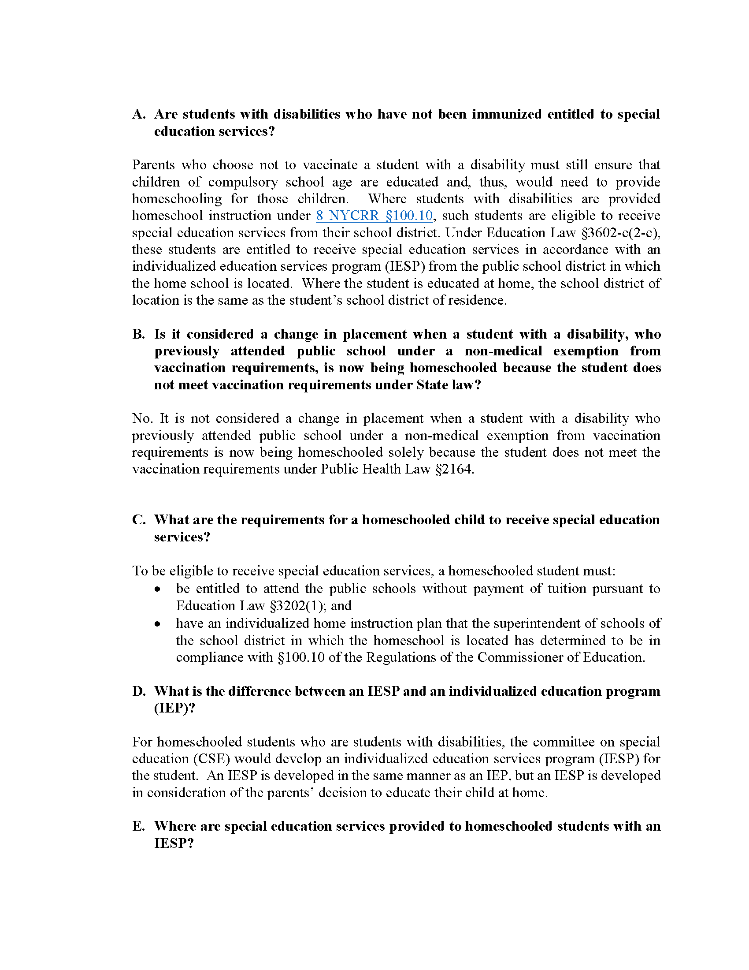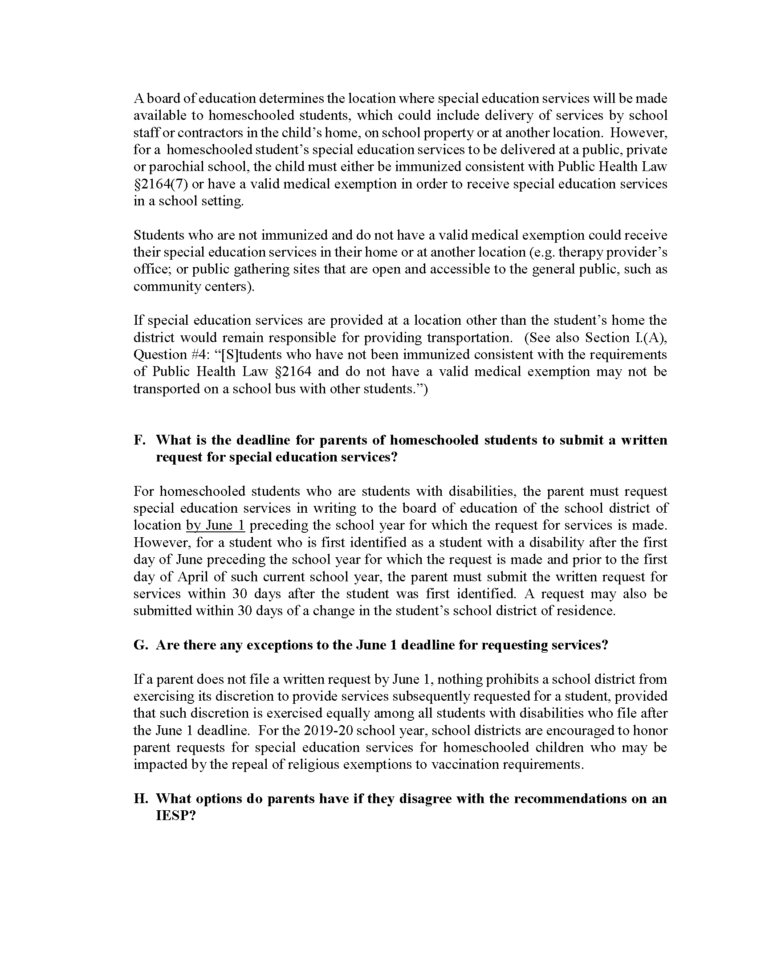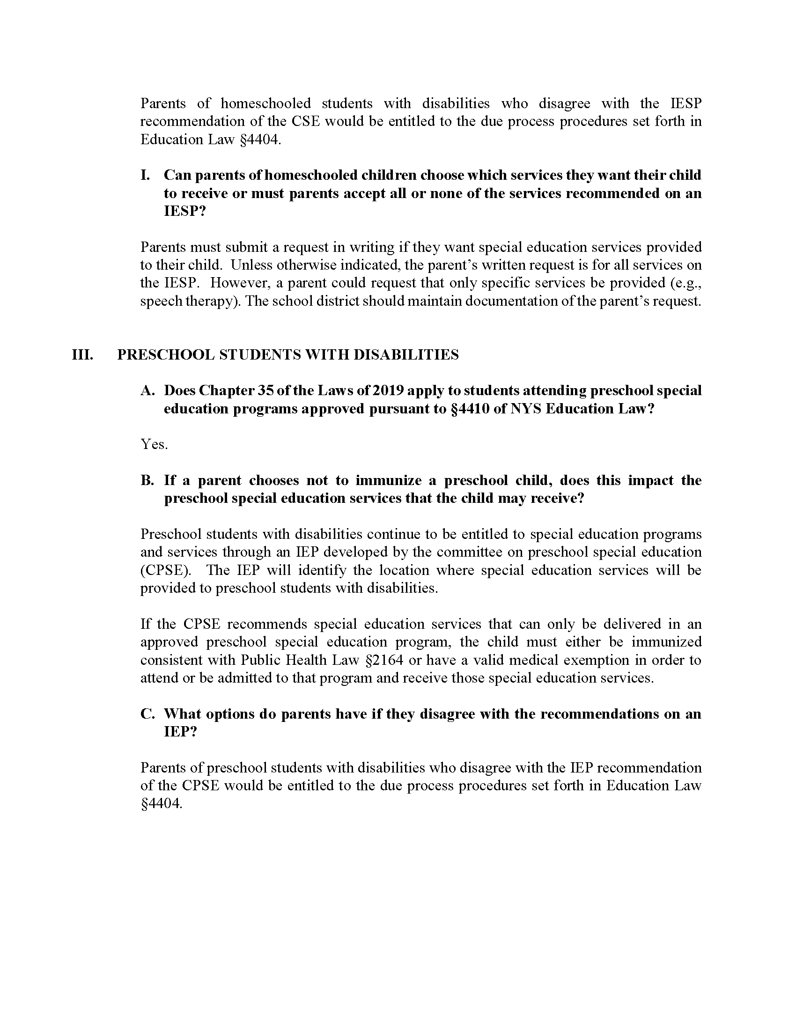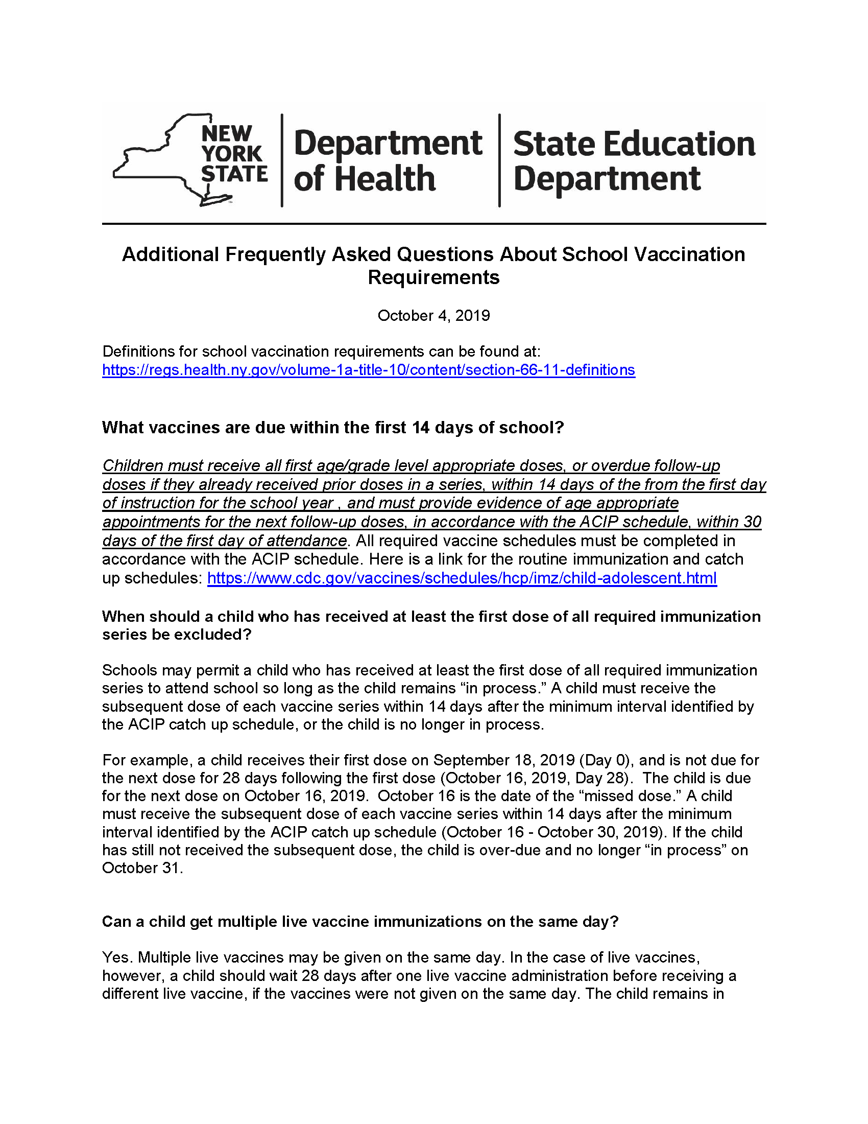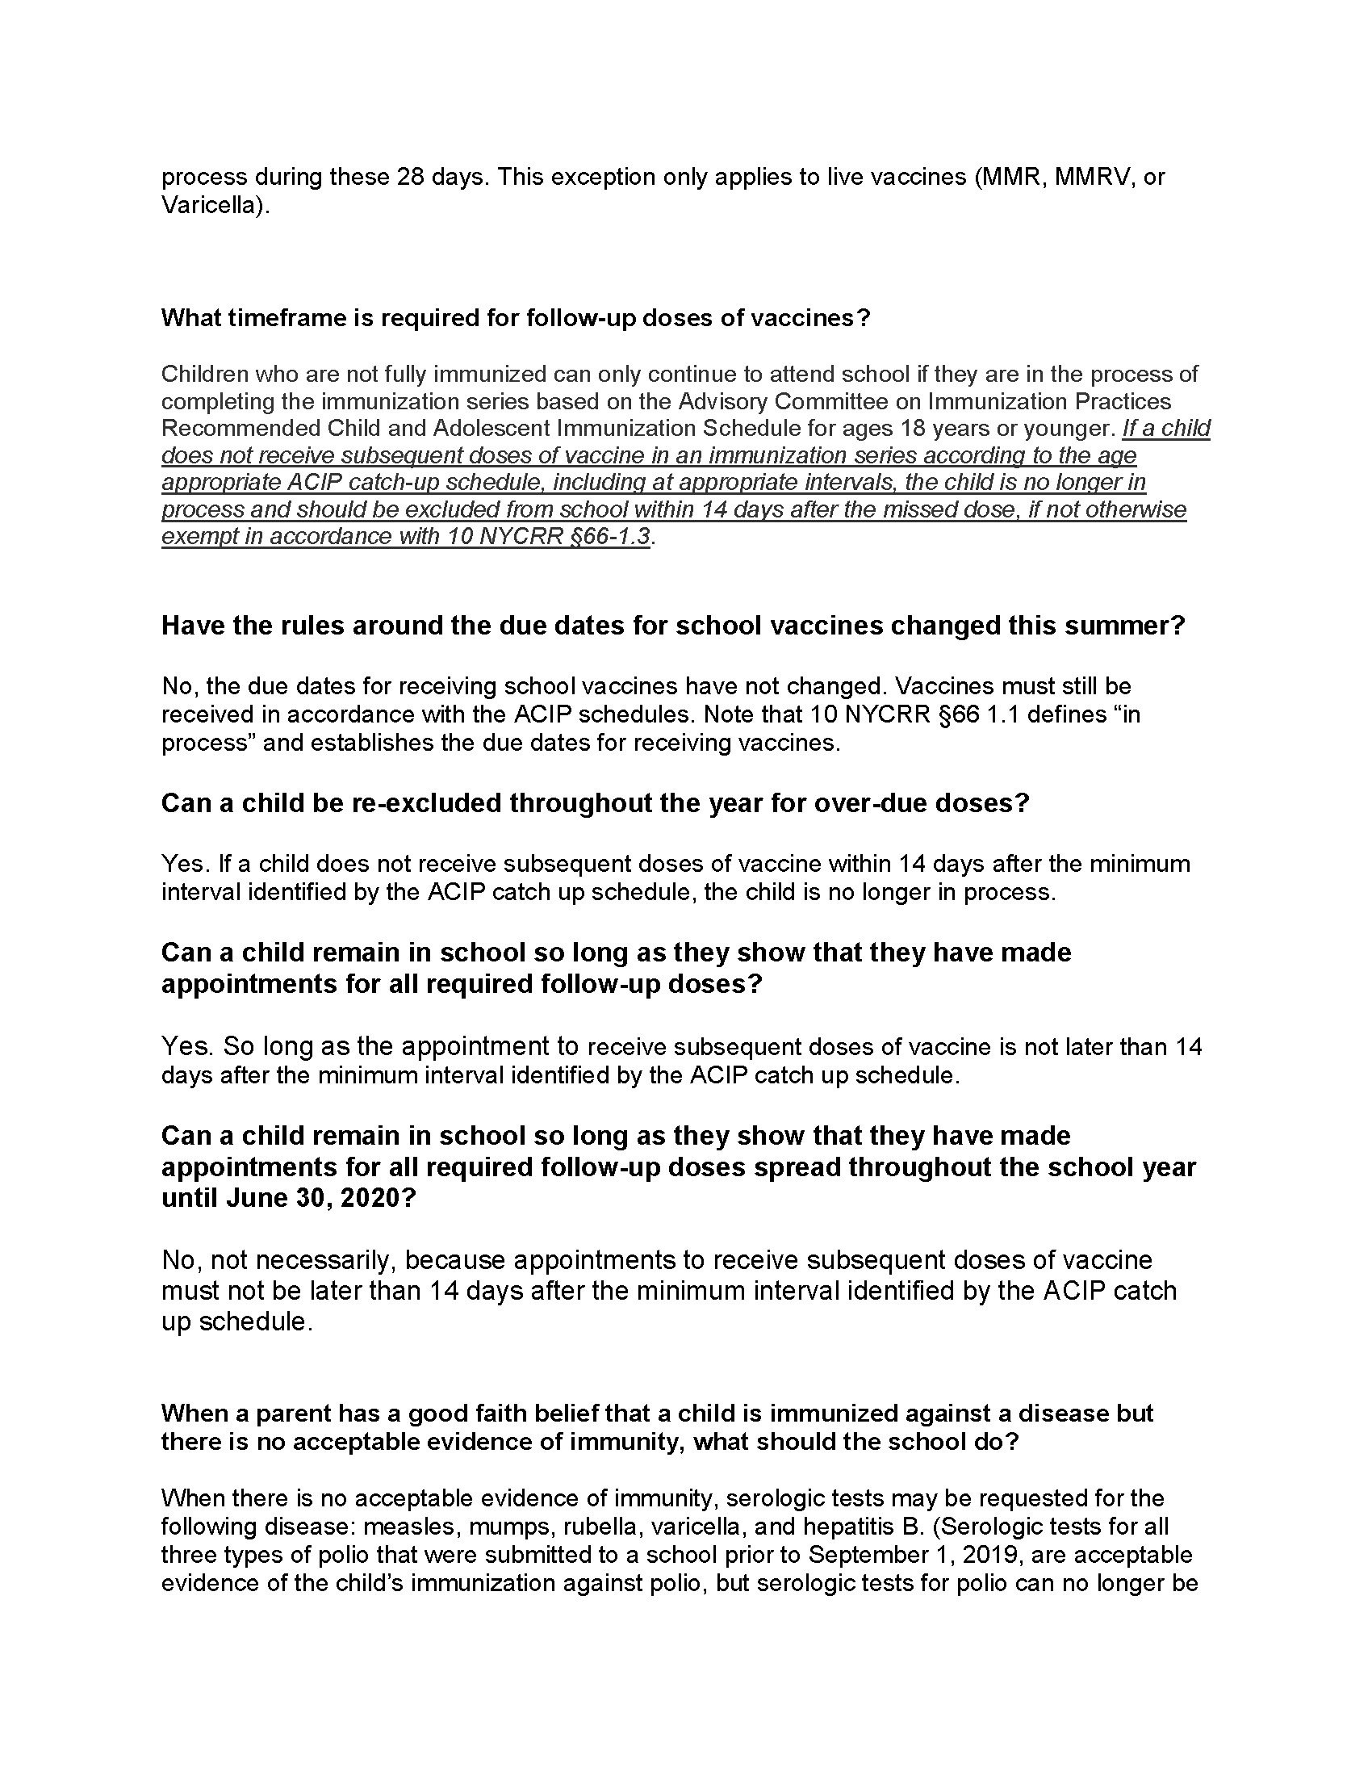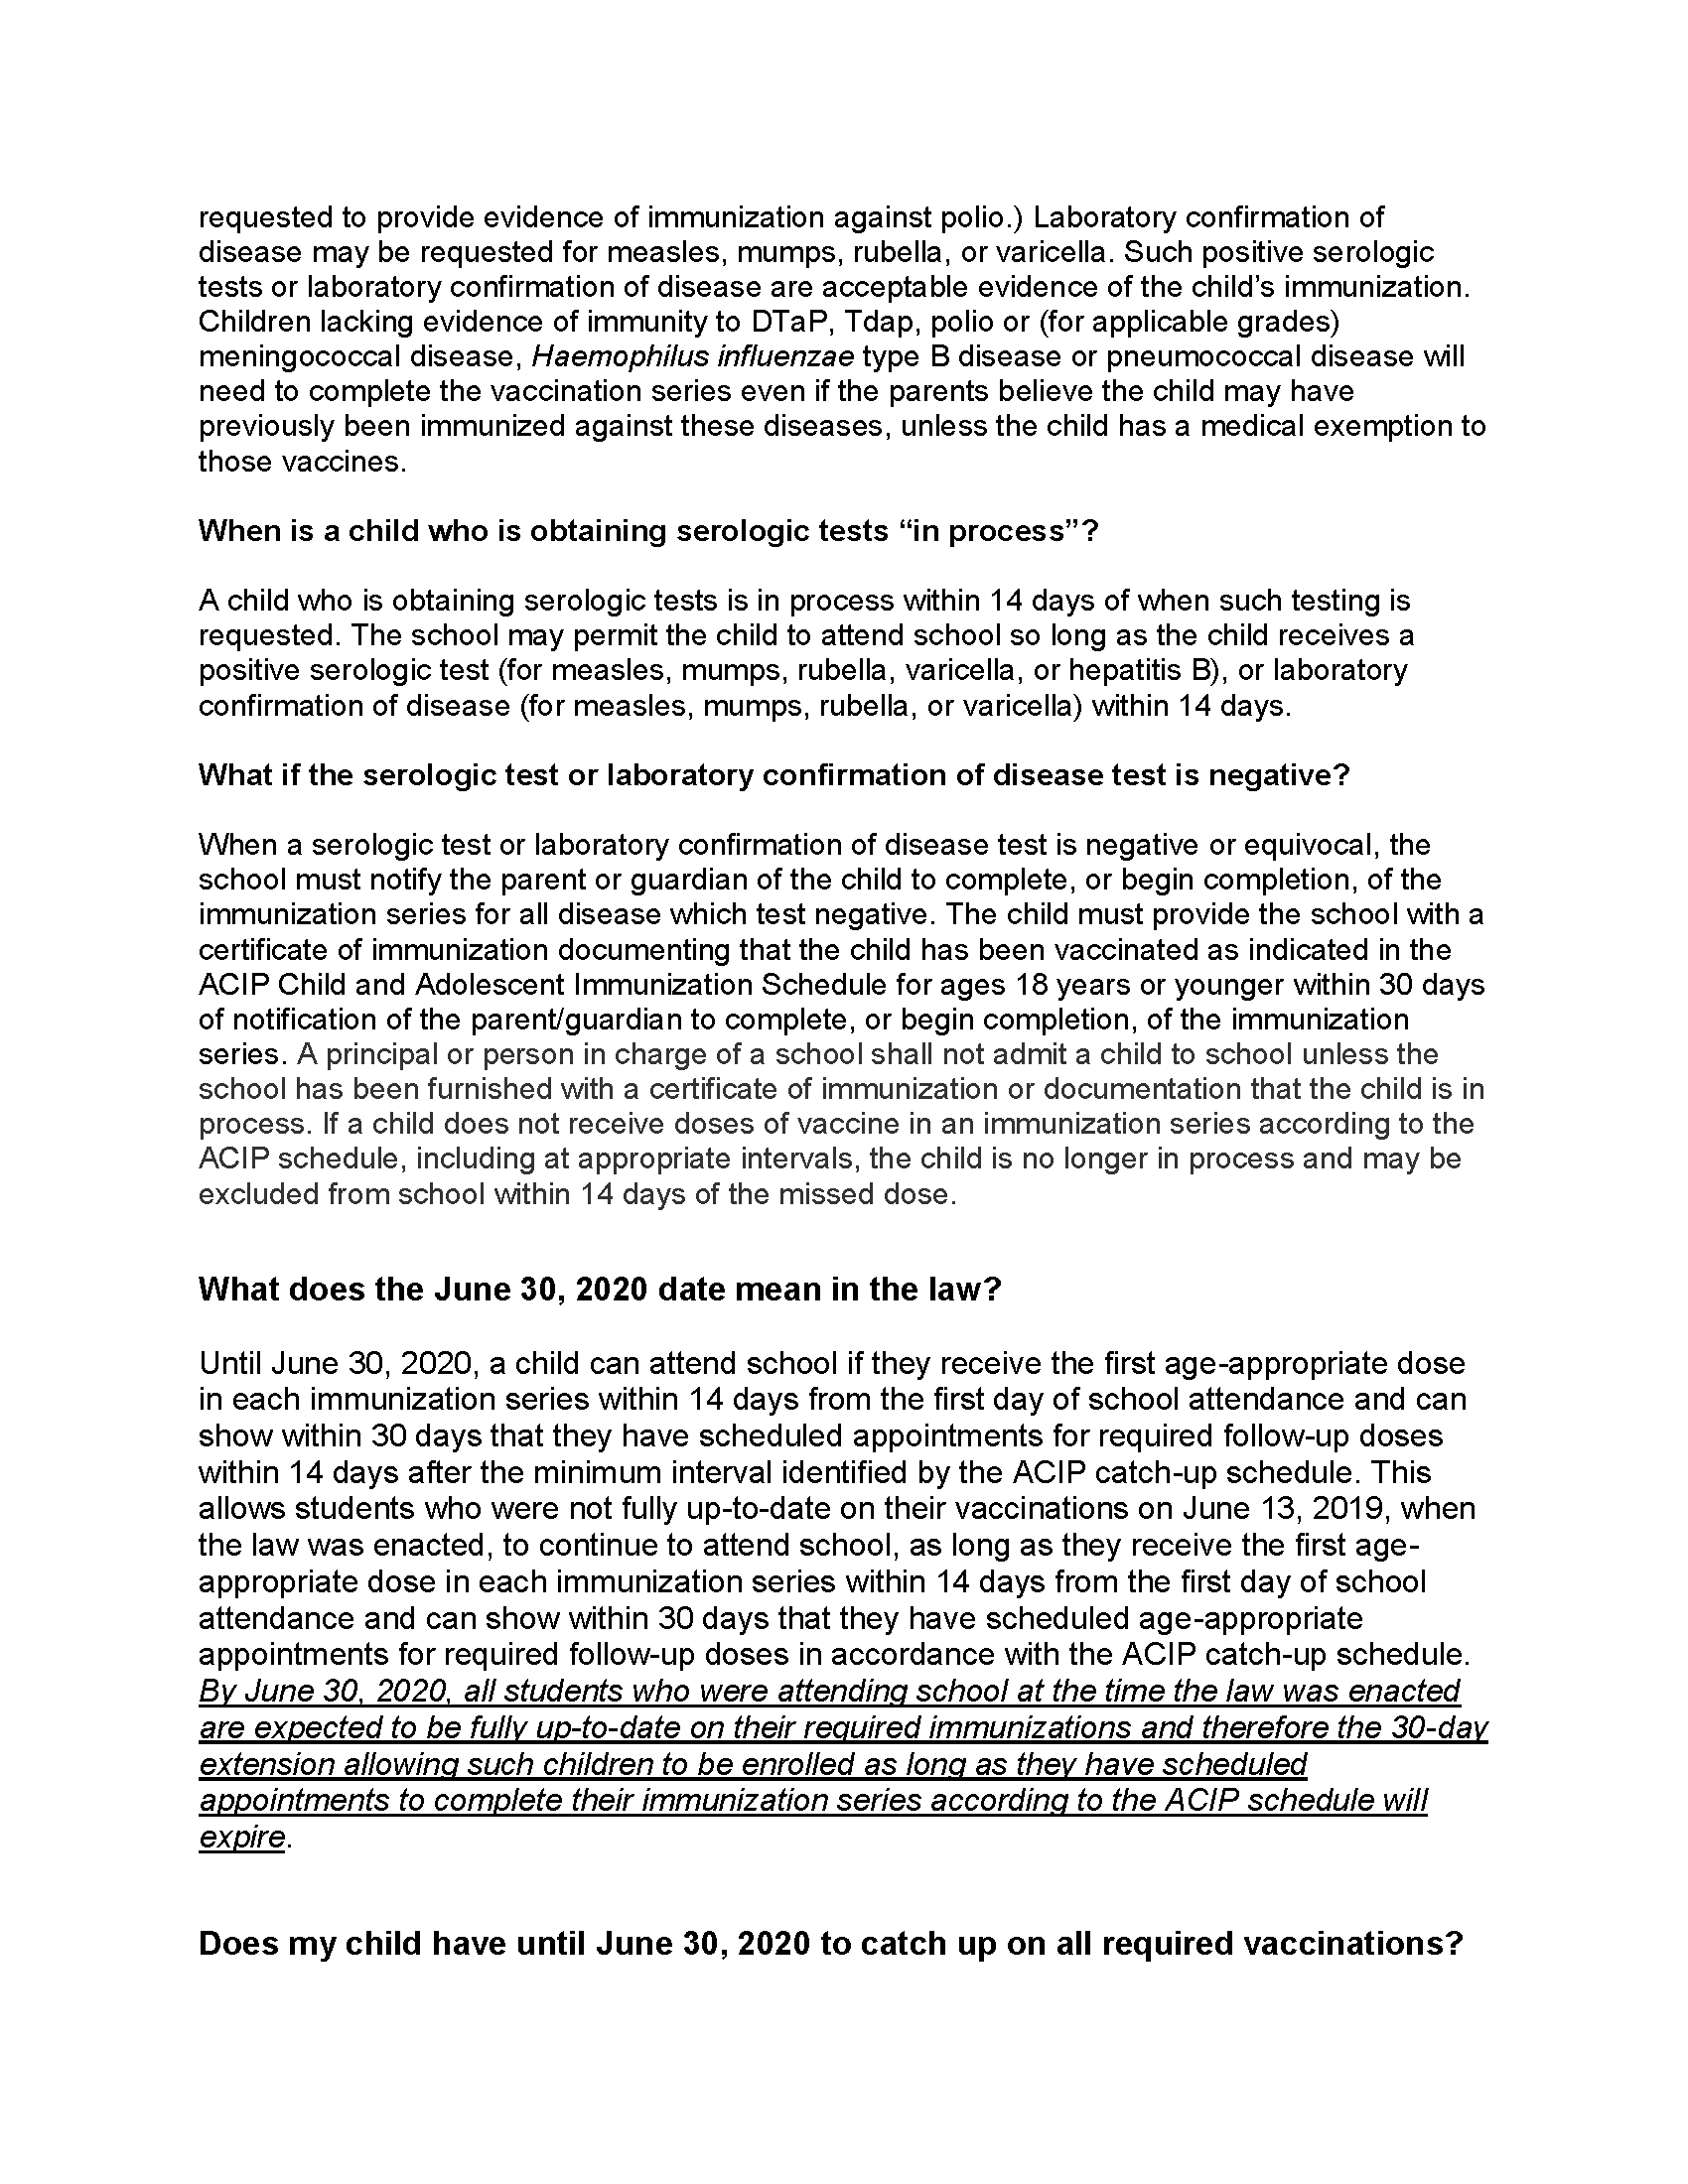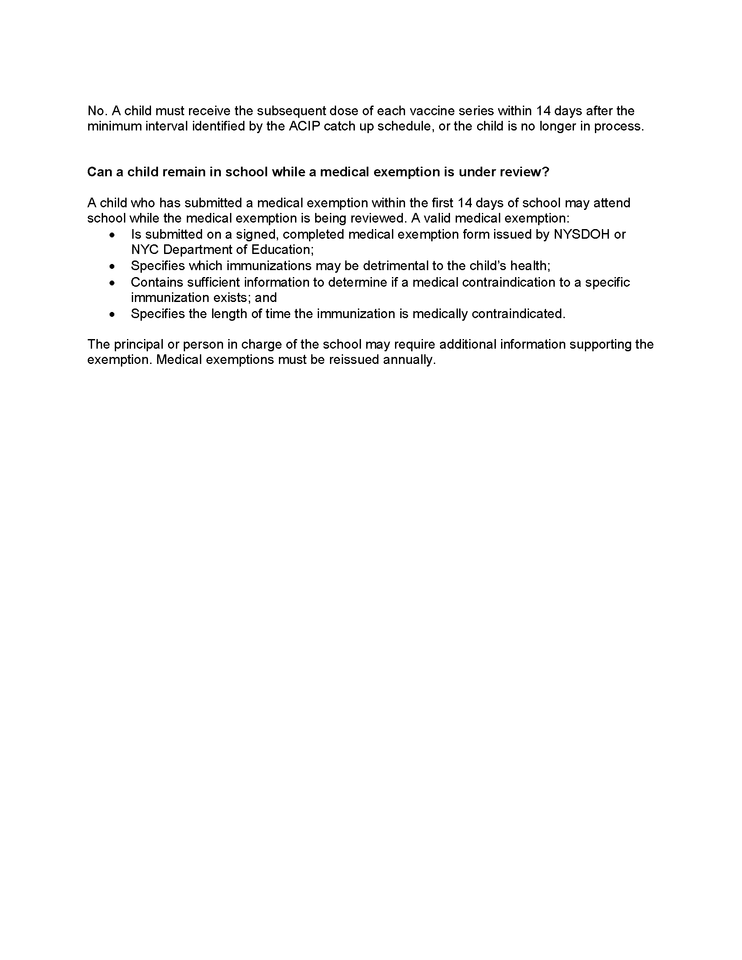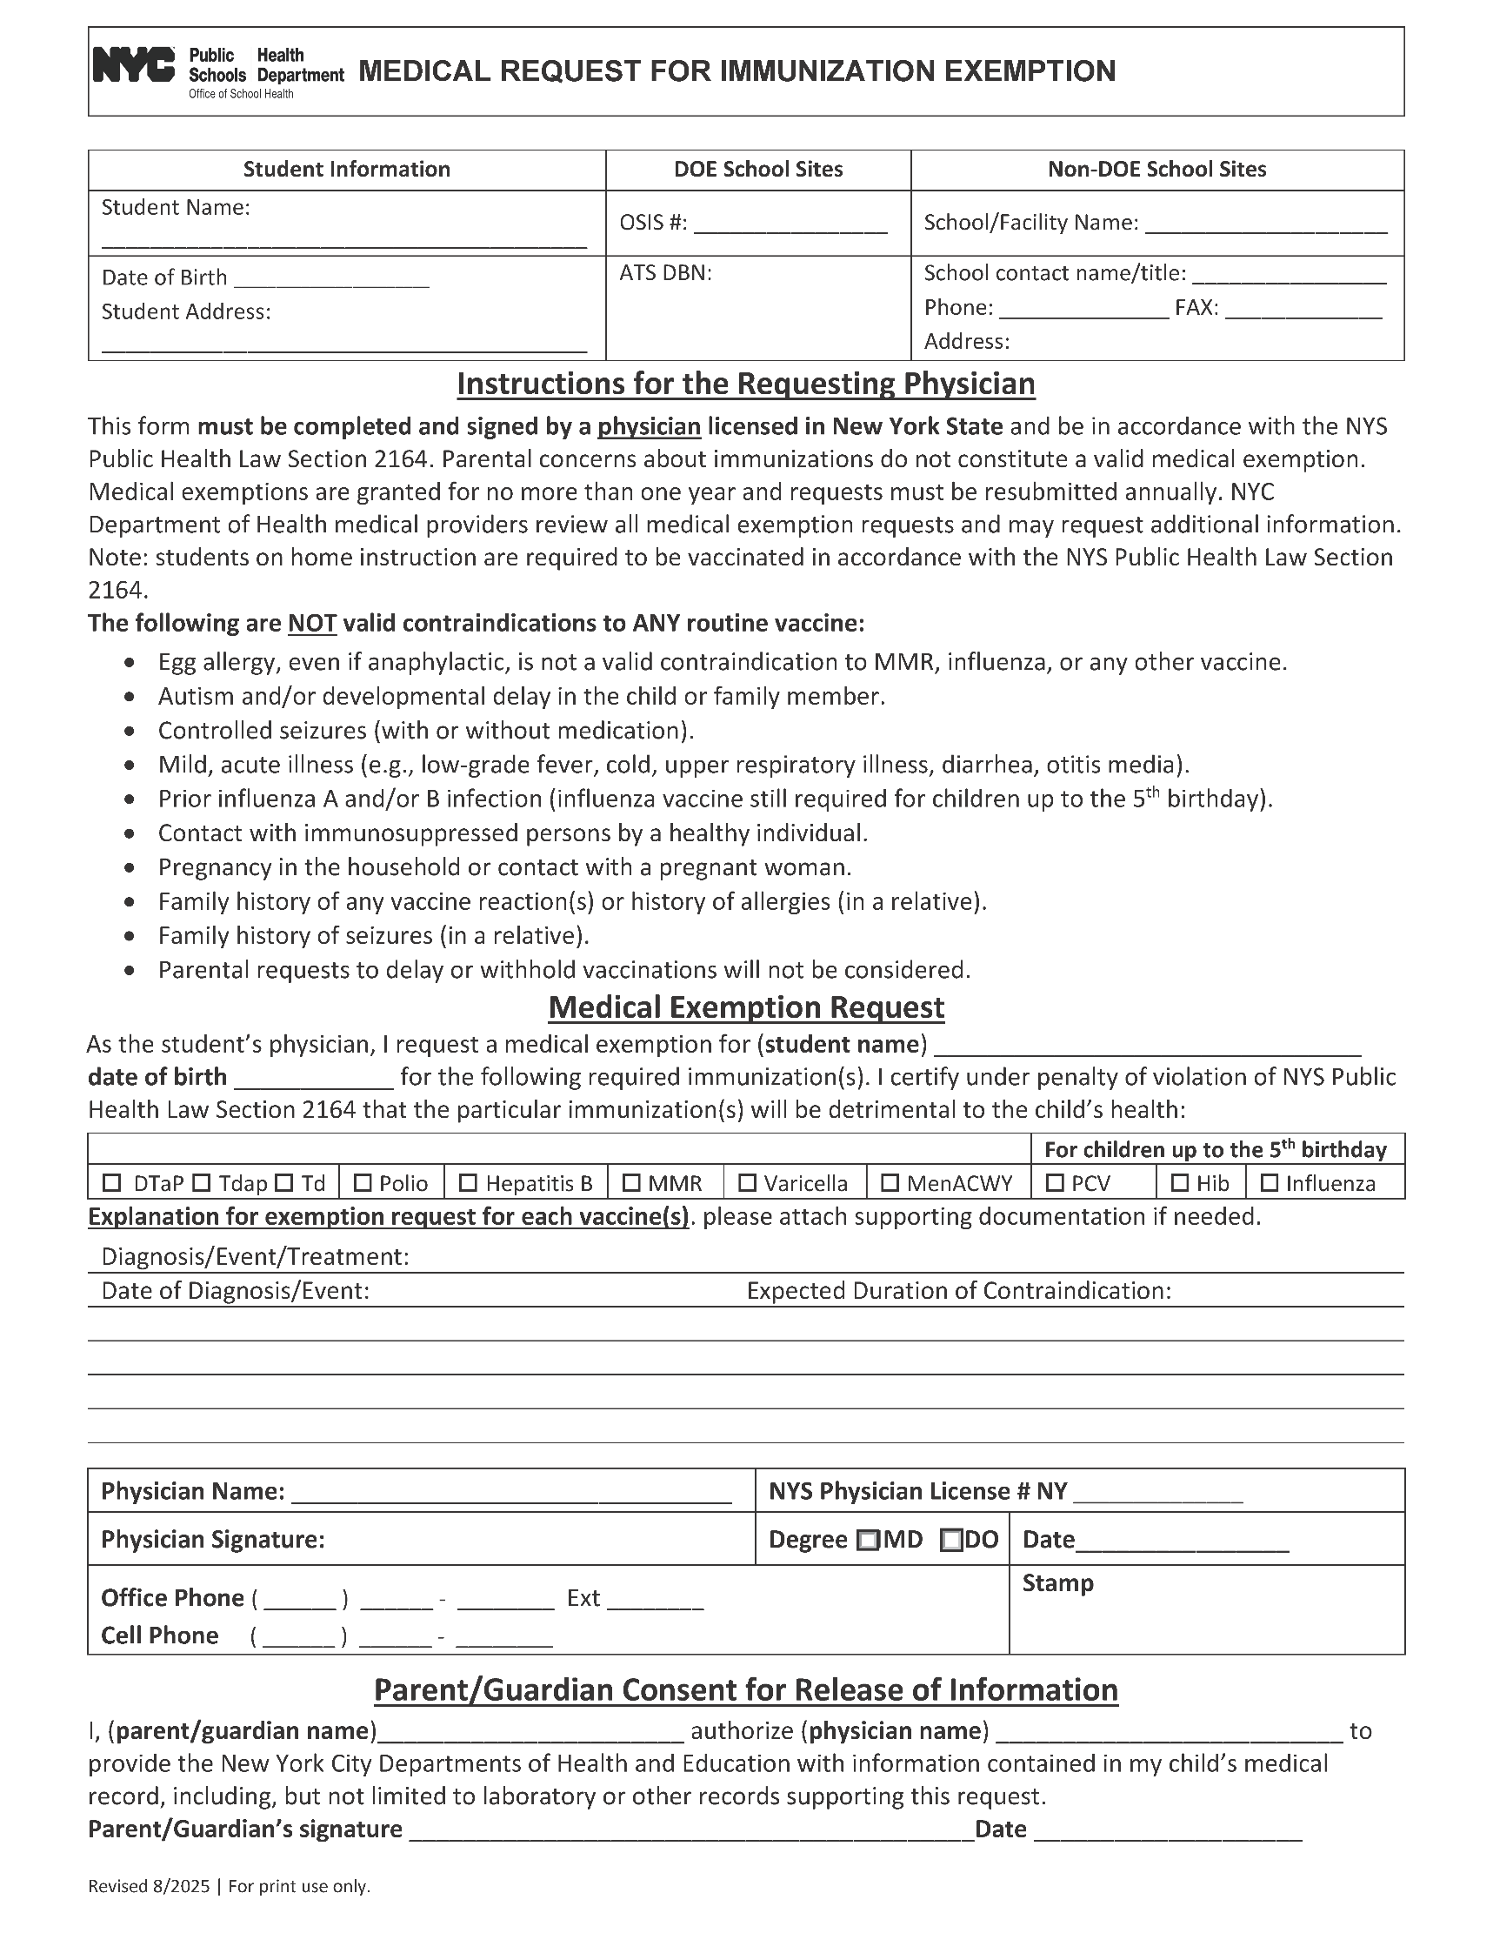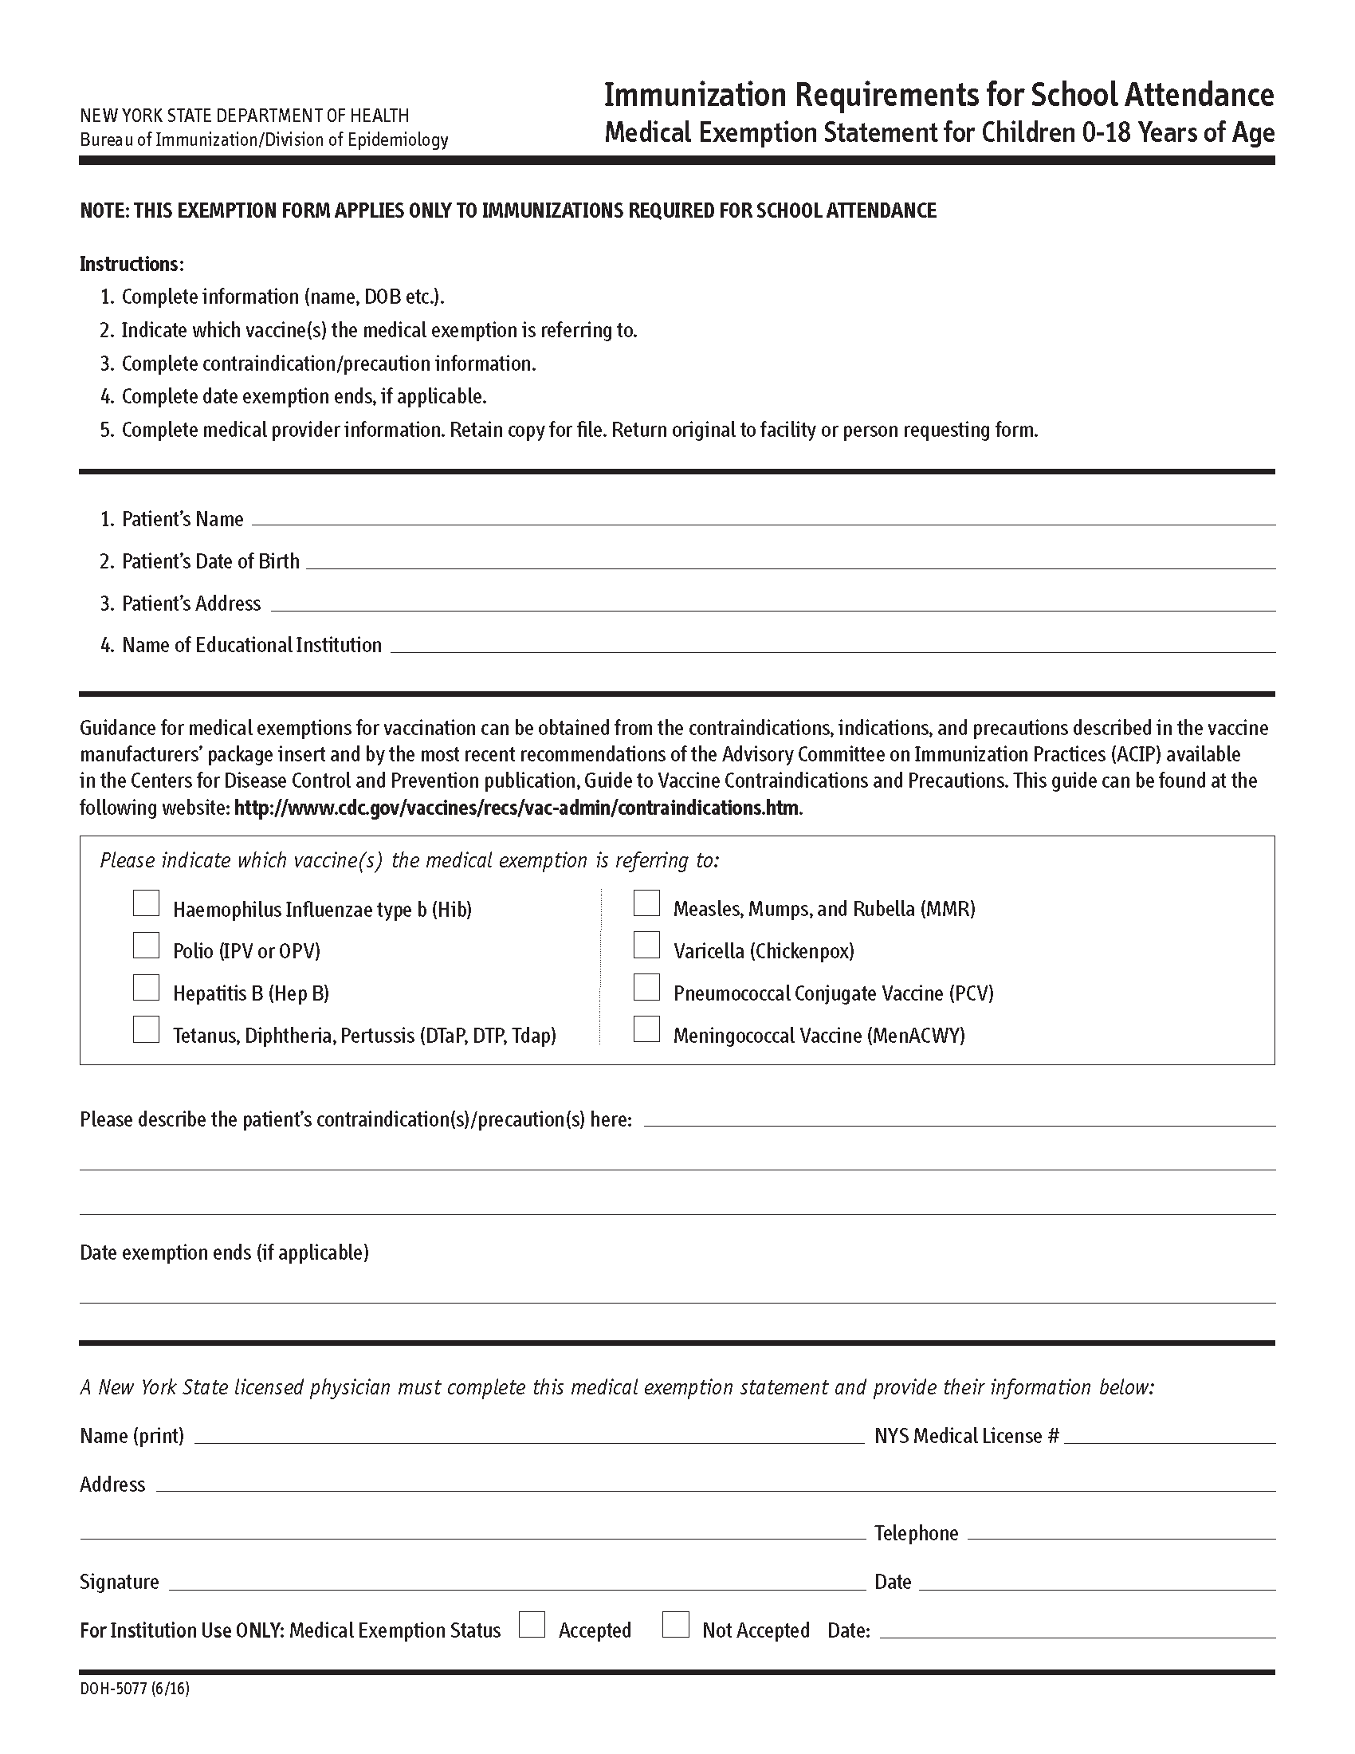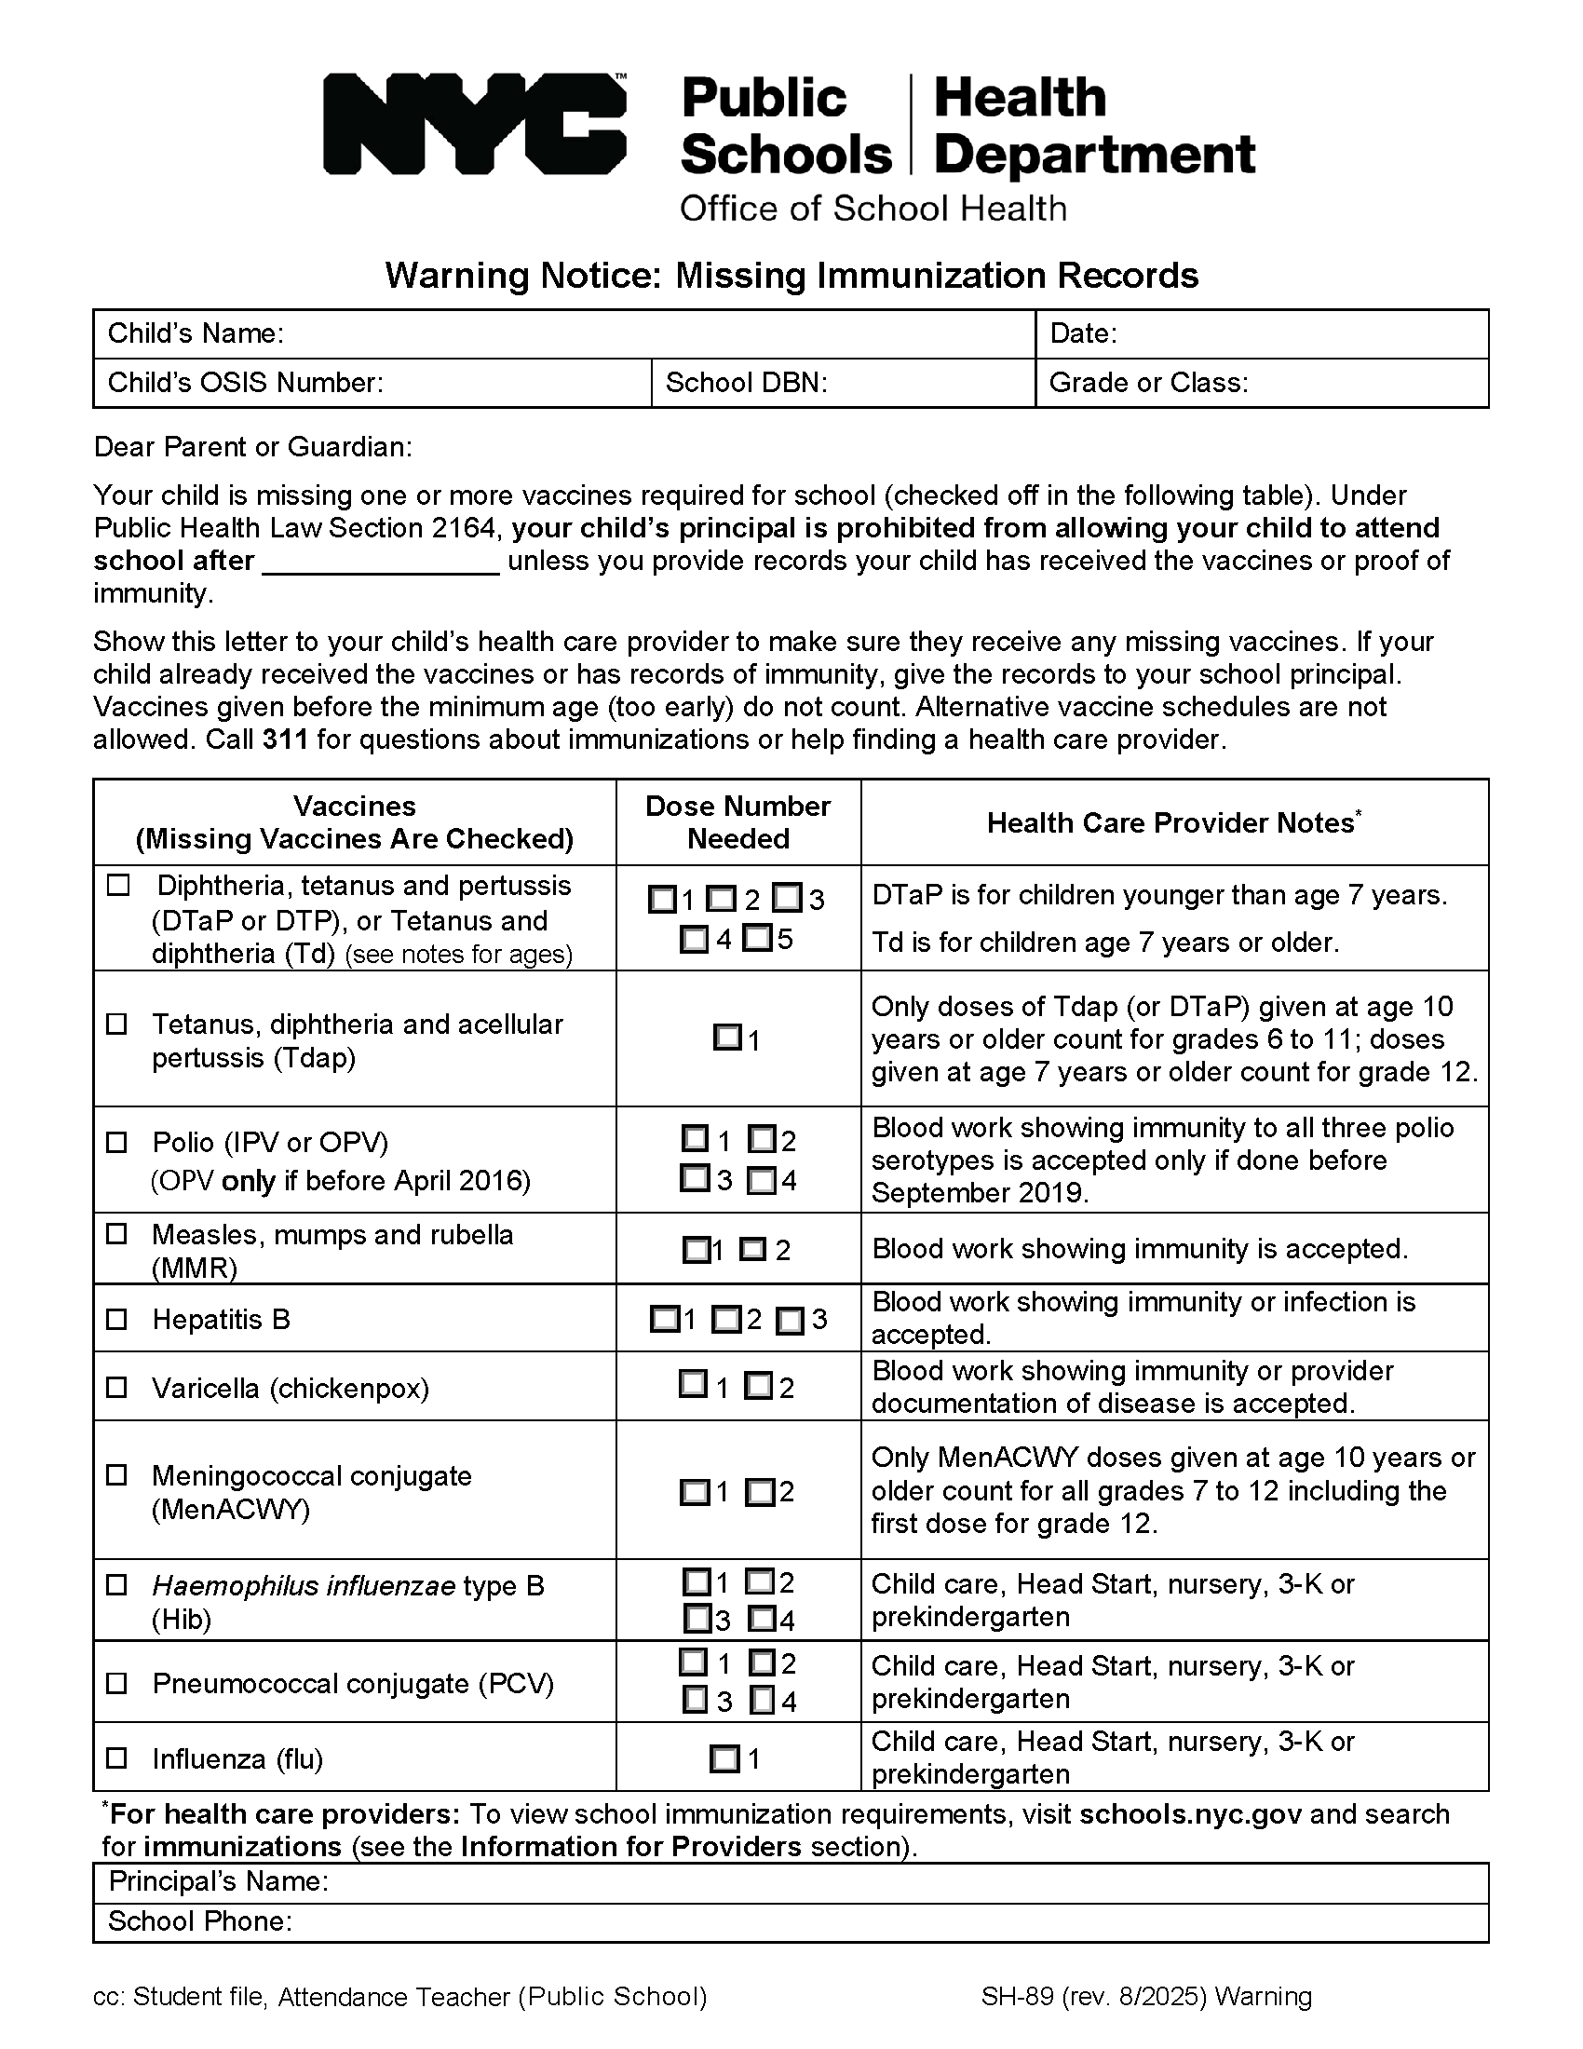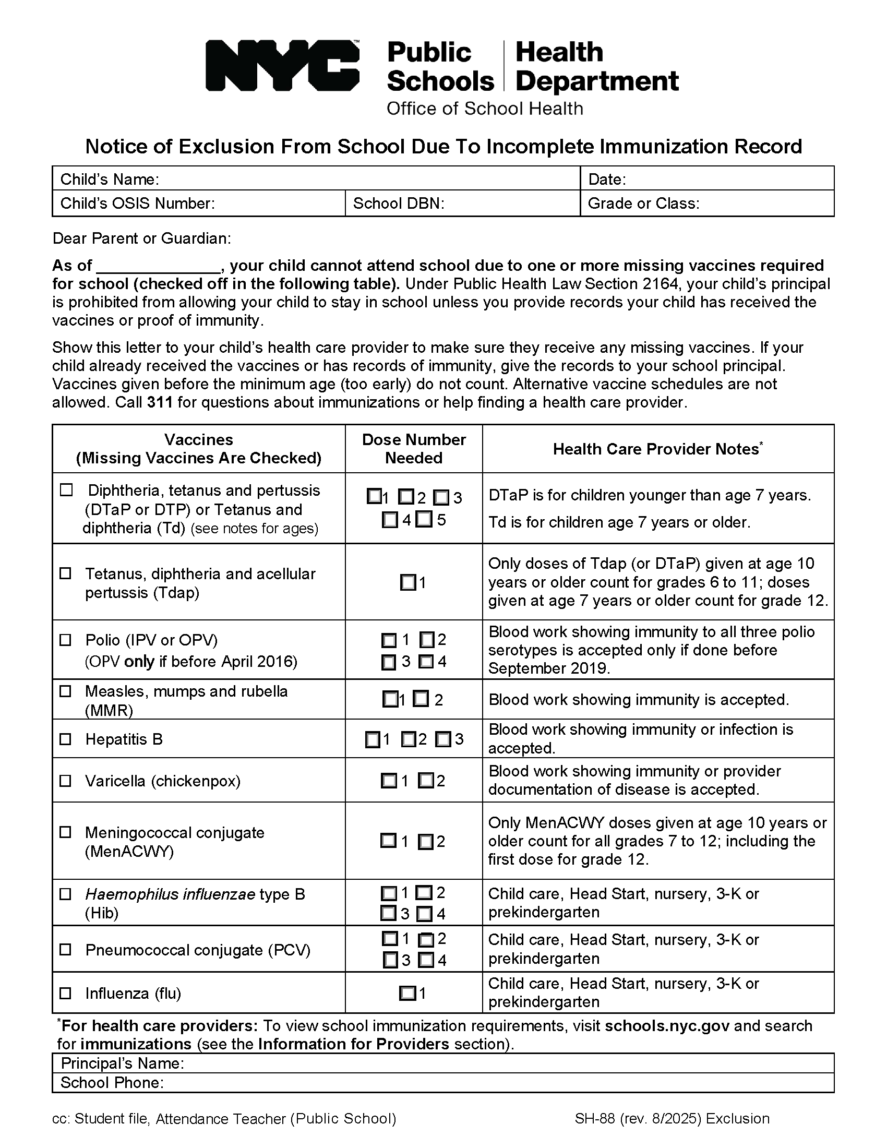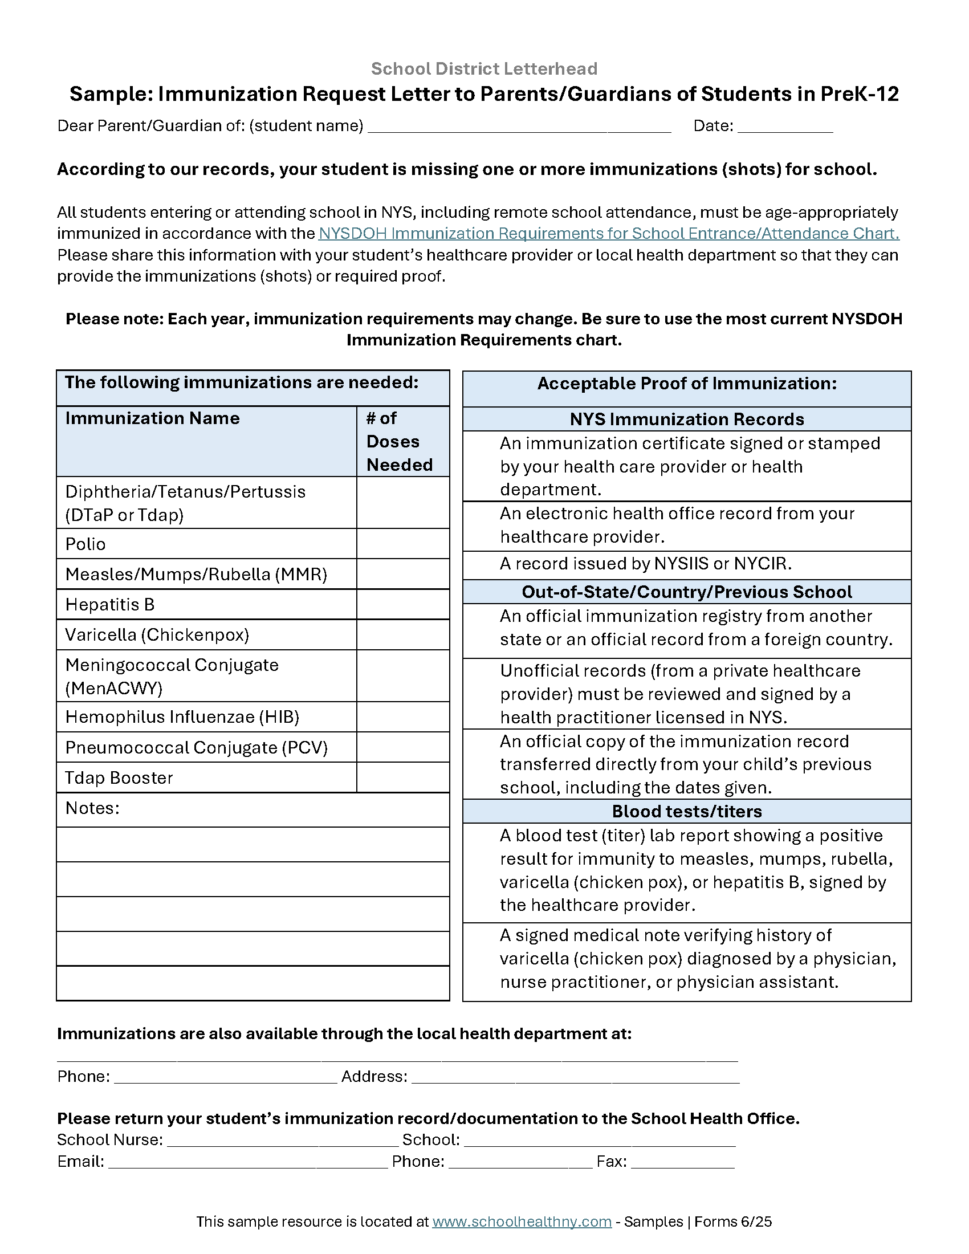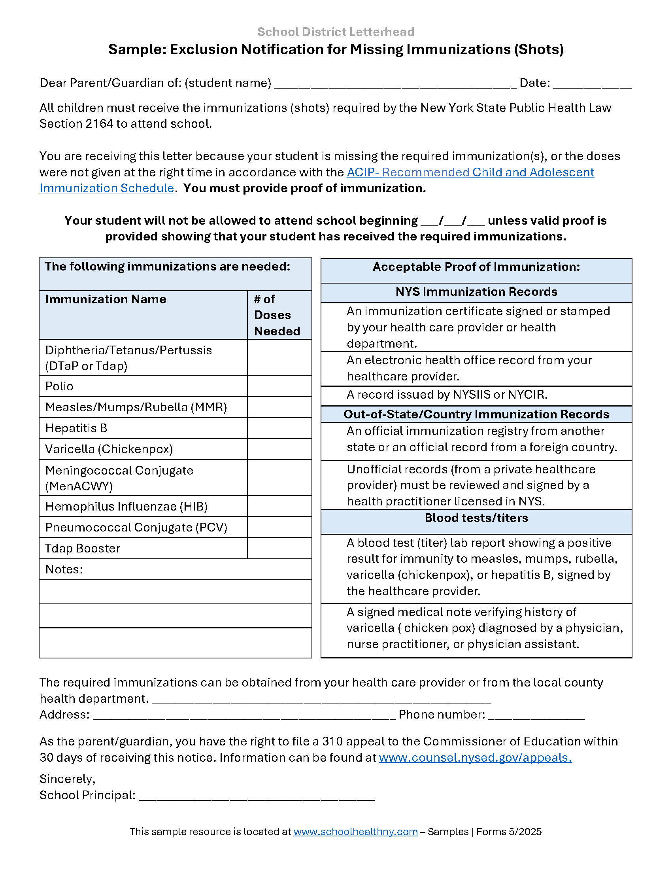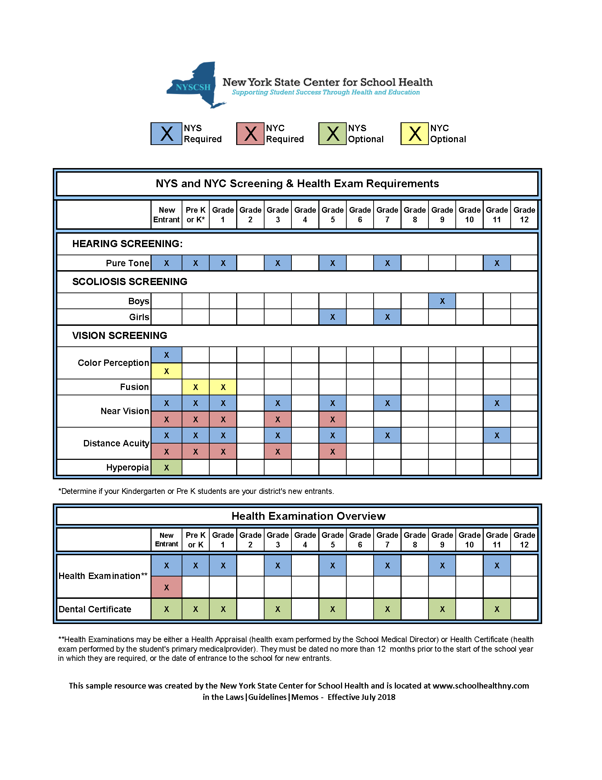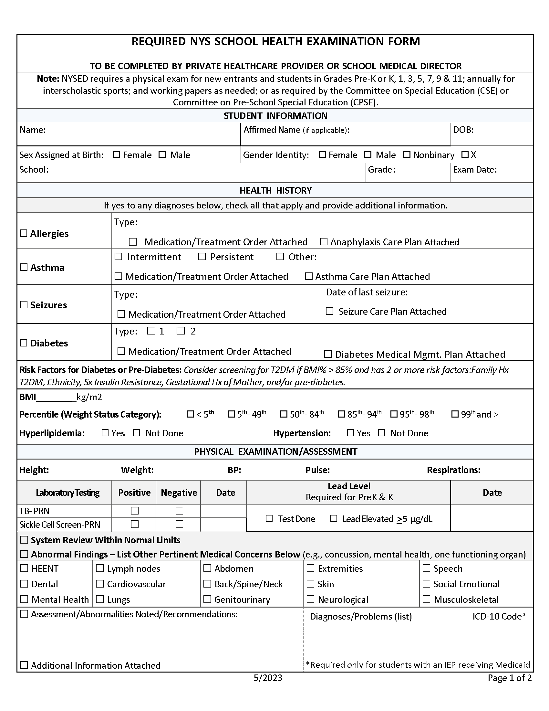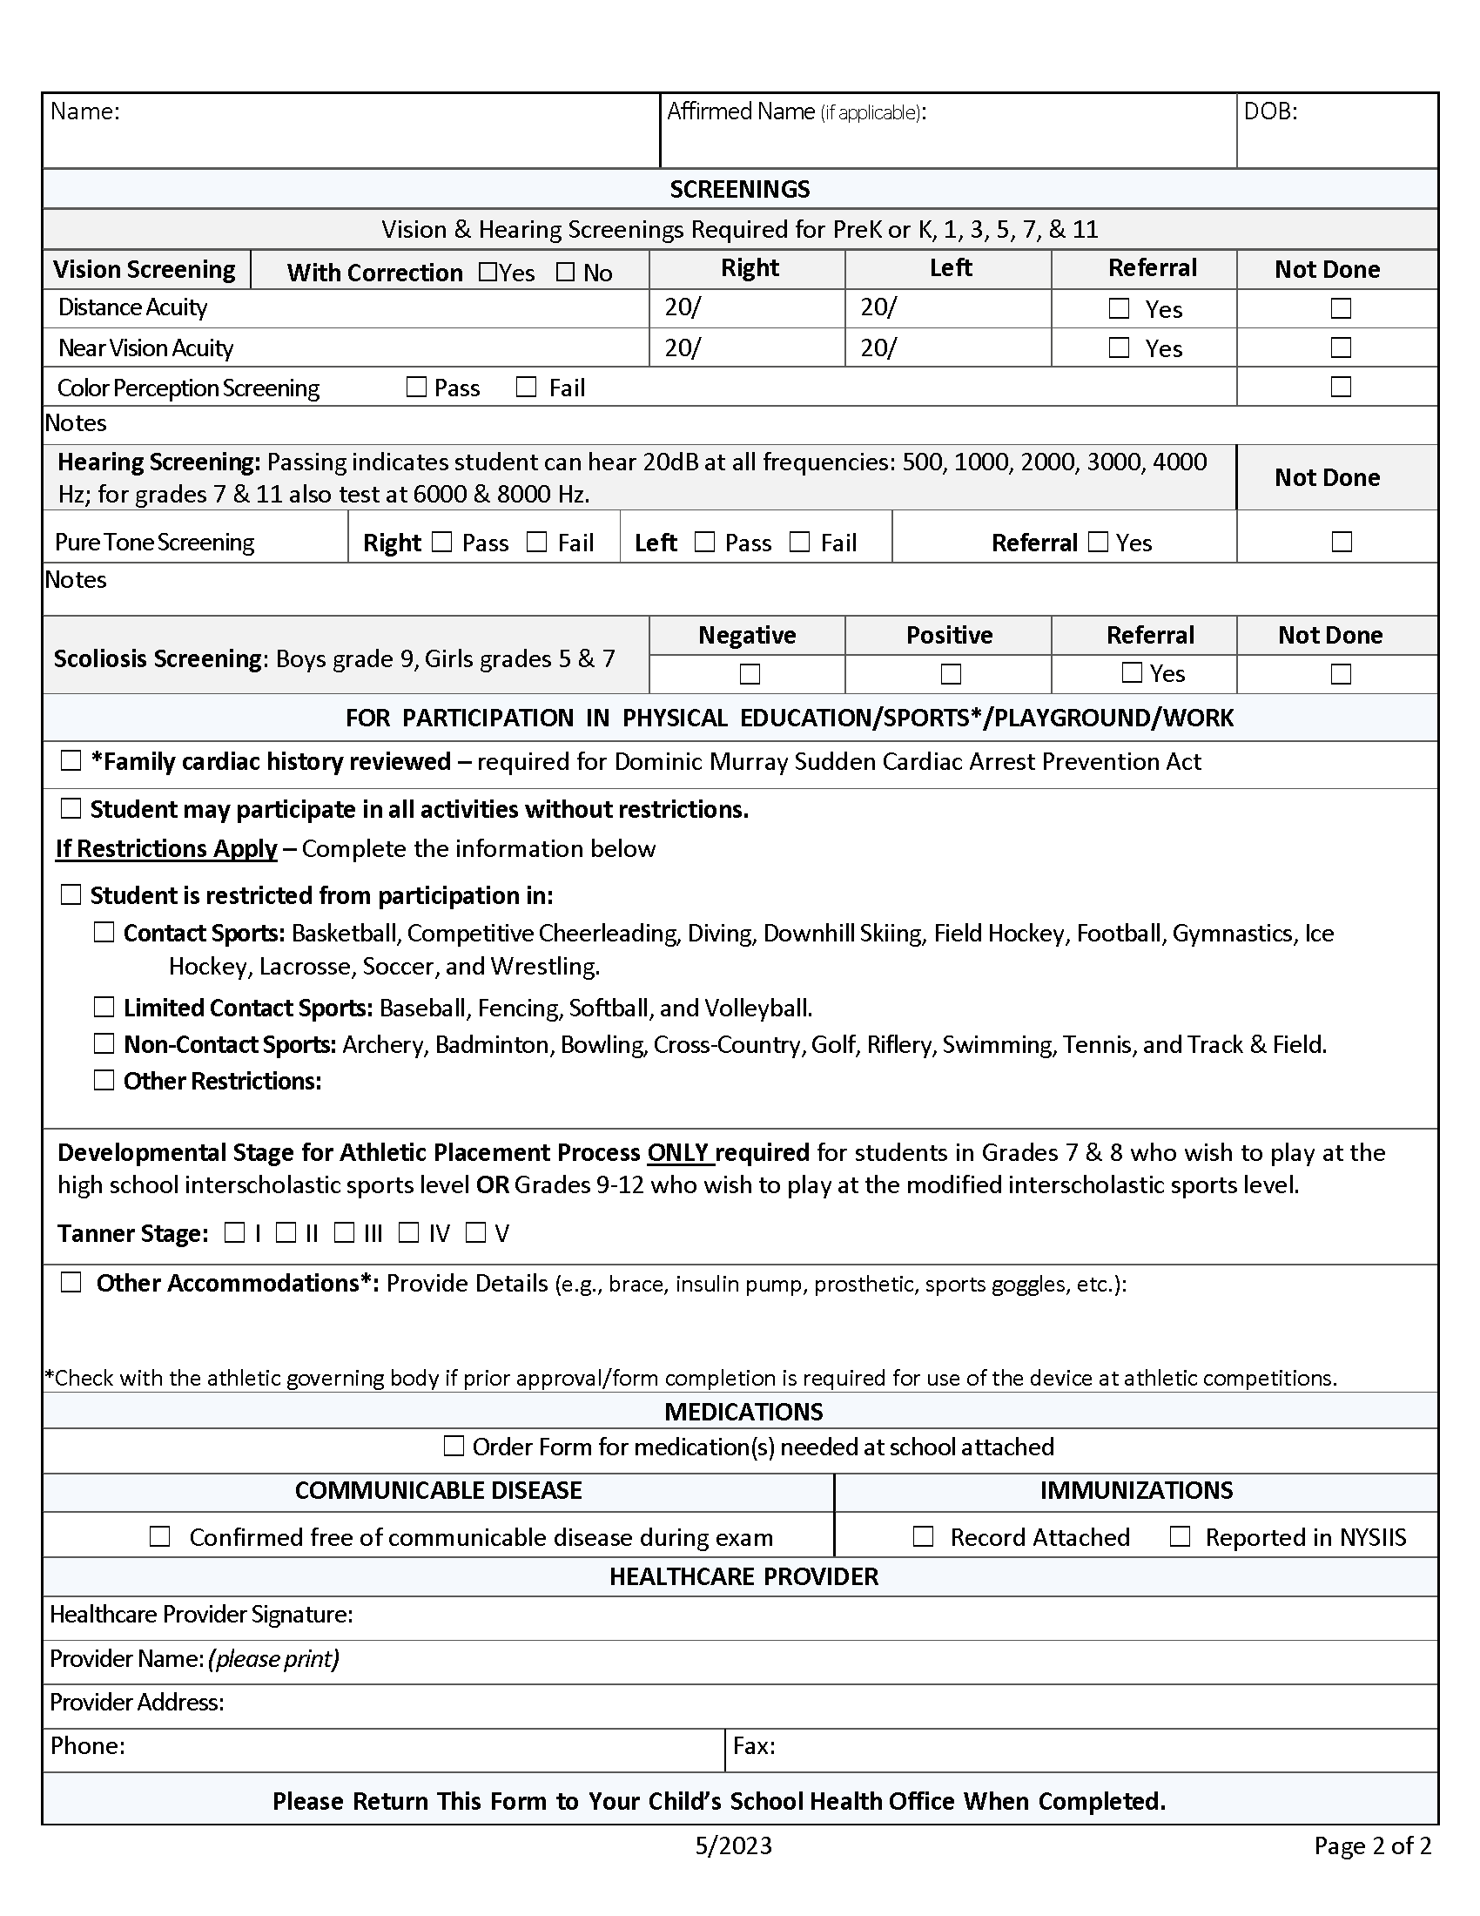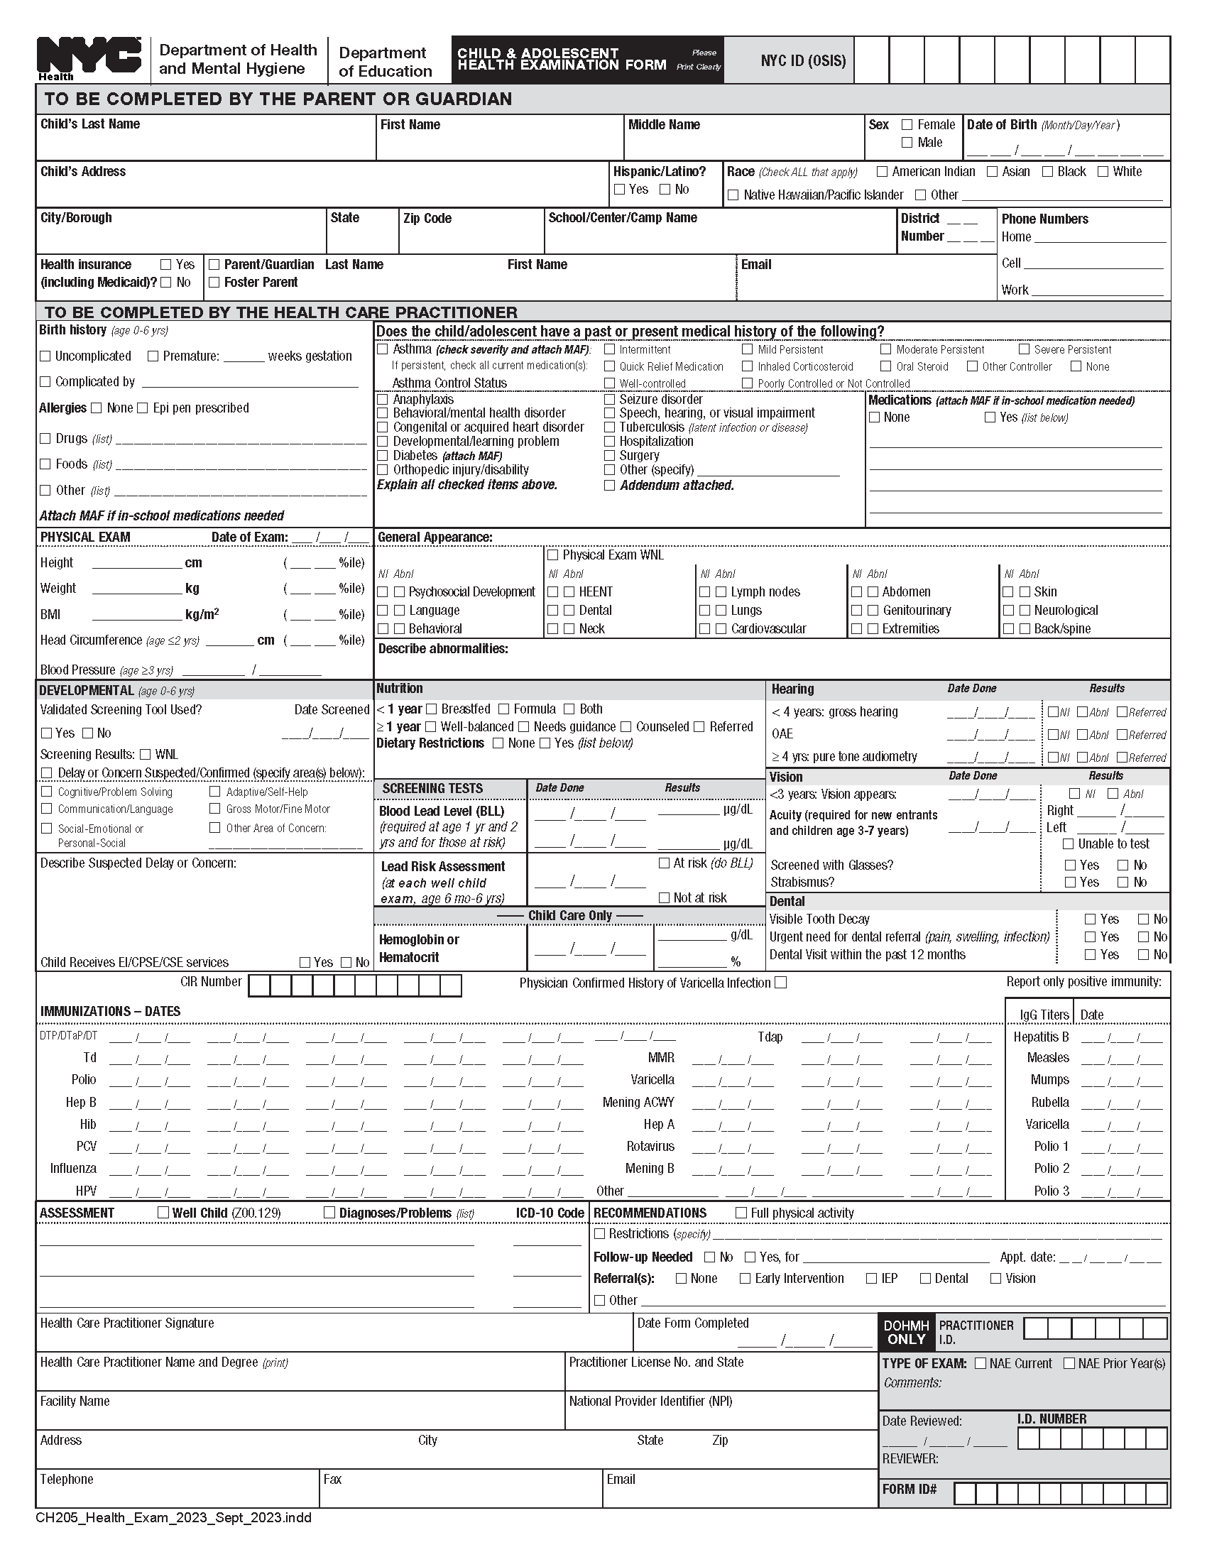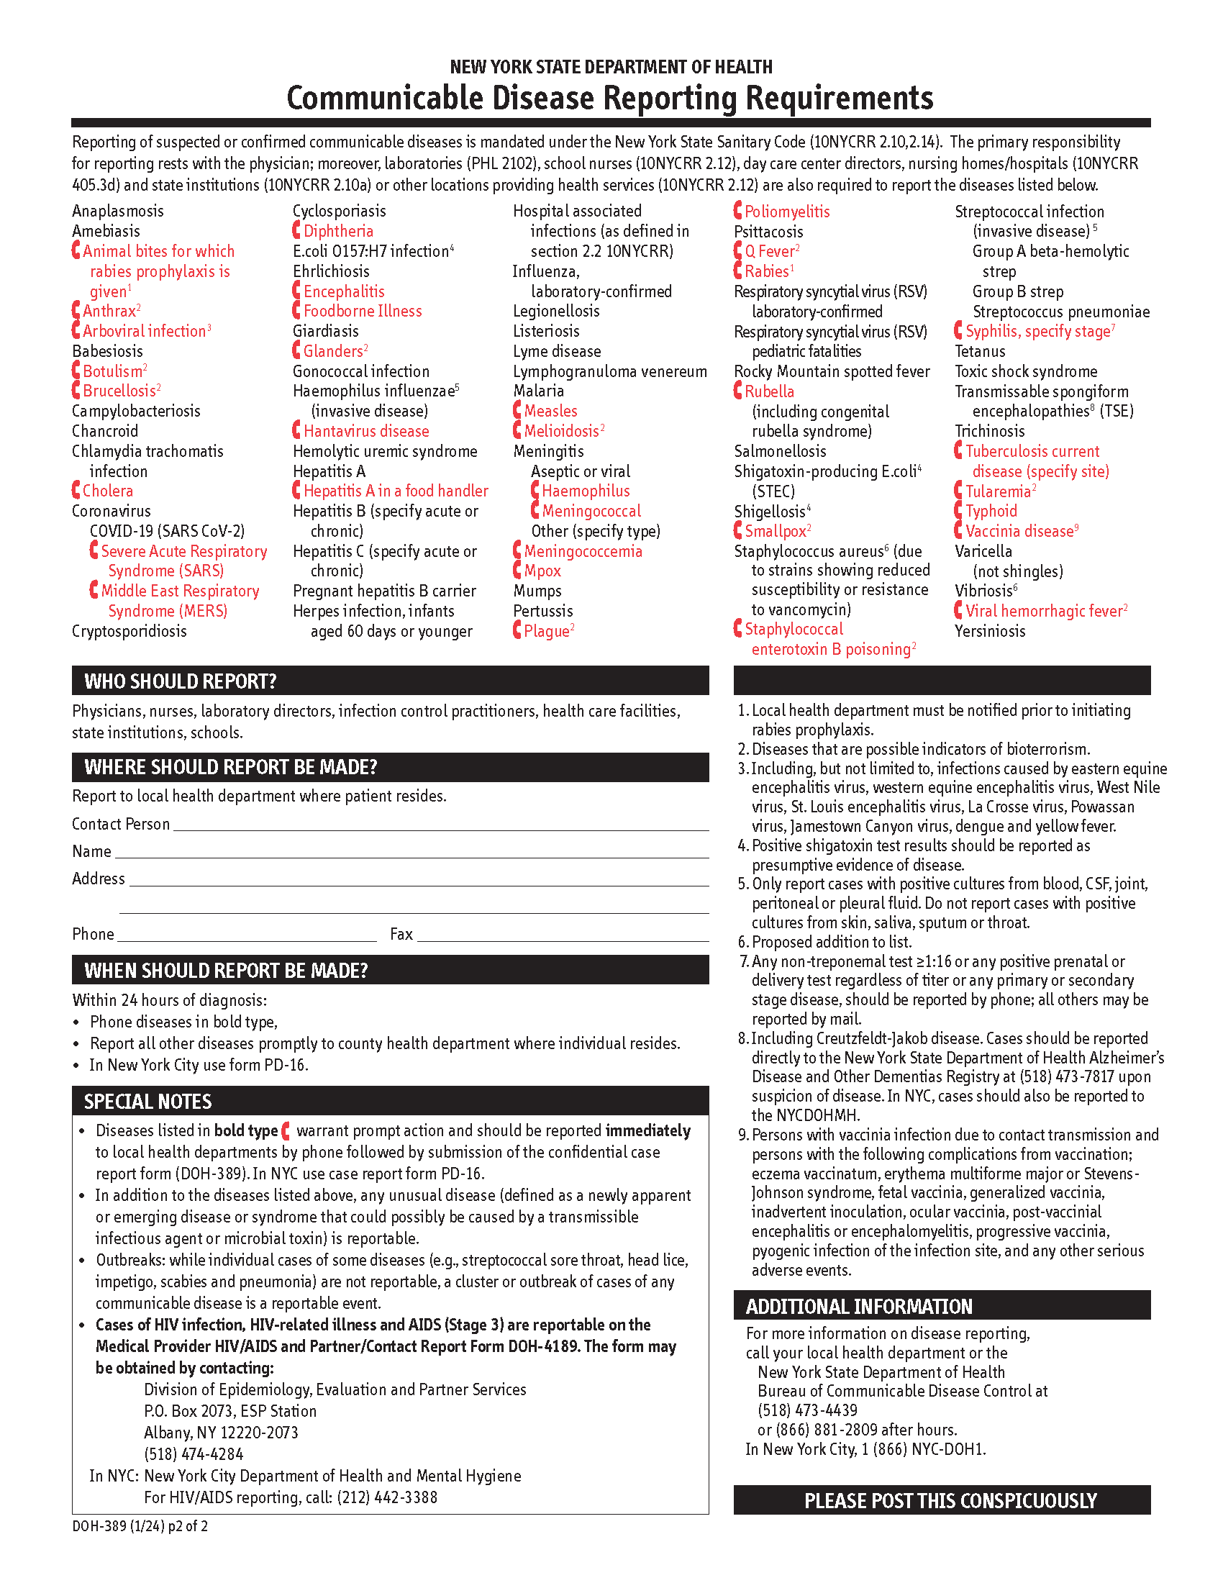

DATA PRIVACY CONSENT FORM
for __________________School

[SCHOOL] puts premium value to the privacy and security of personal data entrusted by its students and parent/guardian for legitimate purposes in connection with the Technology Use/Telecommunications Policy and any hardware and software used in connection therewith.

When we speak of “personal data,” the term includes the concepts of personal information, sensitive personal information, and privileged information. The first two are typically used to distinctively identify you.

Processing of Personal Data

- Collection of Information. We collect your personal data that you provide to us during your application for admission, information we acquire or generate upon enrollment, and during the course of your education with us in order to carry out the purposes associated with our Technology Use/Telecommunications Policy.

- Information you provide us during your application for admission. Upon application for admission, we collect information about personal circumstances and contact information, including, but not limited to, name, address, email address, telephone number and other contact details, family history, previous schools attended, academic performance, disciplinary record, medical record, etc.

- Information we acquire or generate upon enrollment and during the course of your education with us. Upon enrollment and during the course of your education with us, we collect information on your academic or curricular undertakings, the classes you enroll in and scholastic performance, attendance record, medical record, etc. We will also collect information for and in relation to co- curricular matters, such as outreach activities, as well as extra-curricular activities, such as membership in student organizations, leadership positions and participation and attendance in seminars, competitions, and programs. We will also collect information in connection with any disciplinary incident, including accompanying sanctions that you may be involved in. We will also collect information in connection with your use of hardware and software provided to you during the course of your education with us, including, but not limited to, address, telephone number, email address, other unique identifier, passwords or PINs, and account credentials (e.g., username and password).

- Access to Information. Your personal information is accessed and used by us. We use and share your information as permitted or required by law to pursue our legitimate interests as an educational institution, including a variety of academic, administrative, historical, and statistical purposes. Some examples of situations when we may use your information to pursue our legitimate interests as an educational institution are as follows:

- evaluating applications for admission.

- processing confirmation of incoming students and transfer students in preparation for enrollment.

- recording, generating, and maintaining student records of academic, co-curricular and extra- curricular progress.

- establishing and maintaining student information systems.

- maintaining directories and records.

- compiling and generating reports for statistical and research purposes.

- providing services such as health, counseling, information technology, library, sports/recreation, transportation, safety, and security.

- managing and controlling access to campus facilities and equipment.

- communicating official school announcements; sharing marketing and promotional materials regarding school-related functions, events, projects, and activities; and

- soliciting your participation in research and non-commercial surveys.

- Sharing of Information. Some examples of when we may share or disclose your personal information to others include:

- sharing information to persons, including parent/guardian, or next of kin, as required by law or on a need-to-know basis as determined by the school to promote your best interests, or protect your health, safety, and security, or that of others.

- providing academic institutions, companies, government agencies, private or public corporations, or the like, upon their request, with scholastic ranking information or certification of good moral character for purposes of admission.

- reporting and/or disclosing information to government bodies or agencies (e.g., Commission on Higher Education, Department of Education); and

- conducting research or surveys for purposes of institutional development; and

- sharing of information to various third-party vendors who provide services associated with our Technology Use / Telecommunications Policy and any hardware and software used in connection therewith.

Data Protection

We shall implement reasonable and appropriate organizational, physical, and technical security measures for the protection of personal data which we collected. The security measures shall aim to maintain the availability, integrity, and confidentiality of personal data and are intended for the protection of personal data against any accidental or unlawful destruction, alteration, and disclosure, as well as against any other unlawful processing. We only permit your data to be accessed or processed by authorized personnel who hold such information under strict confidentiality, including all third-party vendors.

Any data security incident or breach that comes to the knowledge of us will be recorded and reported as required by law. We will take all necessary and reasonable steps to address such incident or breach and mitigate any negative effect of such incident or breach. If there is strong suspicion that an incident affects your personal information, we will notify you of such incident in an appropriate manner.

Consent

I have read this form, understood its contents and consent to (a) the collection, use, processing and transfer by [SCHOOL] of certain personal information about you (the “Data”); (b) any transfer of Data by any such authorized person for the purposes of implementing, administering and managing the purposes outlined above; (c) the use of such Data by any such authorized person for such purposes; and (d) the transfer to and retention of such Data by third parties in connection with such purposes. I further agree and acknowledge that while [SCHOOL] has taken all necessary and reasonable steps to ensure that all third parties protect such Data, [SCHOOL] has no control over how the third party will use or disseminate my information. I agree to release and hold harmless [SCHOOL], its representatives, officers, employees, contractors, agents, and assignees, from any and all claims of action or damages of any kind arising from, or in any way connected to, the release or use of any information or records by any third party pursuant to this form and as allowed by all applicable laws.

Complete Name of Student/Child/Ward: ___________________________________

Signature of Student: _________________________________________________

Date: ___________________________

If below 18 years old,

As the parent/guardian of this student, I have read the data privacy consent form, understood its contents, and provide consent to use the personal information collected as outlined and in accordance with this form. I hereby give permission to use the personal information collected as outlined and in accordance with this form and certify that I have reviewed this information with my child.

Parent/Guardian’s name (please print): ___________________________________

Parent/Guardian’s Signature: ______________________________ Date:____________

Insert School Logo)

Authorization to Release Records

Parent/Guardian: A separate form must be filled out for each of your children.

I, _____________________________________________________________, the parent(s)/guardian(s) of

______________________________________________________(Student’s Name),

authorize _________________________________________________________(Current School Name) to release

my child’s records to the following school:

__________________________________________________________________(Receiving School Name)

__________________________________________________________________(Receiving School Address)

I understand that once the records are released, I am responsible for any changes thereafter.

Parent/Guardian Signature:_________________________________________________________________

Date:______________________________

PLEASE BE ADVISED NO RECORDS WILL BE SENT TO THE RECEIVING SCHOOL
UNTIL ALL TUITION AND FEES ARE PAID IN FULL.

